Start of PDF Naman_Omar 1

 A Scoping Survey on Cross-reality Systems

83
JONAS AUDA, University of Duisburg-Essen, Germany
UWE GRUENEFELD, University of Duisburg-Essen, Germany SARAH FALTAOUS, University of Duisburg-Essen, Germany SVEN MAYER, LMU Munich, Germany
STEFAN SCHNEEGASS, University of Duisburg-Essen, Germany

Immersive technologies such as Virtual Reality (VR) and Augmented Reality (AR) empower users to expe- rience digital realities. Known as distinct technology classes, the lines between them are becoming increas- ingly blurry with recent technological advancements. New systems enable users to interact across technology classes or transition between them—referred to as cross-reality systems. Nevertheless, these systems are not well understood. Hence, in this article, we conducted a scoping literature review to classify and analyze cross- reality systems proposed in previous work. First, we define these systems by distinguishing three different types. Thereafter, we compile a literature corpus of 306 relevant publications, analyze the proposed systems, and present a comprehensive classification, including research topics, involved environments, and transition types. Based on the gathered literature, we extract nine guiding principles that can inform the development of cross-reality systems. We conclude with research challenges and opportunities.
CCS Concepts: • General and reference → Surveys and overviews; • Human-centered computing →
Mixed / augmented reality; Virtual reality;
Additional Key Words and Phrases: Cross-reality systems, reality-virtuality continuum, augmented reality, augmented virtuality, virtual reality, transitional interfaces, bystander inclusion, collaboration
ACM Reference format:
Jonas Auda, Uwe Gruenefeld, Sarah Faltaous, Sven Mayer, and Stefan Schneegass. 2023. A Scoping Survey on Cross-reality Systems. ACM Comput. Surv. 56, 4, Article 83 (October 2023), 38 pages. https://doi.org/10.1145/3616536

INTRODUCTION
Over the last three decades, devices that deliver immersive, digital experiences like Virtual Re- ality (VR) and Augmented Reality (AR) have reduced in size from bulky hardware [54, 76] to today’s consumer-friendly devices (e.g., Oculus Quest 2, Microsoft Hololens 2). Nowadays, it has become easier to provide great experiences and immersion in a variety of different profes- sional [15, 41] or social settings [184, 321]. In the past, many of these experiences were created around specific manifestations of the Reality-Virtuality Continuum [199], meaning they are limited to concrete technology classes. Here, examples include training in VR [80, 100, 174], enhancing the real world with AR [2, 81, 175, 250], and vice versa enhancing virtual environments with parts of

Authors’ addresses: J. Auda, U. Gruenefeld, S. Faltaous, and S. Schneegass, University of Duisburg-Essen, Essen, Germany; e-mails: {jonas.auda, uwe.gruenefeld, sarah.faltaous, stefan.schneegass}@uni-due.de; S. Mayer, LMU Munich, Munich, Ger- many; e-mail: info@sven-mayer.com.

This work is licensed under a Creative Commons Attribution International 4.0 License.
© 2023 Copyright held by the owner/author(s). 0360-0300/2023/10-ART83
https://doi.org/10.1145/3616536

the real world using Augmented Virtuality (AV) [36, 192, 211]. However, due to recent techno- logical advancements, experiences are not limited to concrete manifestations anymore. Users can interact across different manifestations (e.g., a novice user in AR on-site gets support from a remote expert in VR [41]), or they can transition along the continuum and thereby experience different manifestations (e.g., a book that allows users to transition between reading and experiencing its content [29]). Systems that power such experiences are called cross-reality systems [273] as they involve different or changing actualities—meaning the manifestations that users experience can differ (e.g., one AR and one VR user) or users experience that their actuality is changing over time (e.g., an AR user is transitioning to VR).
Today, we see a trend toward cross-reality systems and research. While these systems provide great opportunities for novel experiences, they also introduce tremendous complexity. The com- plexity of these systems roots in the many users and their actualities, the possibility of bystanders, the different physical objects involved (e.g., keyboards in VR [266]), and the surrounding envi- ronment that may be involved in the experience (e.g., walls in VR [180] and physical forces from in-car VR [118]). This highlights the uniqueness and complexity of cross-reality systems, making them hard to describe and compare. With clear terminology, researchers could compare existing cross-reality systems more easily, while design and implementation rules can guide developers and practitioners through their development process. This would allow a wider range of groups to con- tribute to the emerging field of cross-reality systems and fosters a shared understanding among all involved groups and communities. However, a common language is not yet well established. Thus, it remains challenging how to formalize, interpret, and compare cross-reality systems.

How can we align the language across communities and establish a solid foundation for future work that benefits both researchers and practitioners?
Motivated by this overarching question, we extract three sub-questions, which we will answer in this work. First, we investigate: How to define the terminologies in the field of cross-reality systems? (RQ1)—allowing for a common language. Second, we pose the question: Which design and imple- mentation aspects of cross-reality systems form fundamental principles? (RQ2)—allowing to catego- rize current and future systems. Lastly, we go beyond past and present by targeting the challenges ahead. Here, we ask: What are the future trends of cross-reality systems? (RQ3)—allowing us to support designers and practitioners in developing the next generation of cross-reality systems.
To answer our research questions, we conducted a scoping literature review that investigates cross-reality systems. We identified 306 papers as relevant and analyzed them to provide insight into the current state of cross-reality research. First, we gathered terms and concepts provided by previous research and present a definition of cross-reality systems that distinguishes between three different types (multiple types can apply to the same system): Type 1 (Transitional): subjects transitioning on the continuum experiencing a changing actuality; Type 2 (Substitutional): subjects interacting with objects that are repurposed for the subject’s actuality; and Type 3 (Multi-user): mul- tiple subjects experiencing different actualities. Thereafter, we build up our literature corpus and analyze the introduced systems, following our three types of cross-reality systems. Our analysis reveals these systems are increasingly complex, often using implicit transitions that are hard to comprehend. Next, we present nine guiding principles extracted from previous findings that can guide researchers and developers while building cross-reality systems. Each principle addresses one of the three types of cross-reality systems and provides supportive studies. We conclude our work with research challenges and opportunities for future investigations of cross-reality systems.
Contribution. In this work, we propose definitions for cross-reality systems, categorizing them into three types. Furthermore, we present the results from an analysis of 306 cross-reality systems

proposed in previous work, including the addressed research topics, involved actualities, and tran- sitions. We postulate nine guiding principles that formalize the findings from previous studies to help researchers, developers, and practitioners to build better systems. Finally, we conclude with future research challenges and opportunities.

CROSS-REALITY SYSTEMS
Immersive technologies such as AR and VR allow users to engage in digitally alternated or synthe- sized realities. However, these technologies can isolate their users (e.g., head-mounted display (HMD) users) [258] and exclude bystanders (e.g., non-HMD users) [14, 105, 106]. To tackle these issues, a new research direction has formed—cross-reality systems [273]—that aims to enable in- teraction across different degrees of virtuality along the Reality-Virtuality Continuum [199].
In this work, we present a systematical review of cross-reality systems proposed in previous lit- erature. However, as this research direction has formed recently, a fundamental terminology is not yet established. Thus, we first introduce existing terminology required to understand cross-reality systems (cf. Mixed Reality (MR) [278]). Thereafter, we contribute new terms to the existing termi- nology that allow the classification of these systems and their interactions in a more structured way. Similar to other research [12, 278], we believe structuring the young field of cross-reality systems and introducing common terms helps future researchers, designers, and practitioners entering the field to compare cross-reality system research and develop novel experiences more easily.

The Reality-Virtuality Continuum
At the time of writing, almost 30 years have passed since Milgram and Kishino introduced the Reality-Virtuality Continuum in 1994 [199]. Up to this point, the work has had a profound im- pact, coining terms that are frequently used in the field. According to Google Scholar, the work has reached over 8,000 citations, which highlights its impact. During the last 3 years working on this survey, the article’s citations increased by over 3,000, demonstrating the rapid growth of in- terest in the wide range of related research topics and applications that can be classified using this continuum.
The Reality-Virtuality Continuum that spans between reality and virtuality allows the classifica- tion of different degrees of virtuality. On this continuum, reality refers to the real world, in which every entity is real and subject to the laws of physics. On the other end, virtuality refers to virtual environments, in which every entity is digital and generated by a computer. Certain degrees of virtuality can be referred to as manifestations [199, 200] such as AR and AV. These manifestations allow one to refer to technology classes and the corresponding form of the generated experience that have been frequently researched in previous work and implemented in consumer devices. Each point on this continuum between reality and virtuality refers to a degree of virtuality, which incorporates a different amount of virtuality depending on the position on the continuum. Milgram and Kishino refer to all degrees of virtuality that are not the two extremes as MR.

Manifestations of the Continuum
Along the continuum, there are different areas that represent concrete technology classes, which we refer to as manifestations (e.g., AR [200]). Theoretically, infinite manifestations could exist; however, only a few are distinctive enough to be frequently used in literature. In the following, we discuss these well-known manifestations. However, it should be noted that the Reality-Virtuality Continuum does not inherently define concrete locations or ranges to describe these manifesta- tions. Instead, it specifies where they are positioned relative to one another [199, 200].

Augmented reality (AR). AR alters reality by overlaying digital information. Superimposing information empowers users to interact with virtual objects within the real world [200]. Thus, AR is the manifestation closest to reality, as it results in users perceiving the physical environ- ment to a stronger degree than they do virtual aspects. According to Azuma et al., AR has three characteristics that need to be fulfilled: AR (1) combines real and virtual elements, (2) is interac- tive in real time, and (3) is registered in 3D [20]. A persistent challenge of AR systems is using and interacting with physical objects [152, 343], which is of particular interest for cross-reality research.
Augmented virtuality (AV). In AV, users are immersed in a virtual environment; however, parts of reality are incorporated into the digital experience [192, 200]. In comparison to AR, AV relates more to the virtual environment, while AR relates more to the real environment. With the support of see-through modes in current VR devices, AV has recently gained popularity and is, for example, used to configure the play area for the latest VR devices.
Virtual reality (VR). In VR, users experience an entirely virtual environment with as little inter- ference from the real-world environment as possible. This digital world is not directly bound to the laws of physics and, therefore, can exceed these boundaries [199]. Although one could argue that VR represents virtuality on the continuum, current VR experiences do not completely immerse the user into a virtual environment and, thus, do not represent virtuality. For example, users may bump into walls or get motion sickness if the real-world and VR experiences do not align. Hence, we understand VR as a part of MR. VR can be seen as a mode of reality that exists together with the physical reality to provide its users new forms of experiences [333].
Mixed reality (MR). MR is not a term describing a particular manifestation on the continuum; instead, it represents all possible manifestations on the continuum that involve both reality and virtuality to some extent. In other words, every experience that lies between reality and virtuality is considered to be MR [198, 200]. Three years ago, Speicher et al. [278] published a paper addressing the following question: “What is Mixed Reality?” They conducted interviews with experts and analyzed 68 related papers, finding that different definitions of MR exist. Hence, in our article, we use MR as an umbrella term that represents all manifestations of the continuum, such as AR, AV, and VR. Furthermore, four experts interviewed by Speicher et al. stated that “five or ten years from now, we will not distinguish between AR, MR, and VR anymore.” In other words, there could be one merged category of devices that supports different manifestations. In the future, this category of devices will form the ultimate cross-reality systems.

Actualities
Some cross-reality systems allow for seamless transitions on the continuum, for example, to allow users to transition from the real world into VR [137, 258, 284] or to integrate parts of reality into their VR experience [59, 111, 192]. Here, the existing term manifestation is too inflexible to reflect such experiences and, more importantly, does not allow to describe changes in these experiences over time. Moreover, reality and virtuality are used to describe the extremes, and thus, their use to describe such experiences could be ambiguous (e.g., the user’s reality). Thus, we argue for the term actuality to depict the currently experienced reality of a user. The term actuality goes back to the concept of potentiality and actuality introduced by Aristotle [260]. In short, Aristotle stated that potentiality is a not-yet-realized possibility of all possibilities that can happen, and actuality is the realization of a specific potentiality—the actual thing that became real. The English word actuality is derived from the Latin word actualitas, which translates to in existence or currently happening. Thus, an actuality describes the current reality—the things that currently seem to be

facts for a user. In the context of reality and virtuality and all their combinations, we can use the word actuality to describe the actual experience of a user. For example, we can consider two users—one using VR and one just standing nearby. The actuality for the VR user would be a virtual, digital experience, while for the bystander, the actuality is just reality. Here, two actualities exist, whereas each actuality is described by one point on the Reality-Virtuality Continuum. Moreover, when a user transitions, for example, from reality to VR, we can say that the actuality of this user changes over time. We use actuality as the universal term to refer to the individual experiences that users of cross-reality systems are having at a specific point in time. Our definition aligns with Eissele et al., who suggests using actuality to describe virtual experiences [68].
An actuality refers to the current experienced reality of a user on the Reality-Virtuality Continuum. At each point in time, the actuality of a user can be represented by one point on the continuum. The actuality of a user can change over time, allowing one to experience different degrees of virtuality.
Definition 1: Actuality

Subjects and Objects
Cross-reality systems involve different entities: subjects and objects. The difference between both entities is that subjects have ways of perceiving their environment, while objects have no percep- tion (e.g., a user, bystander, or animal would be a subject, while a table, keyboard, or vacuum cleaner would be an object). Hence, subjects can experience their environment; an actuality that describes their current experience exists. However, besides this difference, subjects and objects also have attributes in common. Primarily, both can exist physically in the real environment, digitally in the virtual environment, or simultaneously in both environments. In previous work, researchers fo- cused mainly on the role of subjects in cross-reality systems. Nevertheless, we believe that objects also play an important role (cf. Section 2.5).
Cross-reality systems can consist of two types of entities: subjects and objects. They differ in the sense that for subjects an actuality exists that describes their current experience, while objects have no perception of their environments, and thus, no actuality is assigned.
Definition 2: Subject and Object

Definition of Cross-reality Systems
Simeone et al. categorized cross-reality systems into two types that either involve (1) a smooth transition between systems using different degrees of virtuality or (2) collaboration between users using different systems with different degrees of virtuality [273]. Following this definition, the role that objects can play in cross-reality systems is somewhat neglected, as the definition focuses on the perspectives of the subjects. Nevertheless, the interaction between subjects and objects should be considered in cross-reality systems as well, especially if the object is not intended purely for the subject’s actuality but instead was repurposed and integrated into the user’s experience (substitu- tional reality). Following this definition, a haptic prop specifically designed for a VR experience should not be considered a cross-reality system; however, if a real-world object such as a vacuum cleaner is repurposed for a VR experience, we consider it a cross-reality system (e.g., Wang et al. [315]). Therefore, we distinguish three different types of cross-reality systems, which can be de- fined through the following definition.

We define three types of cross-reality systems:
Type 1 (Transitional): Subjects transitioning on the continuum experiencing a changing actuality. Type 2 (Substitutional): Subjects interacting with objects repurposed for the subject’s actuality. Type 3 (Multi-user): Multiple subjects experiencing different actualities.
Definition 3: Cross-reality Systems

REVIEW METHOD
This scoping review [233] presents the first compilation of a literature corpus that analyzes cross- reality systems and interactions. While the first publications describing cross-reality systems ap- peared recently (e.g., for the design space of transitional interfaces [313]), they focus on specific types of cross-reality systems and do not provide a holistic overview of the topic. Following our definition of cross-reality systems, we considered a broader range of literature that focused on research involving:
- A subject changes its actuality (e.g., a user transitions into VR [29, 30]): Type 1 (Transitional).
- There is an interaction between at least one subject and at least one object that is repurposed for the current actuality (e.g., a physical keyboard brought into VR for typing [192]): Type 2 (Substitutional).
- There is an interaction between at least one subject and at least one other subject, expe- riencing different actualities each (e.g., users collaborate using AR and VR [41]): Type 3 (Multi-user).
An initial investigation revealed that a systematic search-term-based literature review (e.g., PRISMA1) would not be possible, as terms to describe cross-reality systems are not yet fully es- tablished. Furthermore, relevant aspects are often hidden within a research prototype or system, are a smaller part of a broader research agenda, or seem too marginal for the scope of the corre- sponding publication to be described by the authors. An example would be the paper from Ru- vimova et al. in which a user is distracted by the noise of an open office space and, therefore, transitions into VR for an isolated experience [258]. Here, the developed system was not explic- itly described as a cross-reality system; however, it is an intrinsic part of the approach. Hence, to present the most complete literature corpus, we individually screened our initial literature set manually.
For our literature review, we performed the following steps (see Figure 1):
  - We started by manually going through the proceedings from 2015 to 2022 of the five lead- ing conferences in which related cross-reality system papers were published (in parentheses: corresponding publication count): ACM CHI (5131), ACM UIST (767), ACM VRST (627), IEEE VR (1,539), and IEEE ISMAR (373). The corresponding digital libraries account for 8,437 en- tries for these venues in the given time frame. All authors together checked the title of each paper to identify off-topic research. We considered only full papers, while other types of publications were excluded (e.g., workshop publications, demos, and posters).
  - We then individually read the abstracts (and further sections if necessary) of all remaining publications to identify if the publications fit the scope of our literature review (meaning the three inclusion criteria hold; see Figure 1) and gathered them in a spreadsheet sim- ilar to Doherty and Doherty [61]. If the relevance of a publication was not clear to the

1PRISMA, http://prisma-statement.org/PRISMAStatement/Checklist, last retrieved October 20, 2023.

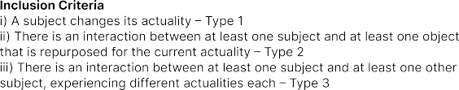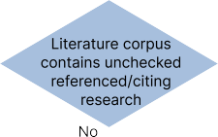
Fig. 1. Literature selection process: The initial literature corpus from five leading conferences was screened based on our inclusion criteria. Then, referenced and citing literature was screened and added based on the same criteria. We repeated this process until we did not find more relevant literature.

screening author, it was discussed with all authors and a mutual decision was made. In total, we identified 160 papers that are relevant for this review.
  - After that, we looked at all references and all citing papers of the already gathered literature to identify further relevant papers, an approach that others have also applied, e.g., Katsini et al. [146]. We applied this process recursively, going through the references and citing pa- pers of newly added ones until we could not find any more relevant publications. In this step, we went through 11,465 references and 13,620 citations and found 103 additional referenced papers and 43 additional cited papers (n = 146).
  - In total, we found 306 relevant papers describing a cross-reality system, which we further classified to extract their core features and identify common themes.
The initial literature corpus was compiled using Google Scholar as the main search engine for citing papers while also relying heavily on the IEEE DL and ACM DL. At this point, it is worth mentioning that this strategy does not guarantee one will identify all relevant papers. We screened a tremendous number of publications, and while our literature corpus grew substantial in size, there is a chance that we missed some relevant publications due to human error. However, strict database queries suffer from similar issues, especially when the terminology of the research field is unclear or not yet fully established. Therefore, we argue that our approach was able to identify more relevant research publications than an automatic approach.
The final publication corpus (n = 306) served as the basis for understanding the interplay among different subjects and their actualities and corresponding objects that manifest across the Reality- Virtuality Continuum. For the publication corpus, we went through all publications and identified important features relevant to this survey to obtain a holistic view of the review corpus. Here, we identified features like the research topic and keywords that briefly describe the given research and involved scenarios as well as the purpose of the scenario (e.g., collaboration, leisure activity). Furthermore, we categorized the scenario together with involved subjects and objects. Therefore, we identified and quantified the involved entities (e.g., users, objects/artifacts) and how they were integrated into their scenarios (e.g., real-world objects brought into VR). Further, we extracted the form-factors (i.e., type of used devices) and modalities (i.e., visual, auditive, or haptic). We then

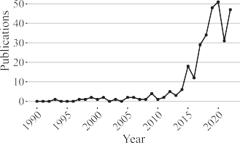


Fig. 2. Descriptive statistics regarding the corpus of literature gathered in our literature review. For the subfigures b and c, we included all venues and authors with at least eight relevant publications.

identified how different entities relate to one another across the Reality-Virtuality Continuum and how they manifest on the continuum (e.g., VR, AV, AR). A complete version of our literature corpus, including a classification concerning different features, can be found as supplementary material.
Descriptive Summary of Literature Corpus. Over the last decade, we see a clear uptick of pub- lications proposing cross-reality systems (see Figure 2(a)), indicating a growing interest in the research community. While the publication count before 2015 may be inaccurate because we did not screen conference proceedings before that year, a clear trend between 2015 and 2022 remains recognizable. Nevertheless, in 2021, a dip in publications is observable, which is likely an artifact of the global Covid-19 pandemic, as in the year after, the publication count recovers. Furthermore, besides the identified five leading conferences, we identified the IEEE journal Transactions on Vi- sualization and Computer Graphics and the ACM SIGGRAPH conference as highly relevant venues (see Figure 2(b)). Finally, our corpus revealed that a few authors have around 10 publications pub- lished on the topic already. Here, Mark Billinghurst is taking the lead with over 20 publications (see Figure 2(c)).

CLASSIFICATION OF RESEARCH PROPOSING CROSS-REALITY SYSTEMS
Our classification of previous research focuses on the user interactions taking place in cross-reality systems. To understand and classify the gathered research, we analyzed our previously collected 306 papers. Each publication presents an artifact contribution (research prototype or system) that involves more than one manifestation of the Reality-Virtuality Continuum. Next, we present the classification of our research corpus concerning the three types of cross-reality systems and their research topics (see Section 4.1). Thereafter, we analyze the involved real and virtual environments (see Section 4.2). Finally, we examine the different transitions taking place (see Section 5).

Types of Cross-reality Systems and Their Research Topics
We started analyzing all 306 papers by assigning categories to each paper, following an open- coding approach with all authors involved (e.g., we assigned the category “HMD user transitions into VR” to the following paper [284]). Thereafter, we applied the method of card sorting [279], clustering the identified categories and assigning a research topic to each cluster (e.g., we clus- tered “HMD user transitions into VR” into the research topic “transitional interface”). Then, we grouped the categories within each research topic into additional types to further classify the dif- ferent papers (e.g., “HMD user transitions into VR” into the type “automatic transition”). Here, it is important to note that a paper can be sorted into multiple research topics and types. Finally, we

Table 1. Publications Representing Research That Investigates Transitional Interfaces

Type | Category | Count | Publications
User controlled | Headset based | 19 | [3, 47, 55, 86, 92, 103, 111, 117, 179, 180, 208, 222, 244,  247, 253, 288, 299, 300, 308]
Mixed form factors |  | 9 | [39, 124, 149, 168, 234, 254–256, 312]
Handheld based |  | 6 | [23, 29, 30, 58, 151, 317]
CAVE-based projection |  | 2 | [161, 268]
Automatic Transition into VR |  | 6 | [4, 5, 137, 280, 284, 303]
Transition into AV |  | 3 | [37, 248, 323]
Transition out of VR |  | 3 | [120, 157, 277]

assigned each research topic to one of the three cross-reality systems types defined in Section 2.5. In the following, we describe the research topics within the three cross-reality system types.
    - Type 1 (Transitional): Subjects Transitioning on the Continuum Experiencing a Changing Actuality. For the first type, we identified one research topic as relevant: transitional interfaces. In sum, we identified 48 of 306 papers (15.69%) that investigate Type 1 systems.
Transitional Interfaces. A transitional interface is a system designed to empower users to tran- sition on the Reality-Virtuality Continuum and experience its various manifestations, proposing a new way to interact and collaborate among these manifestations [23, 124]. An early example is the MagicBook from Billinghurst et al. [29, 30]. The book can be read in reality, augmented with virtual objects in AR, or used as a companion in immersive VR. With AR- and VR-enabled devices becoming part of everyday life, it is imaginable that transitional interfaces will become ubiquitous. In the past, two different categories have been explored (see Table 1): interfaces controlled by the user (36) and interfaces with an automatic transition (12).
User-controlled transitional interfaces allow users to manage shifts between manifestations. Different form factors of these interfaces have been explored in the past, ranging from headset- (e.g., [55, 253, 308]), handheld- (e.g., [23, 29, 58]), and projection-based devices (e.g., CAVEs [268]) to a combination of various form factors (e.g., [124, 234, 255]). The second type of transitional interfaces allow for an automatic transition between manifestations on the continuum, meaning the user may initiate the transition, but then the interface automatically transitions the user to the target manifestation. So far, the majority of investigated transitions are limited to those between re- ality and VR, investigating transitions into VR (e.g., [4, 280, 284]) or out of VR (e.g., [157, 277]). Also, some of the investigated automatic transitions involve users who transition to AV (e.g., [37, 323]).
    - Type 2 (Substitutional): Subjects Interacting with Objects That Are Repurposed for the Sub- ject’s Actuality. For the second type of cross-reality systems, we found that 158 of 306 papers (51.63%) are relevant that are distributed over two different research topics: object utilization (124) and collision avoidance (39). In the following, we present each of the research topics in detail.
Object Utilization. The 124 papers that address object utilization investigated users experiencing a concrete manifestation (e.g., VR) in which they lack relevant objects, for example, real-world objects. Important is that these objects are not components specifically designed for being used in VR such as VR controllers. These controllers have no real purpose in the real world because they are only used to interact with the virtual environment. Hence, to fulfill our definition of Type 2 cross-reality systems, we focus on objects that have specific semantics in the real world (or virtual environment) and are repurposed for the user’s experience. A typical example of this category is a VR user who wants to use a physical keyboard within the VR environment (cf. [192, 306]). In this example, the keyboard is not designed for VR but instead is used to operate a computer in the

Table 2. Publications Representing Research That Investigates Object Utilization

Type Category Count Publications
Passive haptics 23 [19, 26, 27, 38, 42, 65, 67, 74, 79, 85, 86, 110, 114, 179, 205,
206, 221, 229, 232, 254, 274, 275, 324]
Handheld device 17 [3, 6, 22, 28, 32, 59, 60, 66, 69, 133, 155, 269, 287, 307, 310,
311, 348]
Integrate into VR
Environment scan 16 [44, 83, 111, 148, 186, 204, 247, 281, 293, 299, 317, 323, 330,
339, 349, 351]
Input device 12 [33, 101, 102, 150, 159, 196, 197, 227, 245, 266, 306, 345]
Motion 8 [48, 49, 118, 160, 176, 193, 194, 231]
Notifications 6 [94, 122, 177, 189, 222, 259]
Physical objects on demand 5 [31, 37, 108, 192, 248]
Active haptics 3 [9, 107, 315]
Human body 3 [36, 73, 334]
Others 7 [93, 119, 202, 212, 246, 291, 302]
Real-world objects 6 [138, 143, 208, 289, 344, 350]
Integrate into AR
Handheld device 5 [11, 125, 158, 301, 347]
Virtual objects 4 [46, 264, 265, 317]
Environment scan 3 [180, 218, 338]
Passive haptics 3 [117, 243, 262]
Others 3 [95, 130, 213]

real world. A counter-example are VR haptic props (cf. [13]). Here, the haptic props are designed to enhance the virtual experience but have no meaning in the real world, similar to VR controllers that exist with the sole purpose of interacting with the virtual environment. In all papers investigating object utilization, real-world entities are integrated into either VR (100) or AR (24). An overview of all these papers and their categorization is shown in Table 2.
The integrated real-world objects include mostly physical objects from the real world—for VR to deliver passive haptics (23), integrate handheld devices (17), or include input devices (12) such as keyboards, mouses, or instruments, or for AR to utilize them (6) or include handheld devices (5). Furthermore, often they utilize parts of the user’s environment to create more realistic haptic sen- sations in VR. Other approaches range from integrating specific real-world objects [38, 74, 324] to annexing any kind of object automatically [117, 275] or with the help of another user [179]. A side effect of including physical objects is that users are more aware of their presence and are less likely to bump into them. Besides physical objects, previous work investigated the influence of other more abstract objects such as motion or notifications. Integrating real-world motion empowers users to experience VR in moving vehicles without getting motion sickness [118, 193, 194, 231]. In addition, studies have shown that enjoyment and immersion significantly increase with included motion [118]. Finally, various studies have investigated how to integrate notifications without neg- atively affecting immersion [94, 122, 222, 259]. This can be accomplished, for example, by seam- lessly integrating notifications into the virtual environment as diegetic elements [259].
Collision Avoidance. When users are immersed in virtual environments, obstacles in the real world are no longer visible. In order to solve this problem, various collision avoidance approaches have been explored. While these approaches have mostly investigated VR scenarios, the problem is not exclusive to immersive virtual environments [140, 141]. Overall, previous work presents three main strategies for avoiding collisions in VR and AR experiences: manipulating the user (16), manipulating the experience (14), or providing warnings that alert users (9). All approaches previously researched and found in our literature review can be seen in Table 3.

Table 3. Publications Representing Research That Investigates Collision Avoidance

Type | Category | Count | Publications
User manipulation | Redirected walking | 14 | [16, 21, 35, 63, 64, 77, 109, 121, 191, 201,
User manipulation | Resetting user position | 2 | 235, 296, 320, 328]  [18, 319]
Experience manipulation | Adapting environment | 14 | [52, 62, 65, 113, 139, 147, 187, 205, 271, 302,  307, 322, 323, 330]
Collision warning | Visual-based warnings | 4 | [140, 141, 341, 342]
 | Haptic-based warnings | 2 | [71, 304]
 | Multi-modal warnings | 2 | [91, 195]
 | Audio-based warnings | 1 | [1]

Unlike warnings, which are designed to gain the user’s attention, approaches that manipulate the environment or user often incorporate unnoticeable changes into the experience, empowering users to walk around infinite virtual environments without being aware of it (e.g., [16, 65, 205, 328]). These approaches currently have their limitations (e.g., mainly resulting from the induced illusions that only work to a certain degree), making collision warning approaches useful additions to VR scenarios or alternatives for non-VR scenarios (e.g., auditive warnings [1]).
    - Type 3 (Multi-user): Multiple Subjects Experiencing Different Actualities. In total, we found that 133 of the 306 papers (43.46%) investigated Type 3 cross-reality systems. For these papers, we identified the following research topics (in descending order): collaboration (93), bystander inclusion (34), and isolated experiences (11). In the following, we present these topics.
Collaboration. The most frequently researched topic of Type 3 cross-reality systems is collabo- ration, with a total of 93 publications. Here, collaboration between users experiencing the same manifestation on the Reality-Virtuality Continuum was not included in our literature review (as it does not fulfill the definition of Type 3). Thus, we only included publications involving two or more manifestations on the continuum, so-called asymmetric collaboration [82, 285]. We identified two types of asymmetric collaboration: remote (67) and co-located collaboration (27). In Table 4, all of these publications are listed in their respective categories.
Compared to co-located collaboration, remote collaboration is the more extensively researched topic, with a share of over 70.1% of all collaboration-related publications. Different remote collab- oration approaches have been investigated, with collaboration between VR and AR headset users being the most frequent (24). The reason for this is that expert-novice scenarios are explored fre- quently, with the expert in VR and the novice on-site in AR. Other approaches typically involve a headset in combination with another form factor. Here, the most frequently used form factors are traditional 2D displays involved in eight of the remote collaboration approaches as well as a handheld device (8), for example, a mobile touchscreen device [225]. Besides users experiencing concrete manifestations, transitional interfaces have been explored for collaboration as well. They allow users to switch between augmented and virtual views of one collaborator’s space [156] or to use the transition to switch between the spaces of both collaborators [297]. Moreover, others have investigated various combinations that involve tabletops [282, 283], handhelds [78, 84, 185, 282], or projections [82] to enable remote collaboration.
For co-located collaboration, the most frequent combination of form factors is a VR headset
combined with an AR handheld device (e.g., [98, 164, 215]). Another observable trend is that in most co-located collaboration a VR headset is involved (15). However, compared to remote collaboration, utilizing users that experience different actualities has been explored less frequently, with only 27 publications (29.03%). Some of these papers explore highly unique concepts that are difficult to

Table 4. Publications Representing Research That Investigates Collaboration between Users

Type | Category | Count | Publications
Remote | VR headset + AR headset | 24 | [50, 87, 134, 135, 148, 153, 169, 171, 172, 216, 219, 220,  230, 237–239, 290, 293–295, 314, 329, 334, 337]
AR headset + 2D display |  | 8 | [25, 51, 70, 88, 145, 170, 241, 327]
VR headset + handheld |  | 8 | [78, 84, 127, 154, 185, 225, 226, 335]
VR headset + 2D display |  | 7 | [53, 123, 203, 217, 292, 326, 332]
VR headset + 360◦ camera |  | 3 | [144, 210, 252]
Transitional interface |  | 2 | [156, 297]
VR headset + robot |  | 2 | [57, 116]
VR headset + VR headset |  | 2 | [162, 298]
Others |  | 10 | [17, 34, 82, 89, 228, 236, 249, 267, 282, 283]
Co-located VR headset + handheld |  | 5 | [98, 164, 178, 215, 340]
VR headset + AR headset |  | 4 | [56, 179, 256, 276]
VR headset + 2D display |  | 3 | [142, 173, 251]
VR headset + tabletop |  | 3 | [126, 181, 285]
Others |  | 12 | [7, 8, 24, 99, 131, 201, 207, 257, 261, 268, 309, 336]

Table 5. Publications Representing Research That Investigates Bystander Inclusion
Type Category Count Publications

Bystander in MR
Awareness of bystander 14 [31, 75, 96, 163, 165, 192, 195, 209, 223, 286, 305, 307,
316, 331]

Bystander as support | 2 | [43, 45]
Interacting VR and 2D display | 3 | [132, 173, 318]
with VR and no technology | 3 | [69, 224, 346]
bystander VR and HMD display | 2 | [40, 106]
VR and projection | 2 | [72, 104]
Sharing VR via HMD display | 4 | [90, 183, 190, 242]
with VR via CAVE | 2 | [128, 129]
bystander AR via handheld | 1 | [325]
AR via projection | 1 | [112]
group with other publications, such as work from Baudisch et al. [24]. In this paper, the authors investigate multiple users collaborating in the same real-world space; however, they play with a virtual ball that can only occasionally be perceived. We believe this work is relevant because, while the collaborators experience the same manifestation, the scenario still integrates an object that has a different manifestation. Especially interesting here is that the object exists in virtuality, not reality.
Bystander Inclusion. In many publications, researchers investigated a range of approaches to in- clude bystanders in the MR experience (oftentimes of an HMD user). Unlike collaboration scenar- ios, the bystander is a real-world person who does not participate in all aspects of the experience, but rather interacts with the user as needed. Overall, we identified 34 of 133 Type 3 cross-reality system publications as relevant (25.56%) to this research topic. These publications can be classified into three different approaches: bystanders contribute to the user’s experience without a channel back to themselves—unidirectional (16), the user interacts with a bystander—bidirectional (10), or the user shares their experience with a bystander who does not interact with it—unidirectional
(8). In Table 5, all publications researching bystander inclusion are listed with their respective categories.

Table 6. Publications Representing Research That Investigates
Isolated Experiences

Type Category Count Publications
Users in same space VR + VR 7 [18, 21, 62, 64, 165, 188, 240]
VR + Reality 3 [286, 305, 331]
Away from reality VR + Reality 1 [258]

For scenarios in which bystanders are involved in the VR experience, it is always a VR user for whom the bystanders create haptic sensations [43, 45] or to whom bystanders are shown [75, 209, 307]. For interaction between bystanders and users, all approaches describe the interaction between a head-mounted VR user and their bystanders, with two approaches being most frequent: using a 2D display that helps bystanders to participate in the experience [132, 173, 318] or using no technology at all [69, 224, 346]. When sharing an experience with bystanders in two publications, an augmented environment was shared [112, 325]. A VR user often shares their experience using a CAVE [128, 129] or headset display facing bystanders [183, 242].
Isolated Experiences. Isolated experiences aim to separate two users on the Virtuality-Reality Continuum as far as possible from each other. In total, we found 11 publications investigating one of two different scenarios: users share the same physical space while at least one is immersed in a specific manifestation of the continuum, for example, VR (10), or users are immersed into a manifestation to escape reality (1). All scenarios are listed in Table 6. In most cases, VR users share the same space and need to be redirected to avoid collisions between them. This is similar to collision avoidance, except that here two users are involved. For user isolation, an interesting idea has been presented by Ruvimova et al. [258]. They suggest using VR as a solution to evade a crowded office space.
    - Summary. When reflecting on all investigated 306 publications, we identified that differ- ent entities are involved in the explored research topics. To describe these entities, we suggest a classification into two groups: subjects and objects. Subjects can be users or bystanders that per- ceive their environment and can experience different manifestations. Their very own perspective on the scenario depends on these manifestations (e.g., AR or VR) and, therefore, forms their ac- tuality—that what is “currently happening” for them. This can be individual for each subject. In contrast, objects can be various things, such as real-world, physical objects; information (e.g., no- tifications); or even motion. Essential for the classification as an object is that they do not have a perception of the environment. In the investigated publications, we found all three types of cross- reality systems, but with different frequency. It is worth mentioning that a cross-reality system does not have to be limited to one specific type but can be classified as multiple types at the same time (e.g., ARchitect [179], in which users can transition between AR and VR (Type 1), repurpose physical real-world objects for the VR experience (Type 2), and experience different actualities at the same time (Type 3)). In sum, we found 48 publications (15.69%) that investigated Type 1 sys- tems that involve subjects transitioning on the continuum and, thereby, experiencing different actualities. For Type 2 and Type 3, we found 156 (50.98%) and 133 (43.46%) publications, respec- tively. Both types involve multiple entities, with Type 2 systems including at least one subject and one object, while Type 3 systems involve two or more subjects. Furthermore, during our analy- sis, we observed that there are similarities between Type 2 and Type 3 cross-reality systems. For both types, there are research topics that aim to increase the distance between the entities on the Reality-Virtuality Continuum, while there are other research topics that investigate how to decrease the distance between different entities on the continuum (see Table 7). For the research

Table 7. Overview of All Research Topics Involving Multiple Entities (Subjects/Objects) and Their Relationship on the Reality-Virtuality Continuum, Covering Both
Type 2 and Type 3 Cross-reality Systems

Type  Type 2 | Involved Entities Entities Repel Each Othe  Subject + Object Collision avoidance |  | r Entities Attract Each Other  Object utilization
Type 3 | Subject + Subject | Isolated experience | Bystander inclusion/Collaboration

topics of collision avoidance and isolated experiences, the entities should repel each other, mean- ing that the interaction between the entities is decreasing, while in the topics of object utilization, bystander inclusion, and collaboration, the entities should attract each other on the continuum, thereby increasing their interaction. Interestingly, we observed that the majority of publications investigate aspects of entities attracting each other, 251 of 306 (82.57%), while the minority looks at increasing the distance between entities, 50 of 306 (16.34%)—entities that repel each other. Each publication is counted once. Summing numbers from different topics may result in higher totals due to overlapping topics. Publications solely in the topic of transitional interface are excluded.

Combinations of Environments in Cross-reality Systems
Experiences on the Reality-Virtuality Continuum involve different environments. Per definition, these include at least one real environment and one virtual environment between which the con- tinuum spans. They are entangled with each other or otherwise there would not be any influence from one into the other environment. The most simple example is a VR user who experiences some form of digital world but still stands on the real, physical floor. Nevertheless, in a minority of publications, more than two environments are involved (e.g., two VR users in the same phys- ical space who experience different virtual environments [18]). Overall, we found three different environment constellations: scenarios involving one reality and one virtuality (230), scenarios in- volving multiple real-world environments and one virtuality (67), and scenarios involving multiple virtualities and one real-world environment (9).
    - Multiple Real-world Environments. Scenarios of this category involve at least two real- world locations (i.e., different geographical areas) between which physical entities do not move, for example, an expert user joining a novice user from a different real-world location [238]. Overall, we identified 67 publications as relevant for this category (21.9%). While reviewing publications involving multiple real-world environments, we found that they mainly address remote collabo- ration (64), followed by object utilization (6), as the underlying research topics. Object utilization investigated various approaches including the integration of information from the real world, such as notifications or messages (3) [122, 189, 259].
    - Multiple Virtual Environments. We found nine publications involving multiple virtual en- vironments (2.9%). The main research scenario in eight of these publications involved multiple VR users who share the same physical space but not the same virtual experience [18, 21, 62, 64, 167, 188, 240, 263]. In this case, every user has a distinct actuality that differed from the actualities of the other users. Corresponding publications also focus on avoiding collisions between co-located VR users and assume that these users want to engage solely in their individual experiences. On the contrary, Wang et al. [308] recently proposed a transitional interface that allows a user to view other co-located VR players’ experiences. Finally, the number of virtual environments can also be higher than two, for example, if more users are involved and need to share the same physical space [64].

Table 8. Transitions of the Subjects along the Reality-Virtuality Continuum

Transitions |  |  | Count | Publications
AR → RW |  |  | 1 | [141]
VR → RW |  |  | 7 | [40, 72, 120, 157, 177, 183, 242, 277]
RW → AR |  |  | 12 | [39, 112, 117, 125, 130, 137, 145, 151, 168, 208, 212, 218, 234, 247, 255, 268, 317,  325, 338]
RW | → | AV | 5 | [47, 159, 197, 288, 308]
AR | → | AV | 1 | [75, 137, 234, 255, 268]
VR | → | AV | 54 | [1, 3, 31, 32, 37, 38, 44, 59, 69, 71, 86, 91, 96, 102–104, 108, 111, 114, 119, 129,
139, 140, 147, 180, 181, 192, 195, 196, 201, 202, 204, 222–224, 229, 232, 248, 266,
271, 286, 299, 302, 304–307, 312, 316, 322, 323, 330, 331, 342]
RW | → | VR | 20 | [4, 5, 29, 30, 40, 83, 92, 106, 124, 149, 155, 161, 187, 275, 280, 281, 284, 285, 300,
AR | → | VR | 10 | 303, 349]  [23, 39, 55, 58, 99, 156, 179, 244, 247, 253, 254, 256, 317]
Multiple 8 [39, 40, 137, 234, 247, 255, 268, 317]
Involved Manifestations: Real World (RW ), Augmented Reality (AR), Augmented Virtuality (AV ), and Virtual Reality (VR).
    - Summary. We identified the different environment constellations presented in the screened publications. The majority, 75.2%, of the publications investigated scenarios with one real and one virtual environment. When multiple environments are involved, these are often physical locations located apart from each other and are digitally connected mainly for the purpose of collab- oration. We also identified publications that aimed for isolated experiences of users with different virtual experiences. Here, these users were located in the same physical space. Hence, the research aimed for providing isolated experiences and those closely related because of an inevitable inter- action or influence, avoiding collisions. When multiple virtual environments were deployed, we found that most approaches aimed for providing users with an isolated experience, which aimed for less interaction with co-located users. Along with that, collision avoidance was investigated to reduce the number of encounters with other persons to preserve the isolation. Eventually, we did not find any systems that use multiple real-world and multiple virtual environments.

ANALYZING CHANGING ACTUALITIES IN CROSS-REALITY SYSTEMS
When using a Type 1 system, the actuality of a user changes over time due to a transition along the Reality-Virtuality Continuum. However, numerous systems in the literature are not introduced as cross-reality systems, nor are the transitions highlighted in particular because the presented research did not investigate the cross-reality aspects in itself but, for example, topics like user perception [254] or collision avoidance [1]. Therefore, we conducted an in-depth analysis of the literature to find Type 1 systems and corresponding transitions that are not obvious to readers. We identified 118 relevant publications that introduced systems that changed the actualities of its users. Continuing our overview presented in Section 4.1.1, we present our in-depth analysis of these transitions in the following. First, we analyzed the involved manifestations in the described systems (see Section 5.1). Here, we limited ourselves to the distinct manifestation previously in- troduced: VR, AV, and AR, including transitions involving the Real World (RW). Thereafter, we identify the cause of these transitions (see Section 5.2). Finally, we conclude with a summary (see Section 5.2.9).

Transitions between Manifestations
As seen in Table 8, subjects transition along the Reality-Virtuality Continuum from and to var- ious manifestations. Here, the perception of the transition is dependent on the perspective of a

subject—the actuality (e.g., a VR user experiencing VR or a bystander experiencing reality). For ex- ample, a bystander could walk by a VR user and is shown to the VR user in the virtual environment when being close [192]. The bystander’s actuality does not change as the bystander still perceives the RW while crossing the area around the VR user. However, the VR user sees the bystander in the virtual environment; therefore, the VR user’s actuality changes with a transition from VR to AV. This is because the virtual environment is augmented with objects from the real world and therefore is no longer purely virtual, in this case, with the bystander. In the following, we introduce the different manifestations involved in the transitions that we found in the literature.
    - Transitions to Real World. We found eight (2.61%) publications that involved a transition to the RW. Here, taking a glimpse at a bystander while being in VR results in a transition from VR to the real world [40]. This can be useful when immersed VR users want to interact with surrounding persons for a brief moment. To avoid collisions when using AR obstacle detection and accompanying alerts that make users aware of these obstacles forms a transition from AR to the RW [141]. When taking the VR-HMD, and thereby transitioning to the RW, users report that they, for example, felt disoriented [157]. Therefore, gradual exit procedures could help VR users to exit their virtual experience more comfortably and safely. Likewise, one could use metaphors like a door to the real world to exit virtual experiences [277].
    - Transitions to Augmented Reality. We identified 12 (3.95%) publications that investigate switches from the RW to AR. Editing the real world with AR’s help can be seen as a transition from a real environment to AR [338]. Likewise, overlaying virtual objects onto real ones lets a user transition from RW to AR as soon as the overlays are brought into place [117]. Also, sharing content with a bystander can be seen as a transition from the RW to AR [112]. Here, the bystander is the transitioning subject.
    - Transitions to Augmented Virtuality. Overall, we found 60 (19.74%) publications that in- volved transitions to AV. The most common transition within the type are publications investi- gating transitions from VR to AV (54, 17.76%). Bringing in real objects like a cup for drinking, a keyboard for typing [192], or a smartphone [59] when needed depicts a transition from VR to AV. Also, integrating approaching bystanders into the virtual world in order to create awareness or foster interaction results in a transition from pure VR to AV [305] or when actively interacting with them [104]. Further, while in VR, partially showing the RW would result in a transition from VR to AV [111]. Further, transitions from VR to AV can occur in a non-obvious manner and often rely heavily on the visual sense. For example, for two users that use redirected walking to meet each other to shake hands while being immersed in VR [201], as soon as they are redirected toward each other and shake hands, their VR is externally influenced through the handshake, which is part of the real world. In this case, they transition for a brief moment from VR to AV. Additionally, we found five (1.65%) that investigated transitions from the RW to AV. Here, a bystander could enter a VR user’s experience and thereby augment the virtual experiences with their appearance [308].
    - Transitions to Virtual Reality. In sum, we found 37 (12.17%) publications that involved transitions to VR. We identified 10 (3.29%) publications that investigate transitions from AR to VR. Users could start in AR and then, for example, decide to transition to VR [254, 256], to exchange information between the two manifestations [253], or to collaborate [99]. Further, we identified 20 publications (6.58%) involving a transition from RW to VR. For example, Steinicke et al. intro- duced an approach for transitioning into VR through a portal metaphor. They provided a portal from the real environment to VR to the user. The user could enter the portal to enter the virtual environment [284]. Also, it could be shown that a smooth transition into VR helps the user to create awareness of the virtual environment [303].

Table 9. Transition Causes for Transitions of Subjects along the Reality-Virtuality Continuum

Transition Cause Count Publications
Substitution of physical object 26 [44, 47, 83, 86, 111, 117, 139, 147, 151, 180, 187, 197, 204, 208,
212, 247, 254, 275, 281, 288, 299, 302, 323, 330, 338, 349]
Change actuality 22 [4, 5, 92, 103, 120, 124, 137, 149, 157, 161, 177, 244, 253, 255,
256, 268, 277, 280, 284, 300, 303, 307]
Bystander inclusion 21 [40, 69, 72, 75, 96, 104, 106, 112, 129, 181, 183, 195, 222–224,
242, 285, 305, 316, 325, 331]
Interaction with physical object 19 [3, 29–31, 37, 59, 108, 119, 125, 155, 192, 196, 202, 218, 248,
266, 286, 306, 312]
Collision avoidance | 10 | [1, 71, 91, 140, 141, 201, 271, 304, 322, 342]
Collaboration | 8 | [39, 99, 130, 145, 156, 179, 234, 308]
Providing haptic feedback | 8 | [32, 38, 58, 102, 114, 159, 229, 232]
Interaction with virtual object | 4 | [23, 55, 168, 317]
    - Transitions to Multiple Manifestations. We found eight (2.63%) publications that focused on interfaces for transitions along the whole continuum from the RW to AR, then further to AV, and finally to VR. In these scenarios, users transitioned step by step from the real world to the virtual. Each step involved different objects or actions taken by the user [255].
    - Summary. We investigated 118 publications that introduce transitions on the continuum and identified involved manifestations. We found that most transitions (54) are from VR to AV, followed by transitions from the real world to VR (20). Some transition categories are underrep- resented, like transitions from AR to the RW or from AR to AV. Moreover, the presented transi- tions can be non-obvious at first (e.g., VR users transitioning to AV when they meet and shake hands [201]).

Causes of Transitions
Transitions on the Reality-Virtuality Continuum can have different causes. We identified several causes for transitions (see Table 9). In the following, we introduce these causes in greater detail.
    - Substitution of Physical Object. We found 26 (8.55%) publications that substituted phys- ical objects with virtual ones. For instance, providing a realistic walking experience and at the same time enhancing VR can be accomplished by constantly scanning the real-world environment and adapting the virtual world accordingly to let the user walk in the automatically generated world [44]. Here, the user transitions from VR when not adapted to AV when the virtual world is adapted to the surrounding physical environment; in other words, the physical environment is substituted by the virtual environment. Furthermore, real-world objects can be substituted to provide haptic feedback to virtual objects that share similar haptic properties [117].
    - Change Actuality. We found 22 (9.62%) publications that introduce transitions on the con- tinuum that are deliberately caused by the user to access virtual objects or to enter a virtual en- vironment. Such transitions can enhance presence [284]. For example, when entering a virtual environment, transitioning gradually from the RW to VR makes users feel more presence [137]. This can be accomplished by gradually blending out real-world objects and at the same time blend- ing in the virtual environment. Users may also exit VR, which causes a transition from VR to the real world. Here, Knibbe et al. investigated which factors influence transitions out of the virtual experience [157]. The results pointed out that the virtual experiences influences the users beyond the point of exit and therefore need further consideration. To exit virtual experiences, metaphors like portals [308] or curtains [161] can be used to indicate the possibility of a transition between

VR and the RW. Traversing on the continuum can be accomplished by different user actions or using objects [255].
    - Bystander Inclusion. Including bystanders can also be a cause for transitions. We iden- tified 21 (6.91%) publications that investigate transitions caused by bystanders. For example, a transition from the real world to AV can be caused if the bystander enters the tracking space of a VR user [305]. Here, the bystander is integrated visually into the virtual environment. A bystander could also cause a transition from the real world to AR when projections are used to give access to the virtual content that an AR user experiences [112]. Breaking the VR isolation can be done by enabling bystanders to interact with the VR user [104]. Here, the bystander can actively partici- pate in the VR user’s activity and influence the virtual environment. In this scenario, the VR users transition from VR to AV when interacting physically with the bystander. From the perspective of the bystanders, they can see floor projections in the RW and can use a display to enter the virtual experience, which also can be seen as a transition from the RW to VR. Other ways to include by- standers into virtual experiences utilize audio to allow for communication between VR users and bystanders [224].
    - Interaction with Physical Object. We found that most transitions occur due to interactions with physical objects. Here, we found 19 (6.25%) publications. Interaction with the real world can cause transitions, for example, from VR to AV [192]. Users transition when they want to drink or eat something while experiencing VR [37]. Further, we found that the usage of an ex- ternal device causes transitions [59]. Users could check a smartphone for messages [3] or using a tablet [125]. For using a smartphone, one could capture it in the RW by video. Then, the smart- phone can be cropped out of the video feed and presented to the VR user. This augments the VR experience, making it AV. Similarly, using a physical object such as a keyboard in VR constitutes a cause for a transition [266]. Here, the VR user is transitioning from VR to AV when using the keyboard.
    - Collision Avoidance. We found 10 (3.27%) publications in which obstacle avoidance caused transitions of users. Providing such safety features can cause transitions along the continuum, like creating awareness of obstacles in the VR user’s proximity [140, 322]. Modalities other than the visual were also investigated, e.g., auditive feedback, which lets the user transition out of VR to AV as the virtual environment is augmented with auditive warnings of real-world objects [1].
    - Collaboration. We found eight (2.61%) publications in which the cause for a transition was the collaboration among users. Often, collaborators transition from AR to VR when creating a collaborative solution [99, 156, 179]. For instance, they shape a maze in AR and then use the created maze to play a game in VR [179].
5.2./ Providing Haptic Feedback. We found eight (2.63%) publications that introduced transi- tions when providing haptic feedback. For example, to enhance typing in VR, one can integrate a physical keyboard [102, 159] or smartphone [114]. Users also transition when using physical objects around them to mimic the haptics of virtual objects, for example, through haptic retarget- ing [232].
    - Interacting Virtual Object. We identified four (1.32%) publications that introduce transi- tions that allow for the interaction with virtual objects, for instance, when a real-world environ- ment is scanned and edited in AR [317]. Further, a transition can be caused when combining a physical environment with a virtual one [55], or when the real environment is occluded, a user could use a virtual copy of the same to get a better overview [23].

    - Summary. We investigated 118 publications that introduce transitions on the continuum and identified their corresponding transition causes. We found that most transitions (26) occurred when physical objects were substituted in virtual experiences, for example, to design virtual en- vironments on the basis of the physical world [275]. This is followed by 22 publications that in- troduced transitions that occurred when there was the need to deliberately change the actuality, for example, when leaving a virtual experience [157, 277]. The third highest cause of transitions was bystander inclusion into the virtual experience, with 21 publications. Here, bystanders were brought into the virtual experience of, for example, a VR user to create awareness of their presence, thereby making the VR experience an AV experience [305].

NINE GUIDING PRINCIPLES OF CROSS-REALITY SYSTEMS
In an interview study, Ashtari et al. identified eight key barriers that MR creators face today [12]. An important barrier noted by the different groups interviewed (i.e., hobbyists, domain experts, and professional designers) is the lack of concrete design guidelines and examples. Therefore, fol- lowing our previous section that investigated and described current research on cross-reality sys- tems, we continue with the introduction of nine guiding principles for designing and implementing such systems that we derived from our analysis. We categorized the principles according to the three different cross-reality system types introduced in Section 2.5. We grounded our rules in the literature, thereby providing the underlying rationale together with examples of how the rule can benefit the design and implementation of cross-reality systems.

Type 1 (Transitional): Subjects Transitioning on the Continuum
Principle 1: Allow for Smooth Transitions When Changing the User’s Actuality. Allowing users to slowly and gradually transition into a target manifestation can benefit their understanding of what is going on. For example, slowly transitioning into VR allows users to keep an awareness of their physical environment [303], improve the sense of body ownership [137], and increase pres- ence [4, 284], while slowly transitioning out of VR can mitigate disorientation [157] and should be designed non-interactively [120]. A slow and gradual transition can, for example, be implemented by morphing real objects into virtual objects one after another in the target environment [303].
Principle 2: Use Suitable Metaphors to Make Transitions Intelligible and Believable. A possibil- ity to transition should be indicated by a metaphor to help users understand possible actuality changes (e.g., portals [92, 244, 307, 308]). This helps to peek into other manifestations and in- creases presence [284] and immersion. Also, tokens that allow for a transition can be employed as such metaphors (e.g., books [29, 30] or smartphones [92]). Important is that the deployed metaphor communicates its affordance to users.
Principle 3: Give Users Control Over Transitions. Transitions are a powerful technique of cross- reality systems as they enable users to change their actuality. However, they can result in severe issues for users if they are deployed wrong (e.g., a system that automatically transitions from AR to VR while the user navigates traffic would put its users at risk). Following the golden rule “support internal locus of control” from Shneiderman et al. [270], designers and developers should consider three primary aspects to give users control over transitions: (1) users can initiate the transition (e.g., by following a metaphor [29, 30, 55, 92, 244, 308]), (2) users can control the transition (e.g., speed of transition adjusted by the user [103, 303]), and (3) if multiple manifestations can be visited, the user should be able to identify and choose the target manifestation (e.g., [29, 30, 55, 103, 255, 280]). If automatic transitions are deployed, users should understand the transitions’ trigger.

Type 2 (Substitutional): Subjects Interacting with Substitutional Objects
Principle 4: Consider Surrounding Physical Objects to Avoid Collisions. Every object physically ex- isting in the user’s environment should be considered in the experience to avoid collisions [44, 109, 140, 187, 330]. Here, one can either bring over the physical object to the user’s current ac- tuality to raise awareness, for example, by substituting physical objects with feasible digital rep- resentations [275, 302], or one can use solutions that redirect users around the physical obsta- cles [16, 52, 121, 296]. If immersion is not of high importance, designers and developers can also deploy warnings using various modalities to help users avoid collisions (e.g., visual, auditory, or multimodal alerts [1, 91, 141, 195]).
Principle 5: Integrate Relevant Physical Objects to Enrich Experiences. Every object that is relevant to the user should be integrated into the user’s experience [192]. For example, one can enable users to enjoy a drink or use a keyboard [37, 155, 159, 192, 306] or mouse [345] without taking off the VR headset. Here, it is relevant to reduce the mismatch between the real and virtual world by finding a suitable virtual representation of physical objects (e.g., not showing the correct amount of liquid in a glass can result in problems [37]). Furthermore, we consider relevant objects to be more than physical bodies. Objects are also abstract information like notifications [259] or physical phenom- ena like motion [107]. These objects surround us and, thus, influence our perception in various ways. For example, if we experience VR inside a car as a passenger, we need to take the motion into account that is caused by the car driving [118, 193, 194, 231], similarly for VR experienced on board an airplane [321]. If physical phenomena are neglected, it can degrade the experience of users.
Principle 6: Provide Opportunities to Interact with Object in Every Possible Actuality. When ob- jects are present in the experience of users, there should be an interaction possibility for these objects [75]. Furthermore, if the user’s actuality changes throughout the experience, it is valuable to provide interaction possibilities with objects throughout all these actuality changes [29, 30, 168, 255]. These interaction possibilities cannot necessarily remain the same across the changed actual- ity but often require designers/developers to adapt them [208] (e.g., a book that enables transitions changes its appearance in different manifestations [29, 30]).

Type 3 Multi-user: Multiple Subjects Experiencing Different Actualities
Principle 7: Allowing for Isolated Experiences. It can be helpful to opt out of a social context, for example, to gain a distraction-free environment for better working conditions [258]. If surround- ing users should be excluded from the experience of a user (i.e., a mute on social so to speak), one can utilize the different methods provided by collision avoidance research [240] and adapt them while keeping in mind that other users move and are not static. Overall, three different approaches exist: manipulate the experience [167, 258, 296], manipulate the user [263], and give collision warn- ings [91, 140].
Principle 8: Include Bystanders in Closed Experiences. Experiencing a manifestation of MR in a head-mounted device often excludes bystanders from the experience [14, 105]. Hence, cross-reality systems should be capable of including bystanders in the HMD user’s experience. Depending on the goal, a cross-reality system can bridge the actualities of the HMD user and bystander by either providing a representation of the bystander in the MR experience [31, 115, 182, 192, 195, 209, 240,
286, 305, 307, 331] or sharing the MR experience with bystanders [112, 131, 318, 325]. Here, allowing bidirectional communication is possible as well and offers the foundation for collaboration [10, 40, 105, 106, 181, 346].

Principle 9: Enable Collaborators to Understand Each Other’s Actualities. As cross-reality systems enable users with different actualities to collaborate, it is beneficial to communicate these actu- alities, helping collaborators to understand the individual perspectives involved. Designers and developers of cross-reality systems have three ways to apply this rule: (1) they can allow collabo- rators to switch into each other’s perspectives [179, 298], (2) they can allow collaborators to get a glimpse at each other’s perspectives (e.g., in the form of portals [307, 308]), or they can integrate the elements of each other’s perspectives in their own actuality [41, 75, 297, 326].

RESEARCH CHALLENGES AND OPPORTUNITIES
Based on our literature review, it is evident that there has been an uptick in research around cross- reality systems (cf. Figure 2). In recent years, we can see a strongly increasing interest in this topic, with larger numbers of actualities involved and a trend toward more dynamic actualities that frequently change over time. Our literature review revealed that it is difficult to identify relevant research, especially Type 1 (Transitional) cross-reality systems, as occurring transitions on the continuum are often not the focus of the work. Thus, they are not prominently described (see Section 7.1). Further, we found that cross-reality systems can become rather complex due to the different perspectives involved (see Section 7.2). Moreover, we identified that current cross-reality systems partially neglect AR devices (see Section 7.3) and a trend toward AV solutions becomes visible (see Section 7.4). To address the increasing complexity of cross-reality systems, we conclude this section by discussing novel prototyping methods of cross-reality systems as an opportunity to make the field more inclusive and allow for quicker iterations (see Section 7.5).

Implicit Transitions
Many of the surveyed papers contain transitions on the continuum, meaning they change users’ actuality over time. However, the presented evaluations did not or only vaguely investigated the transition, in particular, cf. [91, 183]. Often, authors do not explicitly describe the transition that takes place on the continuum, for example, when the underlying research instead focuses on haptic feedback through the inclusion of real-world objects [159, 275]. Nevertheless, these transitions can be manifold, as they potentially involve multiple actualities and can affect various subjects that interact with the cross-reality system. We refer to these transitions as implicit transitions since they are a byproduct of the proposed system and not the focus of the introduced research. As these implicit transitions between actualities are complex, we found that they are difficult to grasp and hard to articulate. But due to their strong impact, they should be considered. Here, we found that common ground to describe these transitions has not yet been established. As a result, it is tough to extract the transitions’ essence, making an evaluation and comparison non- trivial. To make implicit transitions comprehensible and comparable, we recommend investigating visualization methods that enable one to convey the transitions taking place within a cross-reality system. Finally, cross-reality systems often do not investigate the transitions of their proposed systems. For example, research evaluating different approaches to display a physical keyboard in VR assumes the keyboard is always present [159, 266]. Thereby, these works focus more strongly on interacting with the keyboard in VR but less strongly on the transition between the keyboard being present or not. While it makes sense to focus on interacting with the keyboard, the aspect of how to transition between these states of the keyboard received less attention.

Multiple Actualities
We identified several research topics that involve multiple users and bystanders (cf. Section 4.1.3), which we refer to as Type 3 cross-reality systems. Here, both users and bystanders have differ- ent actualities and can transition along the continuum. Thereby, they can change their actuality,

resulting in more complex interactions. For example, von Willich et al. introduced a cross-reality system in which from the VR user’s perspective, a bystander enters VR and thereby transitions closer to the VR user; however, from the bystander’s perspective, there is no transition into VR, meaning the bystander still experiences the real world [305]. Thus, all perspectives need to be taken into account as they contribute to an all-encompassing understanding of the scenario. However, it remains challenging to grasp and convey users’ and bystanders’ perspectives and actualities to an audience that has not experienced the system itself. Again, we recommend investigating visualiza- tion methods; nevertheless, we emphasize that such visualizations need to consider the different actualities of the users involved in Type 3 cross-reality systems.

Missing Research on Augmented Reality
We revealed that current research investigations mainly focus on cross-reality systems that shape around VR users. We found only a smaller number of systems that proposed cross-reality experi- ences with AR users (VR is present in 236 papers, while AR only exists in 111 papers—less than half). We believe that the tendency of immersive VR to blend out the visual information from the real world while auditory or haptic sensations remain perceivable inherently offers more conflict poten- tial, which previous work has aimed to address. Nonetheless, previous work has demonstrated that AR suffers from similar problems—just to a smaller degree [140, 141]. Still, neglecting these issues can cause severe problems, especially when cross-reality systems are operated in more dangerous environments (e.g., while navigating traffic [136]). Hence, more investigations into head-mounted AR systems are needed, especially as these systems already provide the possibility to communi- cate more easily with bystanders, but the digital content is hidden similar to VR systems. Novel approaches introduced conceptual solutions to these issues [69]. However, especially for cross- reality systems that allow users to transition on the continuum, more hardware is required as only very few devices allow transitioning between AR and VR. Currently, these devices are also limited to video see-through AR.

Trend toward Augmented Virtuality
Current VR systems aim for immersive experiences; however, the physical environment of VR users continues to have an impact [187]. For example, VR users need to be careful not to bump into bystanders or furniture [192]. Thus, in recent years, research has shifted toward cross-reality systems that include parts of the VR users’ environment on demand, meaning they temporally or permanently transition users toward AV. In this work, we define such systems as Type 2 cross- reality systems (or Type 3 if they include other users). Commercial products have followed this trend, for example, Oculus with the release of its Pass-through API. Thereby, researchers have acknowledged the shortcomings of current VR systems and started embracing the opportunities cross-reality systems do offer. In the future, more research is needed to systematically investigate which aspects of users’ real environments need to be introduced to VR experiences and, more im- portantly, when and how users transition to AV with the goal to incorporate these aspects into their experiences. Finally, integrating real-world objects into the experience requires considering many different objects. If we manage to find computational approaches to integrate them automatically (e.g., [117]), it will enable users to engage with more objects.

Prototyping Cross-reality Systems
Prototyping and developing cross-reality systems is still challenging [214] and can be a time- intensive process that often requires software and hardware prototyping expertise [12]. Espe- cially, the creation of cross-reality hardware prototypes (e.g., [44, 104, 105, 192]) has a high entry barrier and requires the use of various hardware components (e.g., displays, projectors, sensors),

engineering skills (e.g., electrical engineering, software development), and design expertise (e.g., rapid prototyping). Enabling fast and low-effort prototyping of cross-reality systems could sup- port researchers, developers, and designers of cross-reality systems to quickly iterate their ideas and designs without the need to fully implement the entire system in both software and hardware (e.g., by avoiding a hardware implementation). We argue that more novel prototyping methods are required to help develop cross-reality systems. Recently, Gruenefeld et al. published VRception, a prototyping concept and toolkit that allows for rapid creation of cross-reality systems entirely in VR [103]. With this system, multiple users can remotely join one virtual environment. In this envi- ronment, they can use various pre-defined virtual components to build cross-reality systems and prototype their functionality in VR. A useful addition to this would be a modular hardware system that allows users to create cross-reality systems with less effort and without the need for extensive software and hardware experience. Such a system could include modular hardware components that can be easily integrated with each other (e.g., small projectors, displays, cameras) and software components that allow for easy integration into virtual environments. Moreover, researchers have proposed various prototyping tools relevant to cross-reality systems [214]. For example, they have presented approaches utilizing VR to prototype AR applications [97, 166] or to enact futuristic in- terfaces [272]. While these approaches are not directly targeting cross-reality systems, they can still be valuable for the prototyping process of these systems.

GENERAL DISCUSSION
In this section, we discuss the current state of cross-reality system research, thereby answering our guiding question: How can we align the language across communities and establish a solid foundation for future work that benefits both researchers and practitioners? For each extracted research question, we have a dedicated paragraph below that aims at discussing our related findings.
Classification of Cross-reality Systems. The field of cross-reality systems is a relatively young research area. Hence, a well-established terminology is not yet present in the relevant research communities. We argue that it is timely to establish a common terminology as we see an increas- ing number of publications that introduce cross-reality systems and research. Through our review, we aimed to provide a terminology that allows one to classify cross-reality systems. This can foster research by providing terms that make such systems more comparable or ease the communication of novel ideas. In this context, we argued for the term actuality to describe the current experience of cross-reality system users. Through this term, we can clearly describe what a user is currently experiencing (e.g., the actuality of a user is VR). Further, we introduced a clear distinction between subjects and objects. Subjects are conscious and can perceive their environment, or in other words, they have an actuality. For example, a person in the real world perceives the physical environment; therefore, the actuality for this person is the real world. When the person uses a VR-HMD, the actu- ality would be VR. To describe cross-reality systems that allow one to transition between different manifestations on the Reality-Virtuality Continuum [200], we introduced Type 1 cross-reality sys- tems. Transitional interfaces [29, 30, 300] can be classified as Type 1 cross-reality systems as they allow their users to transition between various manifestations (e.g., the real world, AR, VR), thereby changing the actuality of their users. Objects play a key role and, with their utilization, form an important new category within cross-reality systems. We have identified a large number of pub- lications that utilize objects within cross-reality systems (158 out of 306 publications). Therefore, we introduced Type 2 cross-reality systems. These types of systems allow one to repurpose objects, for example, from the real world in virtual experiences [192]. Through Type 2 systems, we can de- scribe all systems that integrate objects from another manifestation into the current actuality (e.g., a smartphone into VR [6]). We limit ourselves not only to physical tangible objects. Also, systems

that make use of physical phenomena like heat [291] or motion [48, 193, 194] can be categorized as Type 2 cross-reality systems. To describe systems that involve multiple subjects, each of which experiences different actualities, we introduced Type 3 cross-reality systems. A typical scenario would be users collaborating using AR and VR [220] or bystander inclusion [104, 192, 305]. We argue that this classification allows for structuring the field of cross-reality systems, thereby al- lowing one to get a better understanding of current trends and even recognize research that is not explicitly introduced as part of the cross-reality domain, for instance, utilizing objects within the user’s actuality for haptics [206] or integrating real-world motion into VR [48]. We believe that along these types, we can establish useful terminology and guidelines for researchers and practi- tioners in the area of cross-reality systems. In this sense, we introduced nine guiding principles for the design of cross-reality systems.
Nine Guiding Principles for Cross-reality Systems. As suggested by the literature, there are entry barriers for the development of AR/VR applications [12]. At the same time, MR applications are envisioned to become more relevant in the future [278]. Through our review, we observed a strong rise in contributions to the field of cross-reality systems, yet we lack guidelines that help to design and implement novel cross-reality systems and experiences. At this time, we strongly believe that it is important to propose a set of rules for cross-reality system design. With our nine guiding principles, we proposed such a fundamental set along our three types of cross-reality systems that are grounded in a large literature corpus. Although these rules may be partly familiar to cross- reality experts, formalizing and communicating such a set can benefit the field of cross-reality systems. Novice researchers or practitioners can benefit from years of research distilled into a crisp set of rules that serve as useful guidelines in many practical and educational contexts. The nine guiding principles we have proposed are backed by our extensive literature review. Nevertheless, they are not verified through empirical evaluations. In this sense, future research is necessary to assess their overall applicability. Still, we strongly believe that the rules in their current state form an important starting point for future and well-established guidelines.
Research Challenges and Opportunities. We extracted promising research challenges and oppor- tunities for future work through our literature review. The field of cross-reality systems is mani- fold, ranging from introducing implicit transitions that were not part of the underlying research question [159] to bystander inclusion that focuses primarily on immersed users and less on by- standers [305]. Therefore, little is known about their effects on the corresponding scenario. We see numerous research opportunities here that can help to shape the understanding of cross-reality systems and their effects on all involved users.
Limitations. We acknowledge the following limitations to our survey. We intentionally opted for a manual screening approach to compile our literature corpus because it allowed us to in- clude a larger, more diverse set of publications. On the one hand, this procedure can introduce human error (e.g., overlooking a publication) as our corpus grew substantially in size (overall we screened 33,522 publications). On the other hand, our manual approach allowed for the identifica- tion of publications that investigated cross-reality systems but did not use common terminology or present the research as a cross-reality-related evaluation. An automated approach like a data- base query would have suffered from the same limitations. Hence, we believe that our manual approach led to the compilation of a literature corpus that represents current research in greater detail than an automated one. Further, we compiled the literature corpus starting with HCI-related conferences. Consequently, literature that introduced cross-reality systems in other venues might not be considered in our literature corpus. As this survey approaches cross-reality systems from an interaction perspective, we started with HCI venues. Other venues (e.g., TVCG or SIGGRAPH)

often present graphic-focused publications and might lack the interaction part that is of interest to this survey. Nonetheless, through checking references and citing papers iteratively, we identified a huge amount of cross-reality systems published in other venues. Finally, we did not investigate the underlying population of the corresponding user studies in the reviewed papers. Therefore, our survey does not address possible novelty effects introduced by the presented systems.

CONCLUSION
Due to the increasing interest in cross-reality systems, we conducted a scoping literature review, surveying existing publications that propose such systems. Here, we conducted an in-depth lit- erature review by surveying more than 8,437 papers as an initial pool of papers in this domain, from 2015 to 2022. By following their referenced papers and papers that cited them, we surveyed around 25,000 additional papers (as citing or referenced publications). In sum, we identified 306 papers that describe implementations of cross-reality systems (e.g., [137, 192, 255]). These served as a corpus for classifying their research topics and identifying shared properties. While we see a growing interest in cross-reality systems, we could not identify common terminology. However, to describe cross-reality systems and the aforementioned interplay among different actualities, such terminology should be established. Hence, in our work, we answer the following research ques- tion: How can we align the language across communities and establish a solid foundation for future work that benefits both researchers and practitioners? In particular, we contribute a classification of cross-reality systems into three different types: Type 1: Subjects transitioning on the continuum experiencing a changing actuality; Type 2: Subjects interacting with objects that are repurposed for the subject’s actuality; and Type 3: Multiple subjects experiencing different actualities. Further- more, we contribute to a better understanding of these systems by identifying shared properties and providing nine guiding principles that should be followed when implementing these systems. Finally, we conclude our work with research challenges and opportunities that can benefit cross- reality systems. Here, we address current shortcomings and propose future research perspectives, including visualization and prototyping methods for these systems.

AUTHOR STATEMENT
This work is original and has not been previously published in archival form.

REFERENCES

References marked with • are in the set of reviewed papers.
- • C. Afonso and S. Beckhaus. 2011. How to not hit a virtual wall: Aural spatial awareness for collision avoidance in virtual environments. In Proc. of 6th Audio Mostly Conference: A Conference on Interaction with Sound.
- K. Ahuja, S. Pareddy, R. Xiao, M. Goel, and C. Harrison. 2019. LightAnchors: Appropriating point lights for spatially- anchored augmented reality interfaces. In Proc. of UIST. ACM. https://doi.org/10.1145/3332165.3347884
- G. Alaee, A. P. Deasi, L. Pena-Castillo, E. Brown, and O. Meruvia-Pastor. 2018. A user study on augmented virtuality using depth sensing cameras for near-range awareness in immersive VR. In IEEE VR’s Workshop on Everyday Virtual Reality. IEEE.
- • A. Almutawa. 2021. Effect of smooth transition and hybrid reality on virtual realism : A case of virtual art gallery.
Advances in Science, Technology and Engineering Systems Journal (2021).
- • A. Almutawa and R. Ueoka. 2019. The influence of spatial awareness on VR: Investigating the influence of the familiarity and awareness of content of the real space to the VR. In Proc. of Int. Conf. on Artificial Intelligence and Virtual Reality. ACM. https://doi.org/10.1145/3348488.3348502
- • T. Amano, S. Kajita, H. Yamaguchi, T. Higashino, and M. Takai. 2018. Smartphone applications testbed using virtual reality. In Proc. of Int. Conf. on Mobile and Ubiquitous Systems: Computing, Networking and Services. ACM.
- • J. An, G. Choi, W. Chun, Y. Joo, S. Park, and I. Ihm. 2022. Accurate and stable alignment of virtual and real spaces using consumer-grade trackers. Virtual Reality (2022). https://doi.org/10.1007/s10055-021-00542-1
- • S.-G. An, Y. Kim, J. H. Lee, and S.-H. Bae. 2017. Collaborative experience prototyping of automotive interior in VR with 3D sketching and haptic helpers. In Proc. of AutoUI. ACM. https://doi.org/10.1145/3122986.3123002

- • B. Araujo, R. Jota, V. Perumal, J. X. Yao, K. Singh, and D. Wigdor. 2016. Snake charmer: Physically enabling virtual objects. In Proc. of TEI. ACM. https://doi.org/10.1145/2839462.2839484
- O. Ardaiz, R. Baztan, U. Dominguez, and A. Marzo. 2019. Facilitating physical contact in collocated virtual reality and real-world player games through wearable touchable interfaces. In EA of CHI Play. ACM.
- • R. Arora, R. Habib Kazi, T. Grossman, G. Fitzmaurice, and K. Singh. 2018. SymbiosisSketch: Combining 2D & 3D sketching for designing detailed 3D objects in situ. In Proc. of CHI. ACM. https://doi.org/10.1145/3173574.3173759
- N. Ashtari, A. Bunt, J. McGrenere, M. Nebeling, and P. K. Chilana. 2020. Creating augmented and virtual reality applications: Current practices, challenges, and opportunities. In Proc. of CHI. ACM.
- J. Auda, L. Busse, K. Pfeuffer, U. Gruenefeld, R. Rivu, F. Alt, and S. Schneegass. 2021. I’m in control! transferring object ownership between remote users with haptic props in virtual reality. In Proc. of SUI. ACM.
- J. Auda, U. Gruenefeld, and S. Mayer. 2020. It takes two to tango: Conflicts between users on the reality-virtuality continuum and their bystanders. In International Workshop on Cross-reality (XR) Interaction.
- J. Auda, R. Heger, U. Gruenefeld, and S. Schneegass. 2021. VRSketch: Investigating 2D sketching in virtual reality with different levels of hand and pen transparency. In Interact. Springer. https://doi.org/10.1007/978-3-030-85607-6_14
- • J. Auda, M. Pascher, and S. Schneegass. 2019. Around the (Virtual) world: Infinite walking in virtual reality using electrical muscle stimulation. In Proc. of CHI. ACM. https://doi.org/10.1145/3290605.3300661
- • A. Ayyanchira, E. Mahfoud, W. Wang, and A. Lu. 2022. Toward cross-platform immersive visualization for indoor navigation and collaboration with augmented reality. Journal of Visualization (2022).
- • M. Azmandian, T. Grechkin, and E. S. Rosenberg. 2017. An evaluation of strategies for two-user redirected walking in shared physical spaces. In IEEE VR. IEEE. https://doi.org/10.1109/VR.2017.7892235
- • M. Azmandian, M. Hancock, H. Benko, E. Ofek, and A. D. Wilson. 2016. Haptic retargeting: Dynamic repurposing of passive haptics for enhanced virtual reality experiences. In Proc. of CHI. ACM.
- R. Azuma, Y. Baillot, R. Behringer, S. Feiner, S. J. Julier, and B. MacIntyre. 2001. Recent advances in augmented reality.
IEEE Computer Graphics and Applications (2001). https://doi.org/10.1109/38.963459
- E. R. Bachmann, J. Holm, M. A. Zmuda, and E. Hodgson. 2013. Collision prediction and prevention in a simultaneous two-user immersive virtual environment. In IEEE VR. IEEE. https://doi.org/10.1109/VR.2013.6549377
- • H. Bai, L. Zhang, J. Yang, and M. Billinghurst. 2021. Bringing full-featured mobile phone interaction into virtual reality. Computers & Graphics (2021). https://doi.org/10.1016/j.cag.2021.04.004
- • D. Bambušek, Z. Materna, M. Kapinus, V. Beran, and P. Smrž. 2022. Handheld augmented reality: Overcoming reachability limitations by enabling temporal switching to virtual reality. In ACM/IEEE HRI.
- • P. Baudisch, H. Pohl, S. Reinicke, E. Wittmers, P. Lühne, M. Knaust, S. Köhler, P. Schmidt, and C. Holz. 2013. Imag- inary reality gaming: Ball games without a ball. In Proc. of UIST. ACM. https://doi.org/10.1145/2501988.2502012
- • M. Bauer, G. Kortuem, and Z. Segall. 1999. “Where are you pointing at?” A study of remote collaboration in a wearable videoconference system. In 3rd International Symposium on Wearable Computers. IEEE.
- • L. Beever and N. W. John. 2022. LevelEd SR: A substitutional reality level design workflow. In Conf. on Virtual Reality and 3D User Interfaces. https://doi.org/10.1109/VR51125.2022.00031
- • J. Bergström, A. Mottelson, and J. Knibbe. 2019. Resized grasping in VR: Estimating thresholds for object discrimi- nation. In Proc. of UIST. ACM. https://doi.org/10.1145/3332165.3347939
- • V. Biener, D. Schneider, T. Gesslein, A. Otte, B. Kuth, P. O. Kristensson, E. Ofek, M. Pahud, and J. Grubert. 2020. Breaking the screen: Interaction across touchscreen boundaries in virtual reality for mobile knowledge workers.
IEEE TVCG (2020). https://doi.org/10.1109/TVCG.2020.3023567
- • M. Billinghurst, H. Kato, and I. Poupyrev. 2001. The MagicBook - Moving seamlessly between reality and virtuality.
IEEE Computer Graphics and Applications (2001). https://doi.org/10.1109/38.920621
- • M. Billinghurst, H. Kato, and I. Poupyrev. 2001. The MagicBook: A transitional AR interface. Computers & Graphics
(2001). https://doi.org/10.1016/S0097-8493(01)00117-0
- • D. Boland and M. McGill. 2015. Lost in the rift: Engaging with mixed reality. XRDS (2015).
- • S. Boustila, T. Guégan, K. Takashima, and Y. Kitamura. 2019. Text typing in VR using smartphones touchscreen and HMD. In Conference on Virtual Reality and 3D User Interfaces. IEEE. https://doi.org/10.1109/VR.2019.8798238
- • S. Bovet, A. Kehoe, K. Crowley, N. Curran, M. Gutierrez, M. Meisser, D. O. Sullivan, and T. Rouvinez. 2018. Using traditional keyboards in VR: SteamVR developer kit and pilot game user study. In IEEE Games, Entertainment, Media Conference (GEM ’18). https://doi.org/10.1109/GEM.2018.8516449
- • B. Brown, I. MacColl, M. Chalmers, A. Galani, C. Randell, and A. Steed. 2003. Lessons from the lighthouse: Collab- oration in a shared mixed reality system. In Proc. of CHI. ACM. https://doi.org/10.1145/642611.642711
- • G. Bruder, F. Steinicke, and K. H. Hinrichs. 2009. Arch-explore: A natural user interface for immersive architectural walkthroughs. In IEEE Symposium on 3D User Interfaces. IEEE. https://doi.org/10.1109/3DUI.2009.4811208
- • G. Bruder, F. Steinicke, K. Rothaus, and K. Hinrichs. 2009. Enhancing presence in head-mounted display environ- ments by visual body feedback using head-mounted cameras. In International Conf. on CyberWorlds.

- • P. Budhiraja, R. Sodhi, B. Jones, K. Karsch, B. Bailey, and D. Forsyth. 2015. Where’s My Drink? Enabling Peripheral Real World Interactions While Using HMDs. https://doi.org/10.48550/arXiv.1502.04744
- • M. Cabral, O. Belloc, A. Montes, E. Z. Borba, and M. K. Zuffo. 2016. VR THOR – Virtual reality training with hotstick on operations risks. In IEEE VR. IEEE. https://doi.org/10.1109/VR.2016.7504786
- • M. Cavallo, M. Dholakia, M. Havlena, K. Ocheltree, and M. Podlaseck. 2019. Dataspace: A reconfigurable hybrid reality environment for collaborative information analysis. In IEEE Conf. on Virtual Reality and 3D User Interfaces.
- • L. Chan and K. Minamizawa. 2017. FrontFace: Facilitating communication between HMD users and outsiders using front-facing-screen HMDs. In Proc. of MobileHCI. ACM. https://doi.org/10.1145/3098279.3098548
- M. L. Chenechal, T. Duval, V. Gouranton, J. Royan, and B. Arnaldi. 2016. Vishnu: Virtual immersive support for HelpiNg users an interaction paradigm for collaborative remote guiding in mixed reality. In IEEE 3rd VR International Workshop on Collaborative Virtual Environments. IEEE. https://doi.org/10.1109/3DCVE.2016.7563559
- • L.-P. Cheng, L. Chang, S. Marwecki, and P. Baudisch. 2018. iTurk: Turning passive haptics into active haptics by making users reconfigure props in virtual reality. In Proc. of CHI. ACM. https://doi.org/10.1145/3173574.3173663
- • L.-P. Cheng, P. Lühne, P. Lopes, C. Sterz, and P. Baudisch. 2014. Haptic turk: A motion platform based on people.
In Proc. of CHI. ACM. https://doi.org/10.1145/2556288.2557101
- • L.-P. Cheng, E. Ofek, C. Holz, and A. D. Wilson. 2019. VRoamer: Generating on-the-fly VR experiences while walking inside large, unknown real-world building environments. In Conference on Virtual Reality and 3D User Interfaces. IEEE. https://doi.org/10.1109/VR.2019.8798074
- • L.-P. Cheng, T. Roumen, H. Rantzsch, S. Köhler, P. Schmidt, R. Kovacs, J. Jasper, J. Kemper, and P. Baudisch. 2015.
TurkDeck: Physical virtual reality based on people. In Proc. of UIST. ACM. https://doi.org/10.1145/2807442.2807463
- • Y. Cheng, Y. Yan, X. Yi, Y. Shi, and D. Lindlbauer. 2021. SemanticAdapt: Optimization-based adaptation of mixed reality layouts leveraging virtual-physical semantic connections. In Proc. of UIST. ACM.
- • Y. F. Cheng, H. Yin, Y. Yan, J. Gugenheimer, and D. Lindlbauer. 2022. Towards understanding diminished reality. In
Proc. of CHI. ACM. https://doi.org/10.1145/3491102.3517452
- • H.-J. Cho and G. J. Kim. 2020. RoadVR: Mitigating the effect of vection and sickness by distortion of pathways for in-car virtual reality. In Proc. of ACM VRST. ACM. https://doi.org/10.1145/3385956.3422115
- • H.-J. Cho and G. J. Kim. 2022. RideVR: Reducing sickness for in-car virtual reality by mixed-in presentation of motion flow information. IEEE Access (2022). https://doi.org/10.1109/ACCESS.2022.3162221
- • Y. Cho, J. Kang, J. Jeon, J. Park, M. Kim, and J. Kim. 2021. X-person asymmetric interaction in virtual and augmented realities. Computer Animation and Virtual Worlds (2021). https://doi.org/10.1002/cav.1985
- • M. Cidota, S. Lukosch, D. Datcu, and H. Lukosch. 2016. Workspace awareness in collaborative AR using HMDs: A user study comparing audio and visual notifications. In Proc. of AH. ACM. https://doi.org/10.1145/2875194.2875204
- • G. Cirio, M. Marchal, T. Regia-Corte, and A. Lécuyer. 2009. The magic barrier tape: A novel metaphor for infinite navigation in virtual worlds with a restricted walking workspace. In Proc. of VRST. ACM.
- • D. Clergeaud, J. S. Roo, M. Hachet, and P. Guitton. 2017. Towards seamless interaction between physical and virtual locations for asymmetric collaboration. In Proc. of VRST. ACM. https://doi.org/10.1145/3139131.3139165
- C. Conn, J. Lanier, M. Minsky, S. Fisher, and A. Druin. 1989. Virtual environments and interactivity: Windows to the future. SIGGRAPH Comput. Graph. (1989). https://doi.org/10.1145/77277.77278
- • R. Cools, A. Esteves, and A. L. Simeone. 2022. Blending spaces: Cross-reality interaction techniques for object transitions between distinct virtual and augmented realities. In IEEE ISMAR.
- • R. Cools, J. Han, and A. L. Simeone. 2021. SelectVisAR: Selective visualisation of virtual environments in augmented reality. In Designing Interactive Systems Conference 2021. ACM.
- • F. De Pace, G. Gorjup, H. Bai, A. Sanna, M. Liarokapis, and M. Billinghurst. 2020. Assessing the suitability and effectiveness of mixed reality interfaces for accurate robot teleoperation. In Proc. of ACM VRST. ACM.
- • S. de Ribaupierre, R. Armstrong, D. Noltie, M. Kramers, and R. Eagleson. 2015. VR and AR simulator for neurosur- gical training. In IEEE VR. IEEE. https://doi.org/10.1109/VR.2015.7223338
- • A. P. Desai, L. Peña-Castillo, and O. Meruvia-Pastor. 2017. A window to your smartphone: Exploring interaction and communication in immersive VR with augmented virtuality. In Conf. on Computer and Robot Vision. IEEE.
- • S. A. A. Didehkhorshid, S. Philip, E. Samimi, and R. J. Teather. 2020. Text input in virtual reality using a tracked drawing tablet. In HCII 2020 – Late Breaking Papers. Springer. https://doi.org/10.1007/978-3-030-59990-4_24
- K. Doherty and G. Doherty. 2018. Engagement in HCI: Conception, theory and measurement. ACM Comput. Surv.
(2018). https://doi.org/10.1145/3234149
- • T. Dong, X. Chen, Y. Song, W. Ying, and J. Fan. 2020. Dynamic artificial potential fields for multi-user redirected walking. In Conference on Virtual Reality and 3D User Interfaces. IEEE. https://doi.org/10.1109/VR46266.2020.00033
- • T. Dong, Y. Shen, T. Gao, and J. Fan. 2021. Dynamic density-based redirected walking towards multi-user virtual environments. In IEEE Virtual Reality and 3D User Interfaces. https://doi.org/10.1109/VR50410.2021.00088

- • T. Dong, Y. Song, Y. Shen, and J. Fan. 2019. Simulation and evaluation of three-user redirected walking algorithm in shared physical spaces. In Conference on Virtual Reality and 3D User Interfaces. IEEE.
- • Z.-C. Dong, W. Wu, Z. Xu, Q. Sun, G. Yuan, L. Liu, and X.-M. Fu. 2021. Tailored reality: Perception-aware scene restructuring for adaptive VR navigation. ACM Trans. Graph. (2021). https://doi.org/10.1145/3470847
- • T. Drey, J. Gugenheimer, J. Karlbauer, M. Milo, and E. Rukzio. 2020. VRSketchIn: Exploring the design space of pen and tablet interaction for 3d sketching in virtual reality. In Proc. of CHI. ACM.
- • B. Eckstein, E. Krapp, and B. Lugrin. 2018. Towards serious games and applications in smart substitutional reality. In 2018 10th Int. Conf. on Virtual Worlds and Games for Serious Applications (VS-Games).
- M. Eissele, O. Siemoneit, and T. Ertl. 2006. Transition of mixed, virtual, and augmented reality in smart production environments - An interdisciplinary view. In IEEE Conference on Robotics, Automation and Mechatronics.
- • I. Endo, K. Takashima, M. Inoue, K. Fujita, K. Kiyokawa, and Y. Kitamura. 2021. ModularHMD: A reconfigurable mobile head-mounted display enabling ad-hoc peripheral interactions with the real world. In Proc. of UIST. ACM.
- • Arthur Fages, Cédric Fleury, and Theophanis Tsandilas. 2022. Understanding multi-view collaboration between augmented reality and remote desktop users. Proc. ACM Hum.-Comput. Interact. (2022).
- • S. Faltaous, J. Neuwirth, U. Gruenefeld, and S. Schneegass. 2020. SaVR: Increasing safety in virtual reality environ- ments via electrical muscle stimulation. In Proc. of MUM. ACM. https://doi.org/10.1145/3428361.3428389
- • K. Fan, L. Chan, D. Kato, K. Minamizawa, and M. Inami. 2016. VR planet: Interface for meta-view and feet interaction of VR contents. In ACM SIGGRAPH VR Village. ACM. https://doi.org/10.1145/2929490.2931001
- • C. M. Fang and C. Harrison. 2021. Retargeted self-haptics for increased immersion in VR without instrumentation.
In Proc. of UIST. ACM. https://doi.org/10.1145/3472749.3474810
- • M. Feick, K. P. Regitz, A. Tang, and A. Krüger. 2022. Designing visuo-haptic illusions with proxies in virtual reality: Exploration of grasp, movement trajectory and object mass. In Proc. of CHI. ACM.
- • A. R. Fender and C. Holz. 2022. Causality-preserving asynchronous reality. In Proc. of CHI. ACM.
- S. S. Fisher, M. McGreevy, J. Humphries, and W. Robinett. 1987. Virtual environment display system. In Proc. of 1986 Workshop on Interactive 3D Graphics. ACM. https://doi.org/10.1145/319120.319127
- • J. P. Freiwald, S. Schmidt, B. E. Riecke, and F. Steinicke. 2022. The continuity of locomotion: Rethinking conventions for locomotion and its visualization in shared virtual reality spaces. ACM Trans. Graph. (2022).
- • S. Frish, M. Druchok, and H. Shchur. 2020. Molecular MR multiplayer: A cross-platform collaborative interactive game for scientists. In Proc. of ACM VRST. ACM. https://doi.org/10.1145/3385956.3422098
- • T. Fröhlich, D. Alexandrovsky, T. Stabbert, T. Döring, and R. Malaka. 2018. VRBox: A virtual reality augmented sandbox for immersive playfulness, creativity and exploration. In Proc. of CHI Play. ACM.
- M. Funk, M. Kritzler, and F. Michahelles. 2017. HoloCollab: A shared virtual platform for physical assembly training using spatially-aware head-mounted displays. In Proc. of International Conf. on the Internet of Things. ACM.
- M. Funk, S. Mayer, and A. Schmidt. 2015. Using in-situ projection to support cognitively impaired workers at the workplace. In Proc. of 17th International ACM SIGACCESS Conf. on Computers & Accessibility. ACM.
- • T. Furukawa, D. Yamamoto, M. Sugawa, R. Peiris, and K. Minamizawa. 2019. TeleSight: Enabling asymmetric col- laboration in vr between HMD user and non-HMD users. In ACM SIGGRAPH 2019 Emerging Technologies. ACM.
- • W. Gai, C. Yang, Y. Bian, C. Shen, X. Meng, L. Wang, J. Liu, M. Dong, C. Niu, and C. Lin. 2017. Supporting easy physical-to-virtual creation of mobile VR maze games: A new genre. In Proc. of CHI. ACM.
- • L. Gao, H. Bai, W. He, M. Billinghurst, and R. W. Lindeman. 2018. Real-time visual representations for mobile mixed reality remote collaboration. In SIGGRAPH Asia Virtual & Augmented Reality. ACM.
- • J. F. Garcia, A. L. Simeone, M. Higgins, W. Powell, and V. Powell. 2018. Inside looking out or outside looking in? An evaluation of visualisation modalities to support the creation of a substitutional virtual environment. In Proc. of AVI. ACM. https://doi.org/10.1145/3206505.3206529
- • J. Garcia Estrada and A. L. Simeone. 2017. Recommender system for physical object substitution in VR. In IEEE VR.
IEEE. https://doi.org/10.1109/VR.2017.7892325
- • D. Gasques, J. G. Johnson, T. Sharkey, Y. Feng, R. Wang, Z. R. Xu, E. Zavala, Y. Zhang, W. Xie, X. Zhang, K. Davis,
M. Yip, and N. Weibel. 2021. ARTEMIS: A collaborative mixed-reality system for immersive surgical telementoring.
In Proc. of CHI. ACM. https://doi.org/10.1145/3411764.3445576
- • S. Gauglitz, B. Nuernberger, M. Turk, and T. Höllerer. 2014. In touch with the remote world: Remote collaboration with augmented reality drawings and virtual navigation. In Proc. of VRST. ACM.
- • S. Gauglitz, B. Nuernberger, M. Turk, and T. Höllerer. 2014. World-stabilized annotations and virtual scene naviga- tion for remote collaboration. In Proc. of 2014 UIST. https://doi.org/10.1145/2642918.2647372
- • C. George, P. Janssen, D. Heuss, and F. Alt. 2019. Should I interrupt or not? Understanding interruptions in head- mounted display settings. In Proc. of 2019 on Designing Interactive Systems Conference. ACM.
- • C. George, P. Tamunjoh, and H. Hussmann. 2020. Invisible boundaries for VR: Auditory and haptic signals as indicators for real world boundaries. IEEE TVCG (2020). https://doi.org/10.1109/TVCG.2020.3023607

- • C. George, A. N. Tien, and H. Hussmann. 2020. Seamless, Bi-directional transitions along the reality-virtuality continuum: A conceptualization and prototype exploration. In 2020 IEEE ISMAR. IEEE.
- • K. Gerling, P. Dickinson, K. Hicks, L. Mason, A. L. Simeone, and K. Spiel. 2020. Virtual reality games for people using wheelchairs. In Proc. of CHI. ACM. https://doi.org/10.1145/3313831.3376265
- • S. Ghosh, L. Winston, N. Panchal, P. Kimura-Thollander, J. Hotnog, D. Cheong, G. Reyes, and G. D. Abowd. 2018. NotifiVR: Exploring interruptions and notifications in virtual reality. TVCG (2018).
- • D. Goedicke, A. W.D. Bremers, S. Lee, F. Bu, H. Yasuda, and W. Ju. 2022. XR-OOM: MiXed reality driving simulation with real cars for research and design. In Proc. of CHI. ACM. https://doi.org/10.1145/3491102.3517704
- • M. Gottsacker, N. Norouzi, K. Kim, G. Bruder, and G. Welch. 2021. Diegetic representations for seamless cross-reality interruptions. In IEEE ISMAR. https://doi.org/10.1109/ISMAR52148.2021.00047
- J. G. Grandi, Z. Cao, M. Ogren, and R. Kopper. 2021. Design and simulation of next-generation augmented reality user interfaces in virtual reality. In IEEE Conf. on Virtual Reality and 3D User Interfaces Abstracts and Workshops.
- • J. G. Grandi, H. G. Debarba, and A. Maciel. 2019. Characterizing asymmetric collaborative interactions in virtual and augmented realities. In IEEE Conf. on Virtual Reality and 3D User Interfaces. https://doi.org/10.1109/VR.2019.8798080
- • R. Grasset, P. Lamb, and M. Billinghurst. 2005. Evaluation of mixed-space collaboration. In Proc. of IEEE/ACM ISMAR.
IEEE. https://doi.org/10.1109/ISMAR.2005.30
- S. W. Greenwald, W. Corning, G. McDowell, P. Maes, and J. Belcher. 2019. ElectroVR: An electrostatic playground for collaborative, simulation-based exploratory learning in immersive virtual reality. In Proc. of CSCL. International Society of the Learning Sciences. https://repository.isls.org/bitstream/1/4597/1/997-1000.pdf
- • J. Grubert, L. Witzani, E. Ofek, M. Pahud, M. Kranz, and P. O. Kristensson. 2018. Effects of hand representations for typing in virtual reality. In IEEE Conf. on Virtual Reality and 3D User Interfaces.
- • J. Grubert, L. Witzani, E. Ofek, M. Pahud, M. Kranz, and P. O. Kristensson. 2018. Text entry in immersive head- mounted display-based virtual reality using standard keyboards. In Conference on Virtual Reality and 3D User Inter- faces. IEEE. https://doi.org/10.1109/VR.2018.8446059
- • W. Gruenefeld, J. Auda, F. Mathis, S. Schneegass, M. Khamis, J. Gugenheimer, and S. Mayer. 2022. VRception: Rapid prototyping of cross-reality systems in virtual reality. In Proc. of CHI. ACM. https://doi.org/10.1145/3491102.3501821
- • J. Gugenheimer, E. Stemasov, J. Frommel, and E. Rukzio. 2017. ShareVR: Enabling co-located experiences for virtual reality between HMD and non-HMD users. In Proc. of CHI. ACM. https://doi.org/10.1145/3025453.3025683
- J. Gugenheimer, E. Stemasov, H. Sareen, and E. Rukzio. 2017. FaceDisplay: Enabling multi-user interaction for mobile virtual reality. In EA of CHI. ACM. https://doi.org/10.1145/3027063.3052962
- • J. Gugenheimer, E. Stemasov, H. Sareen, and E. Rukzio. 2018. FaceDisplay: Towards asymmetric multi-user interac- tion for nomadic virtual reality. In Proc. of CHI. ACM. https://doi.org/10.1145/3173574.3173628
- • J. Gugenheimer, D. Wolf, G. Haas, S. Krebs, and E. Rukzio. 2016. SwiVRChair: A motorized swivel chair to nudge users’ orientation for 360 degree storytelling in virtual reality. In Proc. of CHI. ACM.
- • J. Guo, D. Weng, Z. Zhang, H. Jiang, Y. Liu, Y. Wang, and H. B.-L. Duh. 2019. Mixed reality office system based on maslow’s hierarchy of needs: Towards the long-term immersion in virtual environments. In IEEE ISMAR.
- • J. Han, A. V. Moere, and A. L. Simeone. 2022. Foldable spaces: An overt redirection approach for natural walking in virtual reality. In Conf. on Virtual Reality and 3D User Interfaces. https://doi.org/10.1109/VR51125.2022.00035
- • P. H. Han, L. Tsai, J. W. Lin, Y. A. Chan, J. H. Hsu, W. T. Huang, C. E. Hsieh, and Y. P. Hung. 2019. Augmented chair: Exploring the sittable chair in immersive virtual reality for seamless interaction. In Conference on Virtual Reality and 3D User Interfaces. IEEE. https://doi.org/10.1109/VR.2019.8798360
- • J. Hartmann, C. Holz, E. Ofek, and A. D. Wilson. 2019. RealityCheck: Blending virtual environments with situated physical reality. In Proc. of CHI. ACM. https://doi.org/10.1145/3290605.3300577
- • J. Hartmann, Y.-T. Yeh, and D. Vogel. 2020. AAR: augmenting a wearable augmented reality display with an actuated head-mounted projector. In Proc. of UIST. ACM. https://doi.org/10.1145/3379337.3415849
- • Y. He, Y.-T. Liu, Y.-H. Jin, S.-H. Zhang, Y.-K. Lai, and S.-M. Hu. 2022. Context-consistent generation of indoor virtual environments based on geometry constraints. IEEE Transactions on Visualization and Computer Graphics (2022). https:
//doi.org/10.1109/TVCG.2021.3111729
- • Z. He, C. Lutteroth, and K. Perlin. 2022. TapGazer: Text entry with finger tapping and gaze-directed word selection.
In Proc. of CHI. ACM. https://doi.org/10.1145/3491102.3501838
- • Z. He, F. Zhu, K. Perlin, and X. Ma. 2018. Manifest the Invisible: Design for Situational Awareness of Physical Environments in Virtual Reality. https://doi.org/10.48550/arXiv.1809.05837
- • Y. Heshmat, B. Jones, X. Xiong, C. Neustaedter, A. Tang, B. E. Riecke, and L. Yang. 2018. Geocaching with a beam: Shared outdoor activities through a telepresence robot with 360 degree viewing. In Proc. of CHI. ACM.
- • A. Hettiarachchi and D. Wigdor. 2016. Annexing reality: Enabling opportunistic use of everyday objects as tangible proxies in augmented reality. In Proc. of 2016 CHI. ACM. https://doi.org/10.1145/2858036.2858134

- • P. Hock, S. Benedikter, J. Gugenheimer, and E. Rukzio. 2017. CarVR: Enabling in-car virtual reality entertainment.
In Proc. of 2017 CHI. ACM. https://doi.org/10.1145/3025453.3025665
- • H. G. Hoffman, A. Hollander, K. Schroder, S. Rousseau, and T. Furness. 1998. Physically touching and tasting virtual objects enhances the realism of virtual experiences. Virtual Reality (1998).
- • R. Horst, R. Naraghi-Taghi-Off, L. Rau, and R. Dörner. 2021. Back to reality: Transition techniques from short HMD-based virtual experiences to the physical world. Multimedia Tools and Applications (2021).
- • Y. Hoshikawa, K. Fujita, K. Takashima, M. Fjeld, and Y. Kitamura. 2022. RedirectedDoors: Redirection while opening doors in virtual reality. In Conf. on Virtual Reality and 3D User Interfaces.
- • C.-Y. Hsieh, Y.-S. Chiang, H.-Y. Chiu, and Y.-J. Chang. 2020. Bridging the virtual and real worlds: A preliminary study of messaging notifications in virtual reality. In Proc. of CHI. ACM.
- • W. Huang, L. Alem, F. Tecchia, and H. B.-L. Duh. 2018. Augmented 3D hands: A gesture-based mixed reality system for distributed collaboration. Journal on Multimodal User Interfaces (2018).
- • S. Hubenschmid, J. Wieland, D. I. Fink, A. Batch, J. Zagermann, N. Elmqvist, and H. Reiterer. 2022. ReLive: Bridging in-situ and ex-situ visual analytics for analyzing mixed reality user studies. In Proc. of CHI. ACM.
- • S. Hubenschmid, J. Zagermann, S. Butscher, and H. Reiterer. 2021. STREAM: Exploring the combination of spatially- aware tablets with augmented reality head-mounted displays for immersive analytics. In Proc. of CHI. ACM. https:
//doi.org/10.1145/3411764.3445298
- • H. Ibayashi, Y. Sugiura, D. Sakamoto, N. Miyata, M. Tada, T. Okuma, T. Kurata, M. Mochimaru, and T. Igarashi. 2015. Dollhouse VR: A multi-view, multi-user collaborative design workspace with VR technology. In SIGGRAPH Asia 2015 Emerging Technologies. ACM. https://doi.org/10.1145/2818466.2818480
- • K. S. A. Ishigaki, A. W. Ismail, and M. Q. Kamruldzaman. 2022. MR-MEET: Mixed reality collaborative interface for HMD and handheld users. In IEEE Global Conf. on Computing, Power and Communication Technologies (GlobConPT ’22). https://doi.org/10.1109/GlobConPT57482.2022.9938307
- • A. Ishii, M. Tsuruta, I. Suzuki, S. Nakamae, T. Minagawa, J. Suzuki, and Y. Ochiai. 2017. ReverseCAVE: Providing reverse perspectives for sharing VR experience. In ACM SIGGRAPH. ACM.
- • A. Ishii, M. Tsuruta, I. Suzuki, S. Nakamae, J. Suzuki, and Y. Ochiai. 2019. Let your world open: CAVE-based visual- ization methods of public virtual reality towards a shareable VR experience. In Proc. of 10th Augmented Human Int.
Conf. 2019. ACM. https://doi.org/10.1145/3311823.3311860
- • N. Janaka, C. Haigh, H. Kim, S. Zhang, and S. Zhao. 2022. Paracentral and near-peripheral visualizations: Towards attention-maintaining secondary information presentation on OHMDs during in-person social interactions. In Proc. of CHI. ACM. https://doi.org/10.1145/3491102.3502127
- • P. Jansen, F. Fischbach, J. Gugenheimer, E. Stemasov, J. Frommel, and E. Rukzio. 2020. ShARe: Enabling co-located asymmetric multi-user interaction for augmented reality head-mounted displays. In Proc. of UIST. ACM.
- • K. Jeong, J. Kim, M. Kim, J. Lee, and C. Kim. 2020. Asymmetric interface: User interface of asymmetric virtual reality for new presence and experience. Symmetry (2020). https://doi.org/10.3390/sym12010053
- • H.-C. Jetter, R. Rädle, T. Feuchtner, C. Anthes, J. Friedl, and C. N. Klokmose. 2020. “In VR, everything is possible!”: Sketching and simulating spatially-aware interactive spaces in virtual reality. In Proc. of CHI. ACM.
- • D. Jo, K.-H. Kim, and G. J. Kim. 2015. SpaceTime: Adaptive control of the teleported avatar for improved AR tele- conference experience. Computer Animation and Virtual Worlds (2015). https://doi.org/10.1002/cav.1645
- • B. Jones, Y. Zhang, P. N. Y. Wong, and S. Rintel. 2021. Belonging there: VROOM-Ing into the uncanny valley of XR telepresence. Proc. ACM Hum.-Comput. Interact. (2021). https://doi.org/10.1145/3449133
- J. Jung, H. Lee, J. Choi, A. Nanda, U. Gruenefeld, T. Stratmann, and W. Heuten. 2018. Ensuring safety in augmented reality from trade-off between immersion and situation Awareness. In IEEE ISMAR.
- • S. Jung, P. J. Wisniewski, and C. E. Hughes. 2018. In Limbo: The effect of gradual visual transition between real and virtual on virtual body ownership illusion and presence. In Conference on Virtual Reality and 3D User Interfaces.
IEEE. https://doi.org/10.1109/VR.2018.8447562
- • H. Kaimoto, K. Monteiro, M. Faridan, J. Li, S. Farajian, Y. Kakehi, K. Nakagaki, and R. Suzuki. 2022. Sketched reality: Sketching bi-directional interactions between virtual and physical worlds with ar and actuated tangible UI. In Proc. of UIST. ACM. https://doi.org/10.1145/3526113.3545626
- • K. Kanamori, N. Sakata, T. Tominaga, Y. Hijikata, K. Harada, and K. Kiyokawa. 2018. Obstacle avoidance method in real space for virtual reality immersion. In IEEE ISMAR. IEEE. https://doi.org/10.1109/ISMAR.2018.00033
- • H. Kang and J. Han. 2020. SafeXR: Alerting walking persons to obstacles in mobile XR environments. Visual Com- puter (2020). https://doi.org/10.1007/s00371-020-01907-4
- • H. Kang, G. Lee, and J. Han. 2019. Obstacle detection and alert system for smartphone AR users. In 25th ACM VRST.
ACM. https://doi.org/10.1145/3359996.3364256
- • S. Karaosmanoglu, K. Rogers, D. Wolf, E. Rukzio, F. Steinicke, and L. E. Nacke. 2021. Feels like team spirit: Biometric and strategic interdependence in asymmetric multiplayer VR games. In Proc. of CHI. ACM.

- • M. Kari, T. Grosse-Puppendahl, L. F. Coelho, A. R. Fender, D. Bethge, R. Schütte, and C. Holz. 2021. TransforMR: Pose-aware object substitution for composing alternate mixed realities. In IEEE ISMAR.
- • S. Kasahara and J. Rekimoto. 2015. JackIn head: Immersive visual telepresence system with omnidirectional wear- able camera for remote collaboration. In Proc. of VRST. ACM. https://doi.org/10.1145/2821592.2821608
- • H. Kato, M. Billinghurst, S. Weghorst, and T. Furness. 2012. A Mixed Reality 3D Conferencing Application. Technical Report R-99-1 Seattle: Human Interface Technology Laboratory, University of Washington.
- C. Katsini, Y. Abdrabou, G. E. Raptis, M. Khamis, and F. Alt. 2020. The role of eye gaze in security and privacy applications: Survey and future HCI research directions. In Proc. of CHI. ACM.
- • M. Keller and T. Tchilinguirian. 2019. Obstacles awareness methods from occupancy map for free walking in VR.
In Conference on Virtual Reality and 3D User Interfaces. IEEE. https://doi.org/10.1109/VR.2019.8798260
- • M. Keshavarzi, A. Y. Yang, W. Ko, and L. Caldas. 2020. Optimization and manipulation of contextual mutual spaces for multi-user virtual and augmented reality interaction. In Conference on Virtual Reality and 3D User Interfaces. IEEE. https://doi.org/10.1109/VR46266.2020.00055
- • R. Kijima and T. Ojika. 1997. Transition between virtual environment and workstation environment with projective head mounted display. In Proceedings of IEEE 1997 Annual International Symposium on Virtual Reality.
- • K. Kilteni, I. Bergstrom, and M. Slater. 2013. Drumming in immersive virtual reality: The body shapes the way we play. IEEE TVCG (2013). https://doi.org/10.1109/TVCG.2013.29
- • H. Kim, T. Kim, M. Lee, G. J. Kim, and J.-I. Hwang. 2021. CIRO: The effects of visually diminished real objects on human perception in handheld augmented reality. Electronics (2021). https://doi.org/10.3390/electronics10080900
- K. Kim, M. Billinghurst, G. Bruder, H. B. Duh, and G. F. Welch. 2018. Revisiting trends in augmented reality research: A review of the 2nd decade of ISMAR (2008–2017). IEEE Transactions on Visualization and Computer Graphics (2018).
- S. Kim, G. Lee, M. Billinghurst, and W. Huang. 2020. The combination of visual communication cues in mixed reality remote collaboration. Journal on Multimodal User Interfaces (2020). https://doi.org/10.1007/s12193-020-00335-x
- • S. Kim, G. Lee, N. Sakata, and M. Billinghurst. 2014. Improving co-presence with augmented visual communica- tion cues for sharing experience through video conference. In 2014 IEEE ISMAR. https://doi.org/10.1109/ISMAR.2014. 6948412
- • Y. R. Kim and G. J. Kim. 2017. HoVR-Type: Smartphone as a typing interface in VR using hovering. In Int. Conf. on Consumer Electronics. IEEE. https://doi.org/10.1109/ICCE.2017.7889285
- • K. Kiyokawa, H. Takemura, and N. Yokoya. 1999. A collaboration support technique by integrating a shared virtual reality and a shared augmented reality. In IEEE SMC’99. IEEE. https://doi.org/10.1109/ICSMC.1999.816444
- • J. Knibbe, J. Schjerlund, M. Petraeus, and K. Hornbæk. 2018. The dream is collapsing: The experience of exiting VR.
In Proc. of CHI. ACM. https://doi.org/10.1145/3173574.3174057
- • P. Knierim, D. Hein, A. Schmidt, and T. Kosch. 2021. The SmARtphone controller: Leveraging smartphones as input and output modality for improved interaction within mobile augmented reality environments. i-com (2021).
- • P. Knierim, V. Schwind, A. M. Feit, F. Nieuwenhuizen, and N. Henze. 2018. Physical keyboards in virtual reality: Analysis of typing performance and effects of avatar hands. In Proc. of CHI. ACM.
- • R. Kodama, M. Koge, S. Taguchi, and H. Kajimoto. 2017. COMS-VR: Mobile virtual reality entertainment system using electric car and head-mounted display. In Proc. of 3DUI. https://doi.org/10.1109/3DUI.2017.7893329
- • B. Koleva, H. Schnädelbach, S. Benford, and C. Greenhalgh. 2000. Traversable interfaces between real and virtual worlds. In Proc. of CHI. ACM. https://doi.org/10.1145/332040.332437
- • A. Krekhov, D. Preuß, S. Cmentowski, and J. Krüger. 2020. Silhouette games: An interactive one-way mirror ap- proach to watching players in VR. In Proc. of CHI Play. ACM. https://doi.org/10.1145/3410404.3414247
- • Y. Kudo, A. Tang, K. Fujita, I. Endo, K. Takashima, and Y. Kitamura. 2021. Towards balancing VR immersion and bystander awareness. Proc. ACM Hum.-Comput. Interact. (2021). https://doi.org/10.1145/3486950
- • T. Kumaravel, C. Nguyen, S. DiVerdi, and B. Hartmann. 2020. TransceiVR: Bridging asymmetrical communication between VR users and external collaborators. In Proc. of UIST. ACM. https://doi.org/10.1145/3379337.3415827
- • J. Lacoche, N. Pallamin, T. Boggini, and J. Royan. 2017. Collaborators awareness for user cohabitation in co-located collaborative virtual environments. In Proc. of VRST. ACM. https://doi.org/10.1145/3139131.3139142
- J. Lacoche, E. Villain, and A. Foulonneau. 2022. Evaluating usability and user experience of AR applications in VR simulation. Frontiers in Virtual Reality (2022). https://doi.org/10.3389/frvir.2022.881318
- E. Langbehn, E. Harting, and F. Steinicke. 2018. Shadow-avatars: A visualization method to avoid collisions of phys- ically co-located users in room-scale VR. In IEEE Workshop on Everyday Virtual Reality. IEEE.
- • B. Lee, M. Cordeil, A. Prouzeau, B. Jenny, and T. Dwyer. 2022. A design space for data visualisation transformations between 2D and 3D in mixed-reality environments. In Proc. of CHI. ACM. https://doi.org/10.1145/3491102.3501859
- • G. Lee, H. Kang, J. Lee, and J. Han. 2020. A user study on view-sharing techniques for one-to-many mixed reality collaborations. In IEEE Conf. on Virtual Reality and 3D User Interfaces. https://doi.org/10.1109/VR46266.2020.00054

- • G. Lee, S. Kim, Y. Lee, A. Dey, T. Piumsomboon, M. Norman, and M. Billinghurst. 2017. Improving collaboration in augmented video conference using mutually shared gaze. In Proc. of ICAT-EGVE. Eurographics Association.
- • G. A. Lee, T. Teo, S. Kim, and M. Billinghurst. 2017. Mixed reality collaboration through sharing a live panorama.
In SIGGRAPH Asia 2017 Mobile Graphics & Interactive Applications. ACM. https://doi.org/10.1145/3132787.3139203
- • G. A. Lee, T. Teo, S. Kim, and M. Billinghurst. 2018. A user study on MR remote collaboration using live 360 video.
In IEEE ISMAR. IEEE. https://doi.org/10.1109/ISMAR.2018.00051
- • J. Lee, M. Kim, and J. Kim. 2020. RoleVR: Multi-experience in immersive virtual reality between co-located HMD and non-HMD users. Multimedia Tools and Applications (2020). https://doi.org/10.1007/s11042-019-08220-w
- C. Li, W. Liang, C. Quigley, Y. Zhao, and L-F. Yu. 2017. Earthquake safety training through virtual drills. IEEE Trans- actions on Visualization and Computer Graphics (2017). https://doi.org/10.1109/TVCG.2017.2656958
- H. Li, E. Whitmire, A. Mariakakis, V. Chan, A. P. Sample, and S. N. Patel. 2019. IDCam: Precise item identification for AR enhanced object interactions. In Int. Conf. on RFID. IEEE. https://doi.org/10.1109/RFID.2019.8719279
- • J. Li, C. George, A. Ngao, K. Holländer, S. Mayer, and A. Butz. 2021. Rear-seat productivity in virtual reality: Inves- tigating VR interaction in the confined space of a car. Multimodal Technologies and Interaction (2021).
- • J. Li, L. Hirsch, T. Lu, S. Mayer, and A. Butz. 2022. A touch of realities: Car-interior-based haptic interaction supports in-car VR recovery from interruptions. In Proc. of MuC. ACM. https://doi.org/10.1145/3543758.3543768
- • Y. Li and E. Ch’ng. 2022. A framework for sharing cultural heritage objects in hybrid virtual and augmented reality environments. In Visual Heritage: Digital Approaches in Heritage Science. Springer.
- • C. Lin, T. Y. Cheng, and X. Ma. 2020. ARchitect: Building interactive virtual experiences from physical affordances by bringing human-in-the-loop. In Proc. of CHI. ACM. https://doi.org/10.1145/3313831.3376614
- • D. Lindlbauer and A. D. Wilson. 2018. Remixed reality: Manipulating space and time in augmented reality. In Proc. of CHI. ACM. https://doi.org/10.1145/3173574.3173703
- • C. Mai, S. A. Bartsch, and L. Rieger. 2018. Evaluating shared surfaces for co-located mixed-presence collaboration.
In Proc. of MUM. ACM. https://doi.org/10.1145/3282894.3282910
- C. Mai, M. Hassib, and C. George. 2017. Like elephants do: Sensing bystanders during HMD usage. In Proc. of CHI 2017 Workshop on Amplification and Augmentation of Human Perception.
- • C. Mai, L. Rambold, and M. Khamis. 2017. TransparentHMD: Revealing the HMD user’s face to bystanders. In Proc. of MUM. ACM. https://doi.org/10.1145/3152832.3157813
- C. Mai, T. Wiltzius, F. Alt, and H. Hußmann. 2018. Feeling alone in public: Investigating the influence of spatial layout on users’ VR experience. In NordiCHI. ACM. https://doi.org/10.1145/3240167.3240200
- • S. Marks and D. White. 2020. Multi-device collaboration in virtual environments. In Proc. of 2020 4th International Conf. on Virtual and Augmented Reality Simulations. ACM. https://doi.org/10.1145/3385378.3385381
- • E. Maruyama and J. Rekimoto. 2019. CompoundDome: A wearable dome device that enables interaction with the real world by controlling the transparency of the screen. In Proc. of AH. ACM.
- • S. Marwecki and P. Baudisch. 2018. Scenograph: Fitting real-walking VR experiences into various tracking volumes.
In Proc. of UIST. ACM. https://doi.org/10.1145/3242587.3242648
- • S. Marwecki, M. Brehm, L. Wagner, L.-P. Cheng, F. ”Floyd” Mueller, and P. Baudisch. 2018. VirtualSpace - Overload- ing physical space with multiple virtual reality users. In Proc. of CHI. ACM. https://doi.org/10.1145/3173574.3173815
- • F. Mathis, X. Zhang, M. McGill, A. L. Simeone, and M. Khamis. 2020. Assessing social text placement in mixed reality TV. In ACM Int. Conf. on Interactive Media Experiences. ACM. https://doi.org/10.1145/3391614.3399402
- • N. Matsuda, B. Wheelwright, J. Hegland, and D. Lanman. 2021. Reverse pass-through VR. In ACM SIGGRAPH Emerging Technologies. ACM. https://doi.org/10.1145/3450550.3465338
- • K. Matsumoto, T. Narumi, Y. Ban, T. Tanikawa, and M. Hirose. 2017. Turn physically curved paths into virtual curved paths. In IEEE VR. IEEE. https://doi.org/10.1109/VR.2017.7892269
- • M. McGill, D. Boland, R. Murray-Smith, and S. Brewster. 2015. A dose of reality: Overcoming usability challenges in VR head-mounted displays. In Proc. of 2015 CHI. ACM. https://doi.org/10.1145/2702123.2702382
- • M. McGill, A. Ng, and S. Brewster. 2017. I am the passenger: How visual motion cues can influence sickness for in-car VR. In Proc. of CHI. ACM. https://doi.org/10.1145/3025453.3026046
- • M. McGill, G. Wilson, D. Medeiros, and S. A. Brewster. 2022. PassengXR: A low cost platform for any-car, multi-user, motion-based passenger XR experiences. In Proc. of UIST. ACM. https://doi.org/10.1145/3526113.3545657
- • D. Medeiros, R. d. Anjos, N. Pantidi, K. Huang, M. Sousa, C. Anslow, and J. Jorge. 2021. Promoting reality awareness in virtual reality through proxemics. In IEEE Virtual Reality and 3D User Interfaces.
- • T. Menzner, A. Otte, T. Gesslein, J. Grubert, P. Gagel, and D. Schneider. 2019. A capacitive-sensing physical keyboard for VR text entry. In Conf. on Virtual Reality and 3D User Interfaces. IEEE. https://doi.org/10.1109/VR.2019.8797754
- • P. J. Metzger. 1993. Adding reality to the virtual. In Proc. of IEEE VR. IEEE. https://doi.org/10.1109/VRAIS.1993.380805
- P. Milgram and H. W. Colquhoun Jr. 1999. A framework for relating head-mounted displays to mixed reality displays. In Proc. of HFES. SAGE Publications Sage CA.

- P. Milgram and F. Kishino. 1994. A taxonomy of mixed reality visual displays. IEICE Transactions on Information and Systems (1994).
- P. Milgram, H. Takemura, A. Utsumi, and F. Kishino. 1995. Augmented reality: A class of displays on the reality- virtuality continuum. In Telemanipulator and Telepresence Technologies. International Society for Optics and Photon- ics, SPIE.
- • D.-H. Min, D.-Y. Lee, Y.-H. Cho, and I.-K. Lee. 2020. Shaking hands in virtual space: Recovery in redirected walking for direct interaction between two users. In Conference on Virtual Reality and 3D User Interfaces. IEEE.
- • M. Mirzaei, P. Kán, and H. Kaufmann. 2021. Head Up visualization of spatial sound sources in virtual reality for deaf and hard-of-hearing people. In IEEE Virtual Reality and 3D User Interfaces.
- • K. Misawa and J. Rekimoto. 2015. Wearing another’s personality: A human-surrogate system with a telepresence face. In Proc. of ACM ISWC. ACM. https://doi.org/10.1145/2802083.2808392
- • T. Miyaki and J. Rekimoto. 2016. LiDARMAN: Reprogramming reality with egocentric laser depth scanning. In
ACM SIGGRAPH 2016 Emerging Technologies. ACM. https://doi.org/10.1145/2929464.2929481
- • S. Moro and T. Komuro. 2021. Generation of virtual reality environment based on 3D scanned indoor physical space.
In Proc. of ISVC. Springer. https://doi.org/10.1007/978-3-030-90439-5_39
- • T. Muender, A. V. Reinschluessel, S. Drewes, D. Wenig, T. Döring, and R. Malaka. 2019. Does it feel real? Using tangibles with different fidelities to build and explore scenes in virtual reality. In Proc. of CHI. ACM.
- • J. Müller, J. Zagermann, J. Wieland, U. Pfeil, and H. Reiterer. 2019. A qualitative comparison between augmented and virtual reality collaboration with handheld devices. In Proc. of MuC. ACM.
- • L. Müller, K. Pfeuffer, J. Gugenheimer, B. Pfleging, S. Prange, and F. Alt. 2021. SpatialProto: Exploring real-world motion captures for rapid prototyping of interactive mixed reality. In Proc. of CHI. ACM.
- • S. Muto and T. Ijiri. 2020. Life-size sequential photography in a mixed reality environment. In Proc. of ACM VRST.
- • S. Nagai, S. Kasahara, and J. Rekimoto. 2015. LiveSphere: Sharing the surrounding visual environment for immersive experience in remote collaboration. In Proc. of Int. Conf on Tangible, Embedded, and Embodied Interaction. ACM.
- D. Nahon, G. Subileau, and B. Capel. 2015. “Never blind VR” enhancing the virtual reality headset experience with augmented virtuality. In 2015 IEEE VR. IEEE. https://doi.org/10.1109/VR.2015.7223438
- • K. Nakano, D. Horita, N. Sakata, K. Kiyokawa, K. Yanai, and T. Narumi. 2019. DeepTaste: Augmented reality gusta- tory manipulation with GAN-based real-time food-to-food translation. In IEEE ISMAR. IEEE.
- • T. Narumi, Y. Ban, T. Kajinami, T. Tanikawa, and M. Hirose. 2012. Augmented perception of satiety: Controlling food consumption by changing apparent size of food with augmented reality. In Proc. of CHI. ACM.
- M. Nebeling. 2022. XR tools and where they are taking us: Characterizing the evolving research on augmented, virtual, and mixed reality prototyping and development tools. XRDS (2022). https://doi.org/10.1145/3558192
- • M. Nebeling, K. Lewis, Y.-C. Chang, L. Zhu, M. Chung, P. Wang, and J. Nebeling. 2020. XRDirector: A role-based collaborative immersive authoring system. In Proc. of CHI. ACM. https://doi.org/10.1145/3313831.3376637
- • H. Nils, A. Pfeiffer, D. Reverberi, M. O. Mints, and J. Rodewald. 2022. Connecting spatially separated laboratory environments by combining virtual and augmented reality technology. In Proc. of Conf. on Remote Engineering and Virtual Instrumentation. Springer. https://doi.org/10.1007/978-3-031-17091-1_51
- • M. Norman, G. A. Lee, R. T. Smith, and M. Billingurst. 2019. The impact of remote user’s role in a mixed reality mixed presence system. In Proc. of Int. Conf. on Virtual-Reality Continuum and Its Applications in Industry. ACM.
- • B. Nuernberger, E. Ofek, H. Benko, and A. D. Wilson. 2016. SnapToReality: Aligning augmented reality to the real world. In Proc. of CHI. ACM. https://doi.org/10.1145/2858036.2858250
- • N. Numan and A. Steed. 2022. Exploring user behaviour in asymmetric collaborative mixed reality. In Proc. of VRST.
ACM. https://doi.org/10.1145/3562939.3565630
- • O. Oda, C. Elvezio, M. Sukan, S. Feiner, and B. Tversky. 2015. Virtual replicas for remote assistance in virtual and augmented reality. In Proc. of UIST. ACM. https://doi.org/10.1145/2807442.2807497
- • K. Ogawa, K. Fujita, K. Takashima, and Y. Kitamura. 2022. PseudoJumpOn: Jumping onto steps in virtual reality. In
Conf. on Virtual Reality and 3D User Interfaces. https://doi.org/10.1109/VR51125.2022.00084
- • J. O’Hagan and J. R. Williamson. 2020. Reality aware VR headsets. In Proc. of PerDis. ACM.
- • J. O’Hagan, J. R. Williamson, and M. Khamis. 2020. Bystander interruption of VR users. In Proc. of PerDis. ACM.
- • J. O’Hagan, J. R. Williamson, M. Khamis, and M. McGill. 2022. Exploring manipulating in-VR audio to facilitate verbal interactions between VR users and bystanders. In Proc. of AVI. ACM. https://doi.org/10.1145/3531073.3531079
- • P. A. Olin, A. M. Issa, T. Feuchtner, and K. Grønbæk. 2021. Designing for heterogeneous cross-device collaboration and social interaction in virtual reality. In Proc. of Australian Conf. on Human-computer Interaction. ACM.
- • Y. H. Ong, A. W. Ismail, N. A. Iahad, M. R. M. Rameli, and R. Dollah. 2020. A mobile game SDK for remote collabo- rative between two users in augmented and virtual reality. IOP Conference Series: Materials Science and Engineering (2020).

- • A. Otte, T. Menzner, T. Gesslein, P. Gagel, D. Schneider, and J. Grubert. 2019. Towards utilizing touch-sensitive physical keyboards for text entry in virtual reality. In IEEE Conf. on Virtual Reality and 3D User Interfaces.
- • K. Ozacar, T. Hagiwara, J. Huang, K. Takashima, and Y. Kitamura. 2015. Coupled-clay: Physical-virtual 3D collabo- rative interaction environment. In IEEE VR. IEEE. https://doi.org/10.1109/VR.2015.7223392
- • M. Pan and G. Niemeyer. 2017. Catching a real ball in virtual reality. In IEEE VR. IEEE.
- • Y. Pan, D. Sinclair, and K. Mitchell. 2018. Empowerment and embodiment for collaborative mixed reality systems.
Computer Animation and Virtual Worlds (2018). https://doi.org/10.1002/cav.1838
- • P. E. Paredes, S. Balters, K. Qian, E. L. Murnane, F. Ordó nez, W. Ju, and J. A. Landay. 2018. Driving with the fishes: Towards calming and mindful virtual reality experiences for the car. Proc. ACM Interact. Mob. Wearable Ubiquitous Technol. (2018). https://doi.org/10.1145/3287062
- • C. Patras, M. Cibulskis, and N. C. Nilsson. 2022. Body warping versus change blindness remapping: A comparison of two approaches to repurposing haptic proxies for virtual reality. In Conference on Virtual Reality and 3D User Interfaces. https://doi.org/10.1109/VR51125.2022.00039
- M. T. Pham, A. Rajić, J. D. Greig, J. M. Sargeant, A. Papadopoulos, and S. A. McEwen. 2014. A scoping review of scoping reviews: Advancing the approach and enhancing the consistency. Research Synthesis Methods (2014).
- • K. Pietroszek. 2019. IRIS: Inter-reality interactive surface. In Proc. of VRST. ACM.
- • E. Pinson, K. Pietroszek, Q. Sun, and C. Eckhardt. 2020. An open framework for infinite walking with saccadic redirection. In Proc. of ACM VRST. ACM. https://doi.org/10.1145/3385956.3422091
- • T. Piumsomboon, A. Day, B. Ens, Y. Lee, G. Lee, and M. Billinghurst. 2017. Exploring enhancements for remote mixed reality collaboration. In SIGGRAPH Asia Mobile Graphics & Interactive Applications. ACM.
- • T. Piumsomboon, A. Dey, B. Ens, G. Lee, and M. Billinghurst. 2019. The effects of sharing awareness cues in collab- orative mixed reality. Frontiers in Robotics and AI (2019). https://doi.org/10.3389/frobt.2019.00005
- • T. Piumsomboon, G. A. Lee, J. D. Hart, B. Ens, R. W. Lindeman, B. H. Thomas, and M. Billinghurst. 2018. Mini-Me: An adaptive avatar for mixed reality remote collaboration. In Proc. of CHI. ACM.
- • T. Piumsomboon, Y. Lee, G. Lee, and M. Billinghurst. 2017. CoVAR: A collaborative virtual and augmented reality system for remote collaboration. In SIGGRAPH Asia 2017 Emerging Technologies. ACM.
- • I. Podkosova and H. Kaufmann. 2017. Preventing imminent collisions between co-located users in HMD-based VR in non-shared scenarios. In Int. Conf. on Computer Animation and Social Agents. CASA.
- • R. Poelman, O. Akman, S. Lukosch, and P. Jonker. 2012. As if being there: Mediated reality for crime scene investi- gation. In Proc. of CSCW. ACM. https://doi.org/10.1145/2145204.2145394
- • D. Pohl and C. F. de Tejada Quemada. 2016. See what I see: Concepts to improve the social acceptance of HMDs. In
2016 IEEE VR. IEEE. https://doi.org/10.1109/VR.2016.7504756
- • H. Pohl, T.-S. Dalsgaard, V. Krasniqi, and K. Hornbæk. 2020. Body LayARs: A toolkit for body-based augmented reality. In Proc. of ACM VRST. ACM. https://doi.org/10.1145/3385956.3418946
- • F. Pointecker, J. Friedl, D. Schwajda, H.-C. Jetter, and C. Anthes. 2022. Bridging the gap across realities: Visual transitions between virtual and augmented reality. In IEEE ISMAR. https://doi.org/10.1109/ISMAR55827.2022.00101
- • S. Ppali, V. Lalioti, B. Branch, C. S. Ang, A. J. Thomas, B. S. Wohl, and A. Covaci. 2022. Keep the VRhythm going: A musician-centred study investigating how virtual reality can support creative musical practice. ACM.
- • S. Putze, D. Alexandrovsky, F. Putze, S. Höffner, J. D. Smeddinck, and R. Malaka. 2020. Breaking the experience:
Effects of questionnaires in VR user studies. In Proc. of CHI. ACM. https://doi.org/10.1145/3313831.3376144
- • X. Qian, F. He, X. Hu, T. Wang, A. Ipsita, and K. Ramani. 2022. ScalAR: Authoring semantically adaptive augmented reality experiences in virtual reality. In Proc. of CHI. ACM. https://doi.org/10.1145/3491102.3517665
- • M. Rauter, C. Abseher, and M. Safar. 2019. Augmenting virtual reality with near real world objects. In Conference on Virtual Reality and 3D User Interfaces. IEEE. https://doi.org/10.1109/VR.2019.8797873
- • D. F. Reilly, H. Rouzati, A. Wu, J. Y. Hwang, J. Brudvik, and W. K. Edwards. 2010. TwinSpace: An infrastructure for cross-reality team spaces. In Proc. of UIST. ACM. https://doi.org/10.1145/1866029.1866050
- P. Reipschläger and R. Dachselt. 2019. DesignAR: Immersive 3D-modeling combining augmented reality with inter- active displays. In Proc. of 2019 ACM International Conf. on Interactive Surfaces and Spaces. ACM.
- • N. Reski, A. Alissandrakis, J. Tyrkkö, and A. Kerren. 2020. “Oh, that’s where you are!” – Towards a hybrid asym- metric collaborative immersive analytics system. In Proc. of NordiCHI. ACM.
- • T. Rhee, S. Thompson, D. Medeiros, R. dos Anjos, and A. Chalmers. 2020. Augmented virtual teleportation for high-fidelity telecollaboration. IEEE TVCG (2020). https://doi.org/10.1109/TVCG.2020.2973065
- • J. S. Roo, J. Basset, P.-A. Cinquin, and M. Hachet. 2018. Understanding users’ capability to transfer information between mixed and virtual reality: Position estimation across modalities and perspectives. In Proc. of CHI. ACM.
- • J. S. Roo, R. Gervais, J. Frey, and M. Hachet. 2017. Inner garden: Connecting inner states to a mixed reality sandbox for mindfulness. In Proc. of CHI. ACM. https://doi.org/10.1145/3025453.3025743

- • J. S. Roo and M. Hachet. 2017. One reality: Augmenting how the physical world is experienced by combining multiple mixed reality modalities. In Proc. of UIST. ACM. https://doi.org/10.1145/3126594.3126638
- • J. S. Roo and M. Hachet. 2017. Towards a hybrid space combining Spatial Augmented Reality and virtual reality. In
IEEE 3DUI. IEEE. https://doi.org/10.1109/3DUI.2017.7893339
- • A. Rostami, C. Rossitto, and A. Waern. 2018. Frictional realities: Enabling immersion in mixed-reality performances.
In Proc. of TVX. ACM. https://doi.org/10.1145/3210825.3210827
- • A. Ruvimova, J. Kim, T. Fritz, M. Hancock, and D. C. Shepherd. 2020. “Transport me away”: Fostering flow in open offices through virtual reality. In Proc. of CHI. ACM. https://doi.org/10.1145/3313831.3376724
- • R. Rzayev, S. Mayer, C. Krauter, and N. Henze. 2019. Notification in VR: The effect of notification placement, task and environment. In Proc. of CHI Play. ACM. https://doi.org/10.1145/3311350.3347190
- J. Sachs. 2005. Aristotle–motion and its place in nature. In Internet Encyclopedia of Philosophy.
- • P. Sajjadi, E. O. Cebolledo Gutierrez, S. Trullemans, and O. De Troyer. 2014. Maze Commander: A collaborative asynchronous game using the oculus rift & the sifteo cubes. In Proc. of CHI Play. ACM.
- • K. A. Satriadi, J. Smiley, B. Ens, M. Cordeil, T. Czauderna, B. Lee, Y. Yang, T. Dwyer, and B. Jenny. 2022. Tangible globes for data visualisation in augmented reality. In Proc. of CHI. ACM.
- A. Scavarelli and R. J. Teather. 2017. VR collide! Comparing collision-avoidance methods between co-located virtual reality users. In EA of CHI. ACM. https://doi.org/10.1145/3027063.3053180
- • S. Schmidt, O. Ariza, and F. Steinicke. 2020. Intelligent blended agents: Reality–virtuality interaction with artificially intelligent embodied virtual humans. Multimodal Technologies and Interaction (2020).
- • S. Schmidt, O. J. A. Nunez, and F. Steinicke. 2019. Blended agents: Manipulation of physical objects within mixed reality environments and beyond. In Proc. of SUI. ACM. https://doi.org/10.1145/3357251.3357591
- • D. Schneider, A. Otte, T. Gesslein, P. Gagel, B. Kuth, M. S. Damlakhi, O. Dietz, E. Ofek, M. Pahud, P. Kristensson,
J. Müller, and J. Grubert. 2019. ReconViguRation: Reconfiguring physical keyboards in virtual reality. IEEE TVCG
(2019). https://doi.org/10.1109/TVCG.2019.2932239
- • D. Schott, P. Saalfeld, G. Schmidt, F. Joeres, C. Boedecker, F. Huettl, H. Lang, T. Huber, B. Preim, and C. Hansen. 2021. A VR/AR environment for multi-user liver anatomy education. In IEEE Virtual Reality and 3D User Interfaces.
- • C. Schwede and T. Hermann. 2015. HoloR: Interactive mixed-reality rooms. In Int. Conf. on Cognitive Infocommu- nications. IEEE. https://doi.org/10.1109/CogInfoCom.2015.7390647
- • J. Shin and K. Lee. 2022. Incorporating real-world object into virtual reality: Using mobile device input with aug- mented virtuality. Multimedia Tools and Applications (2022). https://doi.org/10.1007/s11042-022-13637-x
- B. Shneiderman. 1998. Designing the User Interface – Strategies for Effective Human-computer-interaction.
- • A. L. Simeone, N. Christian Nilsson, A. Zenner, M. Speicher, and F. Daiber. 2020. The space bender: Supporting natural walking via overt manipulation of the virtual environment. In Conference on Virtual Reality and 3D User Interfaces.
- A. L. Simeone, R. Cools, S. Depuydt, J. M. Gomes, P. Goris, J. Grocott, A. Esteves, and K. Gerling. 2022. Immersive speculative enactments: Bringing future scenarios and technology to life using virtual reality. In Proc. of CHI. ACM.
- A. L. Simeone, M. Khamis, A. Esteves, F. Daiber, M. Kljun, K. Čopič Pucihar, P. Isokoski, and J. Gugenheimer. 2020. International workshop on cross-reality (XR) interaction. In Companion Proc. of ISS.
- • A. L. Simeone, I. Mavridou, and W. Powell. 2017. Altering user movement behaviour in virtual environments. IEEE TVCG (2017). https://doi.org/10.1109/TVCG.2017.2657038
- • A. L. Simeone, E. Velloso, and H. Gellersen. 2015. Substitutional reality: Using the physical environment to design virtual reality experiences. In Proc. of CHI. https://doi.org/10.1145/2702123.2702389
- • A. Singh, R. Kaur, P. Haltner, M. Peachey, M. Gonzalez-Franco, J. Malloch, and D. Reilly. 2021. Story CreatAR: A toolkit for spatially-adaptive augmented reality storytelling. In 2021 IEEE Virtual Reality and 3D User Interfaces.
- • R. Soret, A.-M. Montes-Solano, C. Manzini, V. Peysakhovich, and E. Fabre. 2021. Pushing open the door to reality: On facilitating the transitions from virtual to real environments. Applied Ergonomics (2021).
- M. Speicher, B. D. Hall, and M. Nebeling. 2019. What is mixed reality? In Proc. of 2019 CHI. ACM. https://doi.org/10. 1145/3290605.3300767
- D. Spencer. 2009. Card Sorting: Designing Usable Categories. Rosenfeld Media.
- • D. Sproll, J. Freiberg, T. Grechkin, and B. E. Riecke. 2013. Poster: Paving the way into virtual reality - A transition in five stages. In Proc. of 3DUI. IEEE. https://doi.org/10.1109/3DUI.2013.6550235
- • M. Sra, S. Garrido-Jurado, C. Schmandt, and P. Maes. 2016. Procedurally generated virtual reality from 3D recon- structed physical space. In Proc. of VRST. ACM. https://doi.org/10.1145/2993369.2993372
- • A. Stafford and W. Piekarski. 2008. User evaluation of god-like interaction techniques. In Proc. of 9th Conference on Australasian User Interface. Australian Computer Society.
- • A. Stafford, W. Piekarski, and B. Thomas. 2006. Implementation of god-like interaction techniques for supporting collaboration between outdoor AR and indoor tabletop users. In Proc. of IEEE/ACM ISMAR. IEEE.

- • F. Steinicke, G. Bruder, K. Hinrichs, A. Steed, and A. L. Gerlach. 2009. Does a gradual transition to the virtual world increase presence? In 2009 IEEE VR Conference. IEEE. https://doi.org/10.1109/VR.2009.4811024
- • Y. Sugiura, H. Ibayashi, T. Chong, D. Sakamoto, N. Miyata, M. Tada, T. Okuma, T. Kurata, T. Shinmura, M. Mochi- maru, and T. Igarashi. 2018. An asymmetric collaborative system for architectural-scale space design. In Proc. of ACM SIGGRAPH Int. Conf. on Virtual-Reality Continuum and Its Applications in Industry. ACM.
- • E. A. Suma, D. M. Krum, and M. Bolas. 2011. Sharing space in mixed and virtual reality environments using a low-cost depth sensor. In IEEE International Symposium on VR Innovation. IEEE. https://doi.org/10.1109/ISVRI.2011. 5759673
- • H.B. Surale, A. Gupta, M. Hancock, and D. Vogel. 2019. TabletInVR: Exploring the design space for using a multi- touch tablet in virtual reality. In Proc. of CHI. ACM. https://doi.org/10.1145/3290605.3300243
- • K. Suzuki, S. Wakisaka, and N. Fujii. 2012. Substitutional reality system: A novel experimental platform for experi- encing alternative reality. Scientific Reports (2012). https://doi.org/10.1038/srep00459
- • R. Suzuki, R. H. Kazi, L. Wei, S. DiVerdi, W. Li, and D. Leithinger. 2020. RealitySketch: Embedding responsive graphics and visualizations in AR through dynamic sketching. In ACM UIST. https://doi.org/10.1145/3379337.3415892
- • A. Irlitti B. Ens B. H. Thomas T. Piumsomboon, G. A. Lee and M. Billinghurst. 2019. On the shoulder of the giant: A multi-scale mixed reality collaboration with 360 video sharing and tangible interaction. In Proc. of CHI. ACM.
- • Y. Tao and P. Lopes. 2022. Integrating real-world distractions into virtual reality. In Proc. of UIST. ACM.
- • F. Tecchia, L. Alem, and W. Huang. 2012. 3D helping hands: A gesture based MR system for remote collaboration. In Proc. of SIGGRAPH Int. Conf. on Virtual-Reality Continuum and Its Applications in Industry. ACM.
- • T. Teo, L. Lawrence, G. A. Lee, M. Billinghurst, and M. Adcock. 2019. Mixed reality remote collaboration combining 360 video and 3D reconstruction. In Proc. of CHI. ACM. https://doi.org/10.1145/3290605.3300431
- • T. Teo, G. A. Lee, M. Billinghurst, and M. Adcock. 2019. Supporting visual annotation cues in a live 360 panorama- based mixed reality remote collaboration. In Conference on Virtual Reality and 3D User Interfaces. IEEE.
- • S. Thanyadit, P. Punpongsanon, and T.-C. Pong. 2019. ObserVAR: Visualization system for observing virtual reality users using augmented reality. In IEEE ISMAR. IEEE. https://doi.org/10.1109/ISMAR.2019.00023
- • J. Thomas, C. Hutton Pospick, and E. Suma Rosenberg. 2020. Towards physically interactive virtual environments: reactive alignment with redirected walking. In Proc. of ACM VRST. ACM. https://doi.org/10.1145/3385956.3418966
- • B. Thoravi Kumaravel, F. Anderson, G. Fitzmaurice, B. Hartmann, and T. Grossman. 2019. Loki: Facilitating remote instruction of physical tasks using bi-directional mixed-reality telepresence. In Proc. of UIST. ACM.
- • B. Thoravi Kumaravel and A. D. Wilson. 2022. DreamStream: Immersive and interactive spectating in VR. In Proc. of CHI. ACM. https://doi.org/10.1145/3491102.3517508
- • Y. Tian, C. W. Fu, S. Zhao, R. Li, X. Tang, X. Hu, and P. A. Heng. 2019. Enhancing augmented VR interaction via egocentric scene analysis. Proc. ACM Interact. Mob. Wearable Ubiquitous Technol. (2019).
- • K. T. P. Tran, S. Jung, S. Hoermann, and R. W. Lindeman. 2019. MDI: A multi-channel dynamic immersion headset for seamless switching between virtual and real world activities. In Conference on Virtual Reality and 3D User Interfaces. https://doi.org/10.1109/VR.2019.8798240
- • A. E. Unlu and R. Xiao. 2021. PAIR: Phone as an augmented immersive reality controller. In Proc. of VRST. ACM.
- • I. Valentini, G. Ballestin, C. Bassano, F. Solari, and M. Chessa. 2020. Improving obstacle awareness to enhance interaction in virtual reality. In Conference on Virtual Reality and 3D User Interfaces. IEEE.
- • D. Valkov and S. Flagge. 2017. Smooth immersion: The benefits of making the transition to virtual environments a continuous process. In Proc. of SUI. ACM. https://doi.org/10.1145/3131277.3132183
- • D. Valkov and L. Linsen. 2019. Vibro-tactile feedback for real-world awareness in immersive virtual environments.
In IEEE Conf. on Virtual Reality and 3D User Interfaces. https://doi.org/10.1109/VR.2019.8798036
- • J. von Willich, M. Funk, F. Müller, K. Marky, J. Riemann, and M. Mühlhäuser. 2019. You invaded my tracking space! Using augmented virtuality for spotting passersby in room-scale virtual reality. In Proc. of DIS. ACM.
- • J. Walker, B. Li, K. Vertanen, and S. Kuhl. 2017. Efficient typing on a visually occluded physical keyboard. In Proc. of CHI. ACM. https://doi.org/10.1145/3025453.3025783
- • C.-H. Wang, B.-Y. Chen, and L. Chan. 2022. RealityLens: A user interface for blending customized physical world view into virtual reality. In Proc. of UIST. ACM. https://doi.org/10.1145/3526113.3545686
- • C.-H. Wang, C.-E. Tsai, S. Yong, and L. Chan. 2020. Slice of light: Transparent and integrative transition among realities in a multi-HMD-user environment. In Proc. of UIST. ACM. https://doi.org/10.1145/3379337.3415868
- • C.-H. Wang, S. Yong, H.-Y. Chen, Y.-S. Ye, and L. Chan. 2020. HMD light: Sharing In-VR experience via head-mounted projector for asymmetric interaction. In Proc. of UIST. ACM. https://doi.org/10.1145/3379337.3415847
- • J. Wang and R. Lindeman. 2014. Coordinated 3D interaction in tablet-and HMD-based hybrid virtual environments.
In Proc. of 2nd ACM Symposium on Spatial User Interaction. https://doi.org/10.1145/2659766.2659777
- J. Wang and R. Lindeman. 2015. Coordinated hybrid virtual environments: Seamless interaction contexts for effective virtual reality. Computers & Graphics (2015). https://doi.org/10.1016/j.cag.2015.02.007

- • J. Wang and R. W. Lindeman. 2015. Object impersonation: Towards effective interaction in tablet- and HMD-based hybrid virtual environments. In IEEE VR. https://doi.org/10.1109/VR.2015.7223332
- N. Wang and F. Maurer. 2022. A design space for single-user cross-reality applications. In Proc. of AVI. ACM.
- • X. Wang, H. Ye, C. Sandor, W. Zhang, and H. Fu. 2022. Predict-and-drive: Avatar motion adaption in room-scale augmented reality telepresence with heterogeneous spaces. IEEE TVCG (2022).
- • Y. Wang, Z. (T.) Chen, H. Li, Z. Cao, H. Luo, T. Zhang, K. Ou, J. Raiti, C. Yu, S. Patel, and Y. Shi. 2020. MoveVR: Enabling multiform force feedback in virtual reality using household cleaning robot. In Proc. of CHI. ACM.
- • Y. Wang, K. Otitoju, T. Liu, S. Kim, and D. A. Bowman. 2006. Evaluating the effects of real world distraction on user performance in virtual environments. Proc. of ACM VRST. ACM. https://doi.org/10.1145/1180495.1180501
- • Z. Wang, C. Nguyen, P. Asente, and J. Dorsey. 2021. DistanciAR: Authoring site-specific augmented reality experi- ences for remote environments. In Proc. of CHI. ACM. https://doi.org/10.1145/3411764.3445552
- • F. Welsford-Ackroyd, A. Chalmers, R. Kuffner dos Anjos, D. Medeiros, H. Kim, and T. Rhee. 2021. Spectator view: Enabling asymmetric interaction between HMD wearers and spectators with a large display. Proc. of Hum.-Comput.
Interact. (2021). https://doi.org/10.1145/3486951
- • B. Williams, G. Narasimham, B. Rump, T. P. McNamara, T. H. Carr, J. Rieser, and B. Bodenheimer. 2007. Exploring large virtual environments with an HMD when physical space is limited. In Proc. of SAP. ACM.
- • N. L. Williams, A. Bera, and D. Manocha. 2021. ARC: Alignment-based redirection controller for redirected walking in complex environments. IEEE Transactions on Visualization and Computer Graphics (2021).
- J. R. Williamson, M. McGill, and K. Outram. 2019. PlaneVR: Social acceptability of virtual reality for aeroplane pas- sengers. In Proc. of 2019 CHI. ACM. https://doi.org/10.1145/3290605.3300310
- • P. Wozniak, A. Capobianco, N. Javahiraly, and D. Curticapean. 2018. Towards unobtrusive obstacle detection and notification for VR. In Proc. of VRST. ACM. https://doi.org/10.1145/3281505.3283391
- • F. Wu and E. S. Rosenberg. 2019. Combining dynamic field of view modification with physical obstacle avoidance.
In Conference on Virtual Reality and 3D User Interfaces. IEEE. https://doi.org/10.1109/VR.2019.8798015
- • B. Xie, Q. Zhou, and L. Yu. 2015. A real-time welding training system base on virtual reality. In IEEE VR. IEEE.
- • S. Xu, B. Yang, B. Liu, K. Cheng, S. Masuko, and J. Tanaka. 2019. Sharing augmented reality experience between HMD and non-HMD user. In Human Interface and the Management of Information. Information in Intelligent Systems,
Sakae Yamamoto and Hirohiko Mori (Eds.). Springer Int. Pub. https://doi.org/10.1007/978-3-030-22649-7_16
- • X. Xu, X. Pan, and A. G. Campbell. 2020. ARLS: An asymmetrical remote learning system for sharing anatomy between an HMD and a light field display. In Proc. of ACM VRST. ACM. https://doi.org/10.1145/3385956.3422095
- • S. Yamada and N. P. Chandrasiri. 2018. Evaluation of hand gesture annotation in remote collaboration using aug- mented reality. In Conference on Virtual Reality and 3D User Interfaces. IEEE. https://doi.org/10.1109/VR.2018.8446287
- • T. Yamamoto, J. Shimatani, I. Ohashi, K. Matsumoto, T. Narumi, T. Tanikawa, and M. Hirose. 2018. Mobius walker: Pitch and roll redirected walking. In Conference on Virtual Reality and 3D User Interfaces. IEEE.
- • J. Yang, P. Sasikumar, H. Bai, A. Barde, G. Sörös, and M. Billinghurst. 2020. The effects of spatial auditory and visual cues on mixed reality remote collaboration. Journal on Multimodal User Interfaces (2020).
- • J. (Junrui) Yang, C. Holz, E. Ofek, and A. D. Wilson. 2019. DreamWalker: Substituting real-world walking experi- ences with a virtual reality. In Proc. of UIST. ACM. https://doi.org/10.1145/3332165.3347875
- • K.-T. Yang, C.-H. Wang, and L. Chan. 2018. ShareSpace: Facilitating shared use of the physical space by both VR head-mounted display and external users. In Proc. of UIST. ACM. https://doi.org/10.1145/3242587.3242630
- • A. Yassien, M. A. Soliman, and S. Abdennadher. 2022. QuarantivityVR: Supporting self-embodiment for non-HMD users in asymmetric social VR games. i-com (2022). https://doi.org/10.1515/icom-2022-0005
- M.-S. Yoh. 2001. The reality of virtual reality. In Proc. of VSMM. https://doi.org/10.1109/VSMM.2001.969726
- • B. Yoon, H. Kim, S. Y. Oh, and W. Woo. 2020. Evaluating remote virtual hands models on social presence in hand- based 3D remote collaboration. In 2020 IEEE ISMAR. IEEE. https://doi.org/10.1109/ISMAR50242.2020.00080
- • J. Young, T. Langlotz, M. Cook, S. Mills, and H. Regenbrecht. 2019. Immersive telepresence and remote collaboration using mobile and wearable devices. IEEE Transactions on Visualization and Computer Graphics (TVCG) (2019). https:
//ieeexplore.ieee.org/document/8642375
- • K. Yu, U. Eck, F. Pankratz, M. Lazarovici, D. Wilhelm, and N. Navab. 2022. Duplicated reality for co-located aug- mented reality collaboration. IEEE TVCG (2022). https://doi.org/10.1109/TVCG.2022.3150520
- • K. Yu, G. Gorbachev, U. Eck, F. Pankratz, N. Navab, and D. Roth. 2021. Avatars for teleconsultation: Effects of avatar embodiment techniques on user perception in 3D asymmetric telepresence. IEEE TVCG (2021).
- • Y. Yue, Y. Yang, G. Ren, and W. Wang. 2017. SceneCtrl: Mixed reality enhancement via efficient scene editing. In
Proc. of UIST. ACM. https://doi.org/10.1145/3126594.3126601
- • D. Yule, B. MacKay, and D. Reilly. 2015. Operation citadel: Exploring the role of docents in mixed reality. In Proc. of CHI Play. ACM. https://doi.org/10.1145/2793107.2793135

- • Q. Zhang, J.-S. Ban, M. Kim, H. W. Byun, and C.-H. Kim. 2021. Low-asymmetry interface for multiuser VR experi- ences with both HMD and non-HMD users. Sensors (2021). https://doi.org/10.3390/s21020397
- • Y. Zhang, N. Ladevèze, C. Fleury, and P. Bourdot. 2019. Switch techniques to recover spatial consistency between virtual and real world for navigation with teleportation. In Virtual Reality and Augmented Reality. Springer Int. Pub.
- • Y. Zhang, N. Ladeveze, H. Nguyen, C. Fleury, and P. Bourdot. 2020. Virtual navigation considering user workspace: Automatic and manual positioning before teleportation. In Proc. of ACM VRST. ACM.
- F. Zhou, H. B.-L. Duh, and M. Billinghurst. 2008. Trends in augmented reality tracking, interaction and display: A review of ten years of ISMAR. In IEEE/ACM ISMAR. https://doi.org/10.1109/ISMAR.2008.4637362
- • G. Zhou, A. Nagle, G. Takahashi, T. Hornbeck, A. Loomis, B. Smith, B. Duerstock, and D. Yu. 2022. Bringing patient mannequins to life: 3D projection enhances nursing simulation. In Proc. of CHI. ACM.
- • Q. Zhou, G. Fitzmaurice, and F. Anderson. 2022. In-depth mouse: Integrating desktop mouse into virtual reality. In
Proc. of CHI. ACM. https://doi.org/10.1145/3491102.3501884
- • Z. Zhou, E. Márquez Segura, J. Duval, M. John, and K. Isbister. 2019. Astaire: A collaborative mixed reality dance game for collocated players. In Proc. of CHI Play. ACM. https://doi.org/10.1145/3311350.3347152
- • F. Zhu and T. Grossman. 2020. BISHARE: Exploring bidirectional interactions between smartphones and head- mounted augmented reality. In Proc. of CHI. ACM. https://doi.org/10.1145/3313831.3376233
- • F. Zhu, Z. Lyu, M. Sousa, and T. Grossman. 2022. Touching The droid: Understanding and improving touch precision with mobile devices in virtual reality. In 2022 IEEE ISMAR. https://doi.org/10.1109/ISMAR55827.2022.00099
- • Y. Zhu, K. Zhu, Q. Fu, X. Chen, H. Gong, and J. Yu. 2016. SAVE: Shared augmented virtual environment for real-time mixed reality applications In Proc. of ACM SIGGRAPH Conference on Virtual-Reality Continuum and Its Applications in Industry.. https://doi.org/10.1145/3013971.3013979
- • Z. Zhu, Z. Liu, T. Wang, Y. Zhang, X. Qian, P. F. Raja, A. Villanueva, and K. Ramani. 2022. MechARspace: An authoring system enabling bidirectional binding of augmented reality with toys in real-time. In Proc. of UIST.
- • D. Zingsheim, P. Stotko, S. Krumpen, M. Weinmann, and R. Klein. 2021. Collaborative VR-based 3D labeling of live-captured scenes by remote users. IEEE Computer Graphics and Applications (2021). https://doi.org/10.1109/MCG. 2021.3082267
Received 19 April 2022; revised 14 June 2023; accepted 3 August 2023

Start of PDF Naman_Omar 2


VRception: Rapid Prototyping of Cross-Reality Systems in Virtual Reality

Uwe Gruenefeld University of Duisburg-Essen Essen, Germany
Jonas Auda University of Duisburg-Essen Essen, Germany
Florian Mathis University of Glasgow Glasgow, UK
University of Edinburgh
Stefan Schneegass University of Duisburg-Essen Essen, Germany

uwe.gruenefeld@uni- jonas.auda@uni-due.de
Edinburgh, UK
stefan.schneegass@uni-

due.de florian.mathis@glasgow.ac.uk due.de

Mohamed Khamis University of Glasgow Glasgow, UK
Jan Gugenheimer Institut Polytechnique de Paris, Télécom Paris, LTCI
Sven Mayer LMU Munich Munich, Germany

mohamed.khamis@glasgow.ac.uk Paris, France
info@sven-mayer.com

jan.gugenheimer@telecom- paris.fr
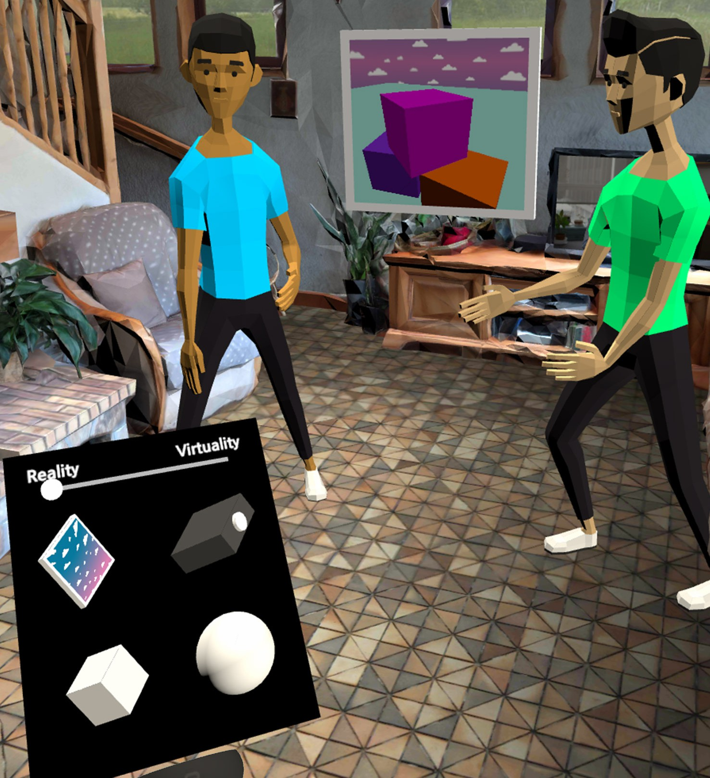
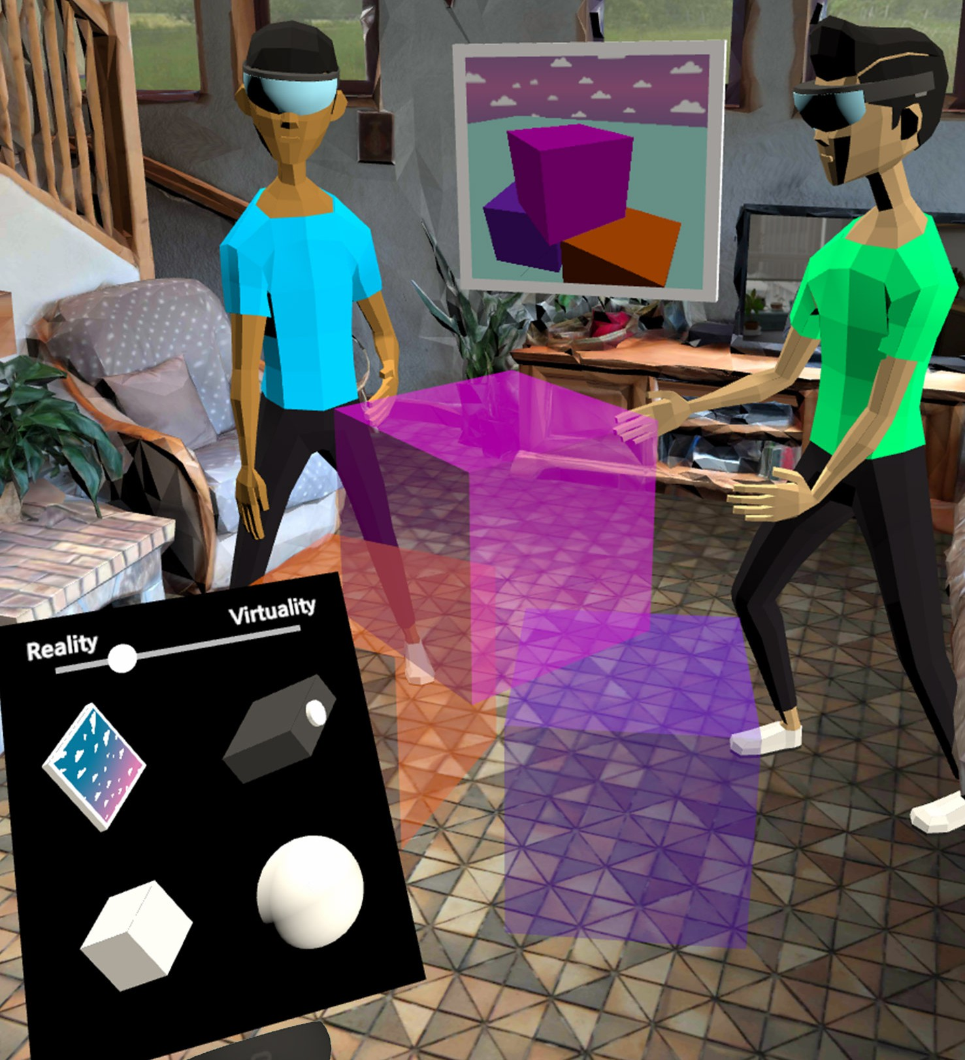
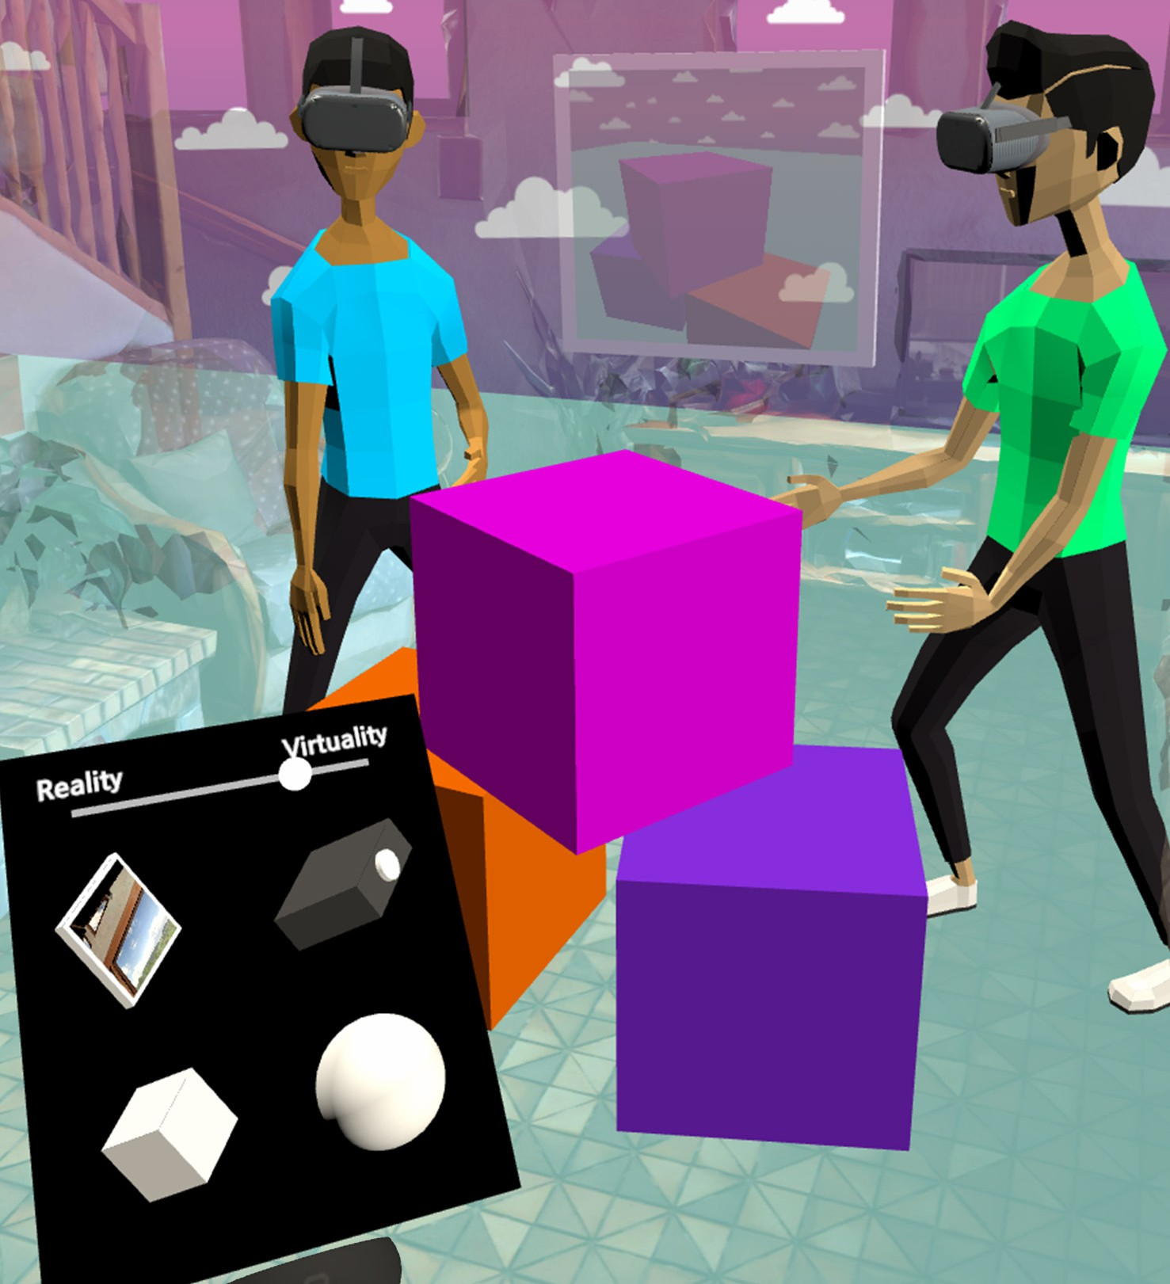
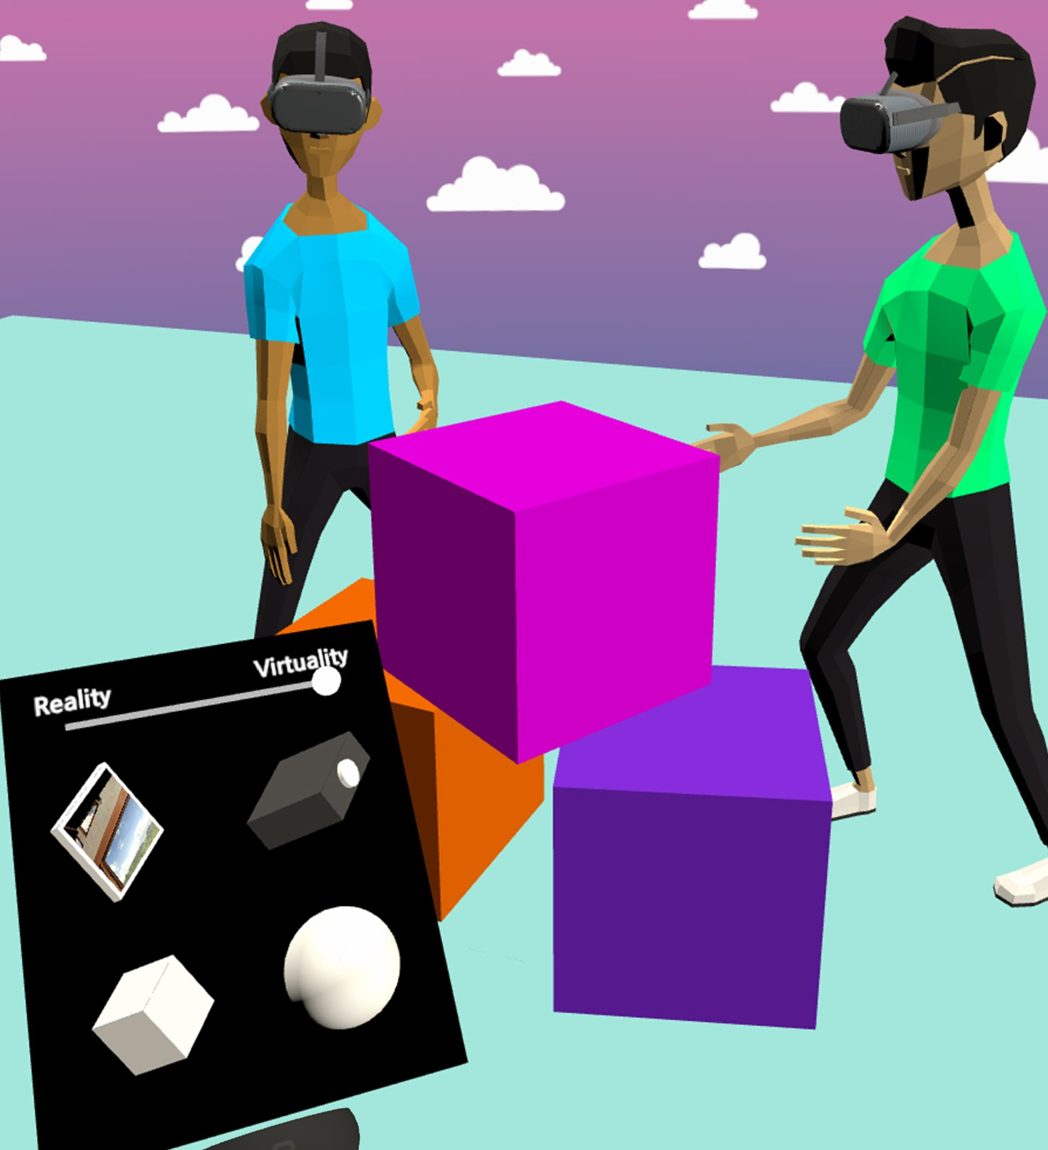
(a) Simulated Reality. (b) Simulated AR. (c) Simulated AV. (d) (Simulated) Virtuality.

Figure 1: The VRception Toolkit allows users to transition on the reality-virtuality continuum [41], simulating different man- ifestations of the continuum, such as Augmented Reality (AR) or Augmented Virtuality (AV), inside of Virtual Reality. The figures (a-d) demonstrate the alpha-blending function to transition between concrete manifestations, however, other transi- tion functions are possible as well.

ABSTRACT
Cross-reality systems empower users to transition along the reality- virtuality continuum or collaborate with others experiencing dif- ferent manifestations of it. However, prototyping these systems is challenging, as it requires sophisticated technical skills, time, and often expensive hardware. We present VRception, a concept and toolkit for quick and easy prototyping of cross-reality systems. By simulating all levels of the reality-virtuality continuum entirely in

Permission to make digital or hard copies of all or part of this work for personal or classroom use is granted without fee provided that copies are not made or distributed for profit or commercial advantage and that copies bear this notice and the full citation on the first page. Copyrights for components of this work owned by others than the author(s) must be honored. Abstracting with credit is permitted. To copy otherwise, or republish, to post on servers or to redistribute to lists, requires prior specific permission and/or a fee. Request permissions from permissions@acm.org.
CHI ’22, April 29-May 5, 2022, New Orleans, LA, USA
Virtual Reality, our concept overcomes the asynchronicity of reali- ties, eliminating technical obstacles. Our VRception Toolkit leverages this concept to allow rapid prototyping of cross-reality systems and easy remixing of elements from all continuum levels. We repli- cated six cross-reality papers using our toolkit and presented them to their authors. Interviews with them revealed that our toolkit sufficiently replicates their core functionalities and allows quick it- erations. Additionally, remote participants used our toolkit in pairs to collaboratively implement prototypes in about eight minutes that they would have otherwise expected to take days.

CCS CONCEPTS
- Human-centered computing → Mixed / augmented reality; Virtual reality; Collaborative interaction.

KEYWORDS

© 2022 Copyright held by the owner/author(s). Publication rights licensed to ACM. Prototyping, Cross-Reality Systems, Virtual Reality, Augmented
ACM ISBN 978-1-4503-9157-3/22/04. . . $15.00

https://doi.org/10.1145/3491102.3501821
Reality, Transitional Interfaces

ACM Reference Format:
Uwe Gruenefeld, Jonas Auda, Florian Mathis, Stefan Schneegass, Mohamed Khamis, Jan Gugenheimer, and Sven Mayer. 2022. VRception: Rapid Pro- totyping of Cross-Reality Systems in Virtual Reality. In CHI Conference on Human Factors in Computing Systems (CHI ’22), April 29-May 5, 2022, New Orleans, LA, USA. ACM, New York, NY, USA, 15 pages. https://doi.org/10. 1145/3491102.3501821

INTRODUCTION
Immersive technologies such as Augmented Reality (AR) and Vir- tual Reality (VR) allow users to engage in alternate digital realities using Head-Mounted Displays (HMD). However, problems that these technologies create are the isolation of users (i.e., HMD users) and the exclusion of bystanders (i.e., non-HMD users) [8, 22]. These issues recently sparked a new research direction – cross-reality systems [58] – which aims to enable interactions across multiple technologies; for example, it allows HMD users in VR to interact with bystanders in the real world. Simeone et al. define them as sys- tems that “envision (i) a smooth transition between systems using different degrees of virtuality or (ii) collaboration between users using different systems with different degrees of virtuality” [58].
Developing prototypes to enable immersive cross-reality systems is often time-consuming and requires both software and hardware prototyping expertise as well as the hardware itself. In particular, cross-reality hardware prototypes (e.g., [13, 21, 22, 40]) have a high entry barrier as they require technology (e.g., displays, projectors, sensors), engineering (e.g., electrical engineering, software devel- opment), and design expertise (e.g., rapid prototyping). Enabling rapid, low effort prototyping of cross-reality systems would sup- port researchers and practitioners (i.e., developers and designers) in quickly iterating these systems and make the research area as a whole more inclusive to people who lack resources or do not have the required prototype-building expertise.
To this end, we present VRception: the concept of simulating cross-reality systems entirely in VR and allowing researchers and practitioners to rapidly prototype these systems. By simulating all levels of the reality-virtuality continuum, our concept overcomes the asynchronicity of realities. In particular, our concept creates a close coupling of both worlds and simulates a co-located asym- metric environment. This allows researchers and practitioners to instantly remix and blend the simulated real and virtual worlds. Moreover, it reduces the need for strong engineering skills, as it is a software-only approach, allowing to prototype cross-reality systems that typically require hardware setups.
Based on our concept, we developed the VRception Toolkit, a multi-user toolkit for quickly and easily prototyping cross-reality systems without the need for hardware prototyping. The goal of our toolkit is to provide an early implementation of our concept that enables researchers to study its’ usefulness, which in combination with the open-source nature of our toolkit, allows the community to add features if needed. Our toolkit supports two different pro- totyping environments: 1) VR with a WYSIWYG (what you see is what you get) editor and 2) Unity. In VR, users are immersed in a simulation of the reality-virtuality continuum (see Figure 1), in which they can combine and configure predefined objects to prototype cross-reality systems. In Unity, users can customize the functionalities of the toolkit, for example, by adding new objects or
new transitions between realities. By providing both environments, we can lower the barrier to entry with a simple-to-use VR editor, while not loosing the ability for more advanced customization.
To evaluate the concept of VRception, we re-implemented six cross-reality papers published in the last five years [13, 21, 31, 36, 40, 68]. Next, we presented the original authors with our imple- mentation and conducted semi-structured interviews to ask the authors if our implementation could simulate their system’s core functionalities and to collect feedback about the implementation of our VRception Toolkit. Our expert interviewees highlighted that our toolkit allows rapid and easy prototyping that is otherwise challenging and agreed that we successfully replicated the original systems. To further evaluate how much effort and time it takes to prototype cross-reality systems using the VRception Toolkit, we con- ducted a workshop with eight participants. We asked participants to implement cross-reality systems that allow one to include real- world content in VR and enable bystanders to see the VR experience. Participants with prior knowledge in VR/AR development were able to create different cross-reality systems in an average time of about eight minutes. This further shows that the VRception Toolkit is easy to learn and allows users to quickly and easily prototype cross-reality systems leveraging the concept of VRception.
The main contributions of our work are:
- The concept of VRception and its evaluation with six experts who developed and published prior cross-reality systems.
- The implementation of the VRception Toolkit as a WYSIWYG application inside a VR headset, enabling novice users to collaboratively and rapidly prototype cross-reality systems without coding or hardware building expertise.
- Insights from a follow-up evaluation through a workshop, where participants (n=8) were able to quickly (in ∼8 minutes) create cross-reality systems using the VRception Toolkit.

RELATED WORK
In 1994, Slater et al. [60] presented the idea of nested virtual re- alities and investigated their influence on presence. In this work, we exploit this idea as nested realities inside of VR. We propose to apply the idea to the domain of cross-reality systems, which we will review first. We will then review literature proposing VR as a research and prototyping tool.
  - Cross-Reality Interaction and Systems Several researchers have pointed out the disconnect between the real world and the digital world [18, 56, 70]. This disconnect is partic-
ularly present when the user engaging with the digital world is not alone [37] and when collaboration between users is important [8]. Thus, a number of researchers envisioned systems that would en- able users to engage with the digital world without totally discon- necting from the real world by using technology to merge the two worlds (e.g., [40, 68]). These systems are referred to as cross-reality systems and they either involve users that can transition on the reality-virtuality continuum to experience different levels of virtual- ity or they enable users that experience different levels of virtuality to collaborate and bridge realities [58]. Today, there are different research prototypes that focus on users transition on the contin- uum, such as by transitioning into VR [63, 65] or back into the real

world [33]. Moreover, there is a great number of prototypes that aim to bridge different realities, such as by using a smartphone as a “win- dow” into VR [2], projecting VR into the real world [16, 21, 29, 30],
or attaching projectors [26, 31, 68] and displays [22] to users and the HMD they wear. However, these prototypes’ unique character- istics, such as their form factor (i.e., weight, size), can affect the user’s experience. For example, Wang et al. [68] used a taut strap to distribute the weight of the device and Jansen et al. [31] outlined that one of their future aims is to reduce their prototype’s weight. As we re-implement six cross-reality systems with our VRception Toolkit in this paper, we provide a more systematic overview of these systems in Section 5.1 and Table 1.

Virtual Reality as a Research Platform
The use of VR for prototyping and studying real-world artifacts is not new. In fact, VR has already been used as a participatory design methodology [42], for the evaluation of user behavior in front of public displays [38], as a test bed for the evaluation of real-world security systems [39], and as an implementation and evaluation method of situated visualization [69], among other uses. Rebelo et al. [53] even argued that VR enables one to develop re- alistic virtual environments that come with greater control of the experimental conditions compared to a lab setting and that user ex- perience (UX) research may benefit from such a VR-based research methodology. In a similar vein, Antonya et al. [5] argued that VR can support the evaluation and modification of mechanical systems and offer engineers more realistic real-time representations of their systems during the design process. Furthermore, it has also been argued that the use of VR enables researchers to evaluate systems in different contexts [3] and that such controlled virtual environments can provide users with rich contextual experiences [28]. Other works have shown that advances in VR technology present new op- portunities for human-centered research. This includes expensive or even dangerous areas to study in the real world, such as pedes- trian safety research [14, 55] or using VR as a training platform for underground coal miners [19]. All the works above highlight the potential of VR as a research platform for human-centered research. As VR is nowadays also used as a research platform, researchers also set out to understand the differences and implications when using VR as a research tool [34, 50]. Here, it is crucial to note that recent investigations into systematically studying the impact of different environments (e.g., laboratory, VR, in-situ) on prototypes have been inconclusive, as effects could not always be replicated in VR [66, 69]. The final component for using VR as an effective research platform is to enable remote studies. Rivu et al. [51], for example, present a framework for remote VR studies and guide- lines for best practices of such studies. Saffo et al. [54] went one step further and conducted remote collaborative VR studies and presented their findings. However, Ratcliffe et al. [52] found that safety and hardware variability issues have to be overcome in order
to run remote studies effectively.

Virtual Reality Prototyping Tools
To be able to implement current AR and VR systems, designers and developers have to use time-consuming expert tools that enable soft- ware as well as hardware prototyping [10]. Expert tools allow one
to design and implement every little detail to create high-fidelity prototypes and products. Frequently used tools for prototyping AR and VR experiences are 3D programming environments such as the Unity 3D or Unreal engine. For these environments, toolkits and programming interfaces exist that help practitioners to im- plement typical user interactions (e.g., Mixed Reality Toolkit1) or integrate the real-world environment (e.g., Oculus Passthrough API2). However, technical barriers such as programming skills and a steep learning curve make it difficult for non-experts to quickly build cross-reality prototypes [7, 43, 47]. Therefore, researchers have started to explore new tools that allow non-experts to quickly prototype AR [17, 46, 62] and VR [43, 45] applications without the need for programming or 3D modeling. Nebeling et al. presented 360proto [45], a toolkit that allows designers to create complex 3D environments using sketches on a piece of paper. They then pre- sented ProtoAR [46], a tookit focused on optimizing the workflow in augmented reality. Leveraging physical props in the environment and the camera of the smartphone, the authors optimized the AR development pipeline by removing the need for programming and 3D modeling. While the VRception Toolkit has a similar goal, it faces different challenges. When designing cross-reality systems, the de- signer has to focus on at least two participants in two parallel and synchronized environments (e.g., real-virtual, virtual-virtual). Addi- tionally, the created scenes must be experienced in an appropriate setting. These are both aspects that are at the core of the VRception Toolkit. To the best of our knowledge, VRception Toolkit is the first multi-user and multi-environment rapid-prototyping toolkit that allows non-experts to build and experience cross-reality systems without the need for hardware prototyping and programming.
- VRCEPTION - CONCEPT
We propose VRception, a concept to simulate different realities in Virtual Reality (VR). Thereby, we enable users to rapidly prototype experiences across different realities. Simulated realities can be physical realities but also digital realities, such as AR, AV, or VR. By bringing different realities into VR, users can easily switch between them and remix their elements. With this, we also overcome the limitations of the physical world and reduce the effort necessary to prototype novel cross-reality systems. In the following, we highlight major characteristics that any implementation of our VRception concept should consider.
Characteristic 1: Enabling Multiple Realities. In theory, an infinite number of realities could be simulated in VR. For example, more than two realities are relevant when two co-located VR users expe- rience different virtualities [67]. Moreover, when users collaborate remotely, they share the virtuality, but two realities exist in the sense that each has their own physical space [49]. In general, mul- tiple realities can be arranged in two ways: 1) in parallel, which means they exist on the same level, or 2) nested, which means they exist within each other to allow stacking depth [60].
Characteristic 2: Enabling Transition between Realities. Support- ing multiple realities requires a mechanism to switch between these

1 Mixed Reality Toolkit. https://github.com/microsoft/MixedRealityToolkit-Unity
2 Oculus Passthrough API. https://developer.oculus.com/blog/mixed-reality-with- passthrough, last retrieved January 4, 2022.

realities. Here, we see two competing approaches: a) the designer (or storyteller) moves the user on the continuum, or b) the user is in control of which reality is visible to them. Furthermore, in many cases, it is crucial to not just render one reality, but to blend or remix these realities. For example, AR requires reality to be fully visible and virtuality to be an overlay (see Figure 1b). In general, we expect different types of transitions to be possible, as shown in previous work [65]. Transitions can either be abrupt (i.e., an instantaneous jump from one reality to the other) or happen gradually (i.e., they morph from one reality to the other). Moreover, transitions can af- fect all objects of a reality simultaneously (increasing transparency on all objects to fade out a reality) or sequentially (more objects disappear as the transition continues).
Characteristic 3: Enabling Rapid Prototyping. An essential char- acteristic of VRception is that any implementation of the concept should enable users to rapidly prototype. Apart from the HMD worn by the user, every part of the simulated realities are software-based and do not require any hardware components. Thus, hardware lim- itations play a minor role; still, these limitations could be simulated if needed (e.g., to simulate sensor limitations [13] or the limited fields of view of AR HMDs [20]). Inherently, without hardware im- plementations required, prototyping becomes less time-consuming, requires less technical knowledge, and becomes less prone to tech- nical failures. Nonetheless, two additional factors are crucial to enable rapid prototyping of cross-reality systems: 1) a set of virtual objects to use and build up prototypes, and 2) intuitive interactions for object manipulation. Here, such virtual objects can be primitive abstract objects (e.g., cube, sphere) which can be combined to create more complex objects.
Characteristic 4: Multi-user Support. Working together allows collaborators to combine their knowledge and shape a collective solution that incorporates different perspectives. Moreover, by col- laborating with others, users can take different roles (e.g., VR, AR) to experiment with asymmetric interactions. Thus, collaboration is an important feature for VRception. Collaboration can be synchronous or asynchronous (which is less often used in cross-reality systems) and it can be co-located or remote. Co-located collaboration enables users to work in the same space, allowing collaborators to experi- ment with close forms of interaction such as touch input. To quickly set up such co-located interactions, a system should incorporate means to host two different instances of the system running on multiple HMDs. Remote collaboration empowers users to bridge geographic distance and opens up the possibility for remote studies.
- VRCEPTION - TOOLKIT
Based on our concept, we developed the VRception Toolkit, a multi- user toolkit for quickly and easily prototyping cross-reality systems. As follows, we introduce the different prototyping environments the toolkit offers and their respective workflows, and provide an overview of the iterative implementation of the VRception Toolkit.
  - Prototyping with the VRception Toolkit Essentially, the VRception Toolkit provides two different environ- ments to rapidly prototype cross-reality systems: 1) VR with a
WYSIWYG (what you see is what you get) editor and 2) Unity
(see Figure 2). By providing both environments, we can lower the barrier to entry with a simple-to-use VR editor, while not losing the ability for advanced customization. Moreover, for teams with different skill-sets, one can imagine having developers with ad- vanced technical skills customize the environment in Unity and creating additional resources, while designers can utilize the VR environment to quickly try out different ideas.
    - Prototyping in Virtual Reality. In VR, users are immersed in a simulation of the reality-virtuality continuum. They are syn- chronized across their locations, represented by full-body avatars, communicate via voice chat, and their actions are recorded for com- plete replay. Users can open a menu containing predefined objects and a slider that allows users to transition on the continuum (see Figure 3a). By grabbing an object from the list, users can add it to the simulation, depending on the reality-virtuality continuum manifestation (slider position). Objects can be manipulated (trans- late/rotate/scale/duplicate/delete) and combined by “sticking” them together. Finally, users can add avatars representing different user types (real-world bystander/AR/AV/VR) that can be placed in the scene to quickly jump to their perspective and enable single users to prototype cross-reality systems (see Figure 3c). The according workflow is demonstrated in Figure 2. While this is most certainly the quickest way to prototype cross-reality systems, it comes at a price because users are limited to the objects provided in the virtual menu (it can be extended easily with additional objects).
    - Prototyping in Unity3D. Unity3D is a powerful development tool that allows relatively easy navigation and provides exten- sive functionalities. Our VRception Toolkit is implemented within Unity3D and we aimed to provide a well-structured project that can be easily extended in terms of functionality. In a similar fashion, our toolkit allows experienced developers to extend our scripts, en- abling them to build richer interactions using the editor and C#. In Unity, developers can quickly add additional predefined objects to the menu (e.g., cylinder, projector screen, *.fbx file). Moreover, devel- opers can load existing Unity scenes (e.g., scenes from prior projects) and use them as representations of specific realities (configurable: one can also simulate two virtualities). Additionally, developers can change the way the transitions between realities work.
  - Implementation of the VRception Toolkit
In the following, we present a reference implementation of VRcep- tion, which we refer to as the VRception Toolkit. We implemented the VRception Toolkit in Unity3D (2020.1.8f1) using the Oculus SDK3 . Our implementation has two goals. First, we wanted to create a VR application that allows users to experience VRception, thus en- abling quick prototyping of cross-reality systems in VR. Second, we wanted to provide a well-structured Unity3D project that em- powers others to extend the functionality easily and build their own versions. Therefore, we published our source code on GitHub4 under the MIT license, empowering researchers and practition- ers to benefit from our toolkit. In the following, we describe our implementation of the characteristics listed above.

3 Oculus Developer. http://developer.oculus.com, last retrieved January 4, 2022.
4 VRception Toolkit. https://github.com/UweGruenefeld/VRception


A
Unity3D (Desktop Computer)
Optional customization (toolkit provides scripts)
B
WYSIWYG (Virtual Reality)
Rapid-prototyping (multi-user support, voice chat, replay, save/load)
1 Customize 3 Customize 1 Add 3 Experience
Realities Prefabs Prefabs Transitions
deploy
reuse/create Unity3D scenes and set them as reality or virtuality
import supported models (e.g., *.fbx) or create new ones and add them
to the menu
drag and drop prefabs from the menu into reality or virtuality
select an implemented transition function and experience the prototype
Workflow B (WYSIWYG)
Workflow A (Unity3D + WYSIWYG)
add mannequins to the scene to jump into
their perspectives or simulate users
modify prefabs that utilize cameras
such as displays and projectors
translate, rotate, scale, duplicate, and delete prefabs
Configure
Transform
Perspectives
1.2
1.1
2 Configure
implement additional transitions and adjust existing ones
2 Customize
Transitions

Figure 2: Workfows and Environments of the VRception toolkit. The Unity3D option is designed to maximize expert devel- opers’ ability to customized the toolkit. The WYSIWYG mode allows developers that are not experts in Unity to experiment with cross-reality systems; thereby, lowering the barrier to entry.

Reality and Virtuality. To present different realities, we make use of multiple scenes, each holding one world that can be designed in- dependently. Our implementation currently supports two realities, e.g., reality and virtuality or virtuality-1 and virtuality-2. With our implementation, we can load any existing Unity3D scene as part of one of the two realities, allowing the reuse of existing projects. Additionally, we can have a shared scene containing shared objects that are visible in both realities, such as the player’s avatar.
Interaction. Users have full control over the realities with their two controllers. Here, the left controller is mainly used to provide a virtual menu, which can be opened with a button on that con- troller. The menu contains a horizontal slider that allows users to transition between the two realities (cf. Figure 3a). Additionally, it contains a set of predefined objects. The users can drag these objects into the scene, attach them to one another, or manipulate them to create more complex systems, objects, or structures. To directly manipulate objects, users can select them with their right controller and translate, rotate, scale, duplicate, or delete them.
Gradual Transition Between Realities. In our toolkit, a horizontal slider — the reality-virtuality slider — allows users to transition between the two realities, with reality on the left side and virtuality on the right. The slider is a representation of the reality-virtuality continuum [41]. Positioning the slider knob at one of the ends will render only one of the two realities. Between the extreme positions, transparency is applied to gradually blend all objects from all realities, depending on the position (cf. Figure 1). Each user has a slider to independently switch between realities and different glasses on their avatars show their current reality. Objects from shared scenes are always visible and unaffected by the slider. We implemented this with two stacked cameras (one for each reality) and transparency-compatible shaders attached to all objects.
Additionally, our toolkit supports individual blending or remix- ing of realities via a feature that we refer to as experiences. Here, every experience can implement a highly customizable rendering of the different realities beyond well-known manifestations such as AR, AV, and VR. Such an experience could, for example, render from
Predefined Objects. To empower users to quickly prototype cross- reality systems, we created an initial set of objects. While the objects in the virtual menu can be changed and extended easily, we decided for four predefined objects as the default set of objects that ship with our prototyping tool (described below). During our development, we created many different objects (with some of them used to replicate the research prototypes in Section 5.2); however, some of the objects are less generic (e.g., the lightsaber created to replicate ShareVR [21]). Thus, we selected four objects to demonstrate our toolkit’s potential. To create objects inside the VR environment, users simply drag them from the menu into the currently selected reality, which is set by the reality-virtuality slider. If the slider knob is more towards reality, objects spawn in reality, and vice versa.
We included two primitive shapes: cube and sphere. We selected them because they are great building blocks (e.g., demonstrated by the Game Minecraft5). Both objects can be manipulated and com- bined to represent more complex objects. For example, in Figure 5c, users formed a table and character from these shapes.
We implemented a display that allows one to bridge realities. While it exists in one reality, it shows the other (cf. Figure 3b), depending on the reality-virtuality slider. To realize the virtual displays, we use an additional camera that renders onto a texture attached to the display. To control the displays, users can adapt the position and direction of the camera independent of the display position. Both objects representing camera position and direction can also be attached to other objects. We selected the display object as many research prototypes use them (c.f., Table 1).
Finally, we implemented a projector that works similarly to the displays. However, instead of rendering the camera texture onto a plane, it projects it into the scene (cf. Figure 3c). Projectors also allow the user to adapt position and direction of the camera. We selected projectors because they are found in many prototypes [26, 31, 68].

Iterated Implementation of the Toolkit
After the expert interviews (see Section 6), we iterated our imple- mentation in preparation for the design workshop (see Section 7), implementing collaboration and integrating the expert feedback.

one reality only the objects closer to the observer while rendering

everything of the other reality unconditionally.
5 Game Minecraft. https://www.minecraft.net, last retrieved January 4, 2022.

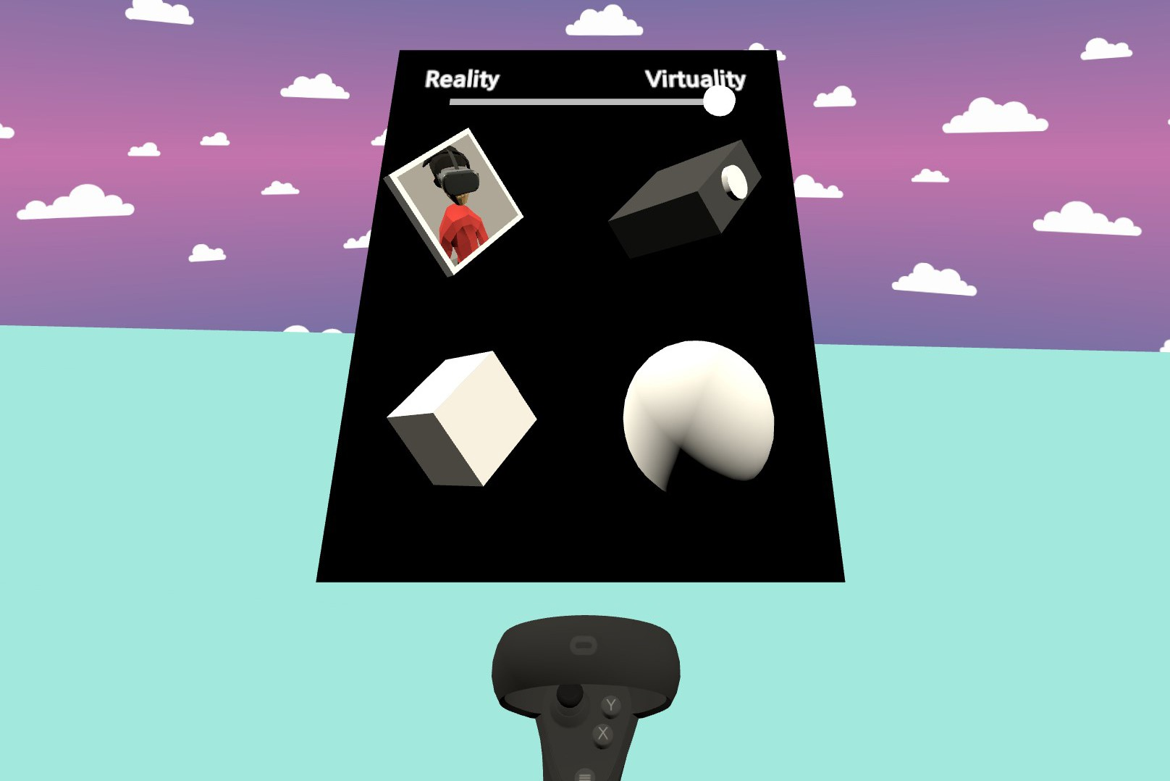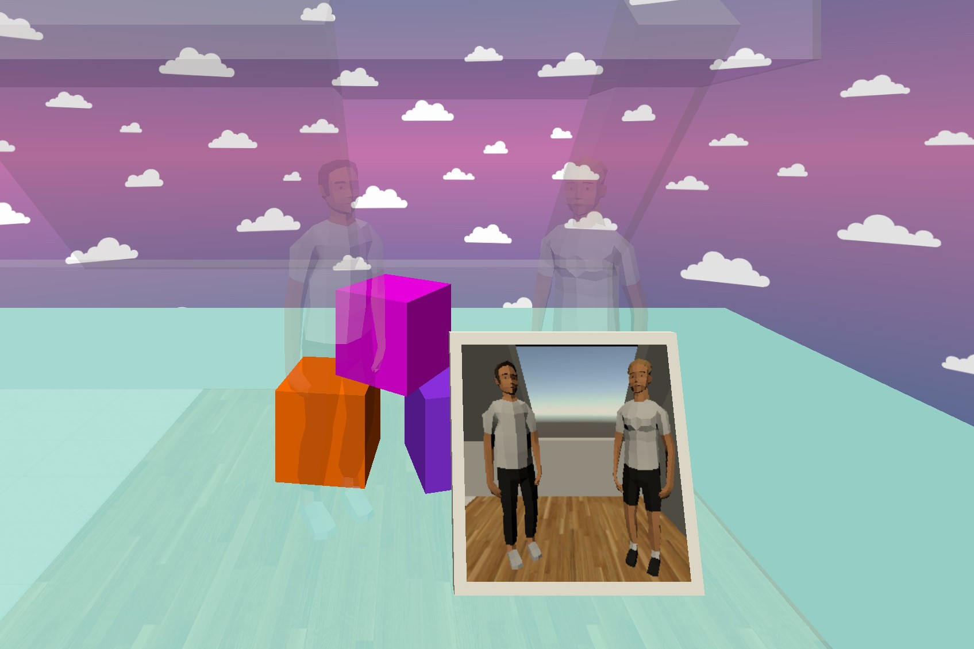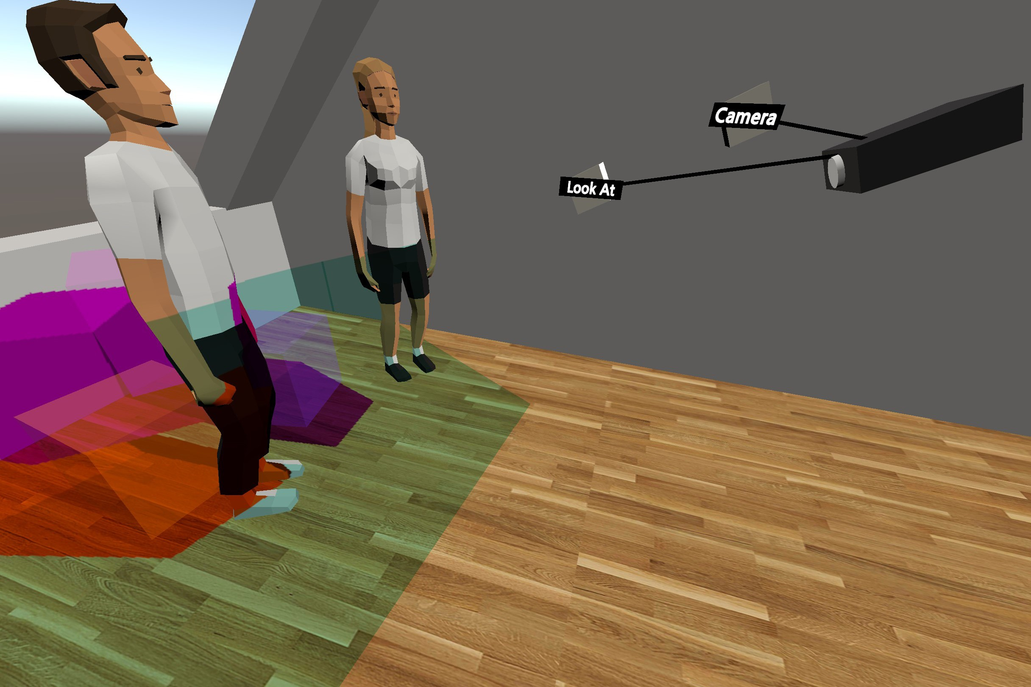
(a) Virtual menu attached to controller. (b) Example of display showing reality. (c) Example of projector showing virtuality.

Figure 3: Implementation details of the VRception Toolkit, showing a) the virtual menu attached to the user’s left controller, b) a virtual display that renders reality on the screen (blended in reality for orientation), and c) a projector that projects virtuality on the foor (blended in virtuality for orientation). Additionally, in c) one can see the “Look At” and “Camera” objects, which allow the user to adjust the direction and position of the camera, respectively; similar objects exist for the display as well.

Networking. To enable multiple users to collaborate within the VRception Toolkit, we implemented network synchronization that keeps all clients in a consistent state. We used the Photon Engine6 which allows up to 20 concurrent users (in the free version) without the need to host a dedicated server. Additionally, we implemented an in-game voice chat with 3D spatialized audio to allow collabora- tors to talk to one another using the Photon Voice feature. A test with five concurrent users on the Oculus Quest 1 showed no frame drops (stable 72Hz) and <250KB data transferred per minute.
Avatars. To represent collaborators in our VRception Toolkit, we adapted a rigged character from the Unity3D Asset Store7 (cf. Fig- ure 1). Moreover, we used inverse kinematic (IK) to map the con- trollers and headset to fitting poses of the avatar character. Specifi- cally, we used the FinalIK package8 that implements a variety of IK solvers such as CCD [32] and FABRIK [6] and performs better than the Unity3D built-in solver. Last, we adjusted the shirt color and hairstyle to give each collaborator a unique look.
Real-world Scan. To increase the realism of the reality within our VRception Toolkit, we decided to include a 3D scan taken from a private living room9. The advantage of such a real-world scan is that the scanning technology required for it has recently become available to more people (e.g., with the LIDAR sensors integrated in selected Apple products). Furthermore, compared to modeling with higher levels of realism, scanning can be done quickly and does not require any advanced skills, allowing developers to bring their own room into the VRception Toolkit.
Replay. The replay feature allows researchers to watch recorded sessions again, implemented as state-based replay. Here, we were inspired by previous work on analyzing user sessions in mixed reality [1]. The feature supports viewing within VR or within the Unity3D editor and uses a self-hosted database to store all changes that occur during a recording.

6 PhotonEngine. https://photonengine.com, last retrieved January 4, 2022.
7 Liam. https://assetstore.unity.com/packages/3d/characters/humanoids/humans/liam-
lowpoly-character-100007, last retrieved January 4, 2022.
8 FinalIK. http://root-motion.com, last retrieved January 4, 2022.
9 Chalet in France. https://skfb.ly/6ZynL, last retrieved January 4, 2022.

SHOWCASES OF PROTOTYPING TOOL
We re-implemented six prototypes from prior work using our VR- ception Toolkit, demonstrating its potential. Therefore, we first give an overview of research prototypes proposed in previous work and then select six of these prototypes for re-implementation.

Selection of Cross-Reality Research
To better understand cross-reality research, we manually reviewed all papers (no keyword search) on cross-reality systems published in HCI and VR venues, including UIST, CHI, IEEE VR, MobileHCI, and SIGGRAPH. In our brief review, we focused on research that was published no earlier than 2015. We did not aim to compile a complete literature corpus; instead, our goal was to identify a vari- ety of different systems and see if they could be replicated using our toolkit. Therefore, we first checked the title of each paper to identify relevant research. We then read the abstracts (or further sections if necessary) of all publications whose titles seemed relevant in order to identify relevant research prototypes. If a paper seemed relevant, we collected it in a spreadsheet (cf. [15]) and identified the relevant features of its prototype. From the selected papers, we classified three directions of interaction as possible: (1) unidirectional inter- action from virtuality to reality (VR→RW), (2) unidirectional in-
teraction from reality to virtuality (RW→VR), and (3) bidirectional interaction between reality and virtuality (RW↔VR). In Table 1, we present a selection of the collected research categorized into the
three mentioned categories.
From Table 1, we selected two research prototypes from each category, resulting in a total of six prototypes. For each category, we selected two prototypes with several years between their publi- cations (to include earlier and newer research), which differed in their implementation from a hardware perspective. For example, for “VR→RW,” we selected one prototype that used a display and another that utilized a projector. For “RW↔VR,” we selected one prototype for VR and another based on AR. We focused mainly on VR systems as they were more frequent and their nature of excluding reality was considered more interesting. Therefore, our final set of papers is as follows: [13, 21, 31, 36, 40, 68]; see Table 1.

Table 1: Examples of research papers that investigate cross-reality systems and interaction, ordered by publication year and sorted by direction of interaction. For example, RW→VR implies that users of this system transition from the Real World to VR. The selected prototypes are highlighted in light gray.

Authors Short Title Description Direction Year Conference
Mai et al. [36] TransparentHMD revealing HMD user’s face to bystanders VR→RW 2017 MUM Chan et al. [12] FrontFace attaching a front-facing screen to an HMD VR→RW 2017 MobileHCI Ishii et al. [29] ReverseCAVE reverse CAVE showing VR to bystanders VR→RW 2019 SIGGRAPH Hartmann et al. [26] AAR projector attached to AR-HMD AR→RW 2020 UIST
Wang et al. [68] HMD Light sharing VR experience via VR-HMD VR→RW 2020 UIST
McGill et al. [40] A Dose of Reality blending real-world objects into VR RW→VR 2015 CHI
Nuernberger et al. [48] SnapToReality align objects in AR to the real world RW→AR 2016 CHI
Hock et al. [27] CarVR using real-world motion for VR world RW→VR 2017 CHI Hartmann et al. [25] RealityCheck reconstruction of reality with depth sensing RW→VR 2019 CHI
Cheng et al. [13] VRoamer generating VR experiences on the fly RW→VR 2019 IEEE VR
Gugenheimer et al. [21] ShareVR co-located HMD and non-HMD users RW↔VR 2017 CHI Yang et al. [71] ShareSpace bystander can communicate need for space RW↔VR 2018 UIST Gugenheimer et al. [22] FaceDisplay touch displays attached to VR HMD RW↔VR 2018 CHI
Kumaravel et al. [64] TransceiVR sync info between asymmetric users RW↔VR 2020 UIST
Jansen et al. [31] ShARe interact via projector attached to AR-HMD RW↔AR 2020 UIST

Re-implementation of Selected Research
We re-implemented the six selected research prototypes; see Fig- ure 4 for an overview of the re-implemented systems. Our goal was to see how easily we would be able to replicate them in the VRception Toolkit. We used the prototyping workflow A (Unity3D
+ WYSIWYG; see Figure 2) and re-implemented each prototype in less than one hour.
TransparentHMD. The fundamental idea of TransparentHMD is to reveal the HMD user’s eyes to bystanders and thereby reduce communication problems [36]. For our re-implementation, we at- tached our developed display component (cf. Section 4.2) to the HMD of the VR user. Then, we adjusted the position and clipping of the camera that renders onto the display to show the eyes of the avatar (see Figure 4a).
HMD Light. In their system, the authors attached a projector to a VR HMD, revealing the VR user’s experience to bystanders [68]. To re-implement the system, we attached our projector component (cf. Section 4.2) to the HMD of the VR user. Then we implemented a script that controls the orientation of the projector to show the projection closer to the bystander (see Figure 4d).
A Dose of Reality. The authors envisioned being able to selec- tively embed real-world objects in the VR experience [40]. In our re-implementation, we focused on two of the proposed research prototypes, in which a bystander and a keyboard are integrated into the VR experience (see Figure 4b). Here, we created a custom experience (cf. Section 4.2) to fade in these objects, depending on their proximity.
VRoamer. In essence, VRoamer allows one to generate virtual worlds from the sensed physical environment on the fly [13]. To re-implement this system, we created a custom experience in which real objects are represented by virtual objects when the VR user gets within sensing range (see Figure 4e). For physical structures (e.g.,
walls), we replaced the texture; for other obstacles, we superseded the mesh and texture.

ShareVR. The ShareVR prototype utilizes floor projection and mobile displays to visualize the VR experience for non-HMD users and enable interaction between a VR user and a bystander [21]. We re-implemented both floor projection and mobile display attached to a controller held by the bystander (see Figure 4c). Moreover, we implemented lightsabers for the bystander and VR user.

ShARe. The authors of ShARe proposed using a projector at- tached to an AR HMD to share the AR experience with bystanders and to enable them to interact with the AR content [31]. For our re-implementation, we attached a projector to a HoloLens HMD, constructed a table and recreated a simplified version of the game board demonstrated in the original paper (see Figure 4f).

EXPERT INTERVIEWS
From the related work presented in Table 1, we replicated six sys- tems [13, 21, 31, 36, 40, 68] using our VRception Toolkit. For each of the replications, we invited one of the authors as an expert to provide feedback on our concept, our tool, and the replication of their system. We asked them only about their system because we wanted to understand their individual prototyping experience.

Participants
Our six interviewed experts (5 male, 1 female) were between 21 and 35 (M=28, SD=5) and had 2 to 7 years of experience in VR/AR development (M=4, SD=2). In addition, they conducted research on cross-reality interaction, personal fabrication, and HCI. All of them had hands-on experience in prototyping cross-reality systems and had prototyped at least one previously. All interviewees used their own VR headset (i.e., Quest 1 or 2) to experience the replicas.

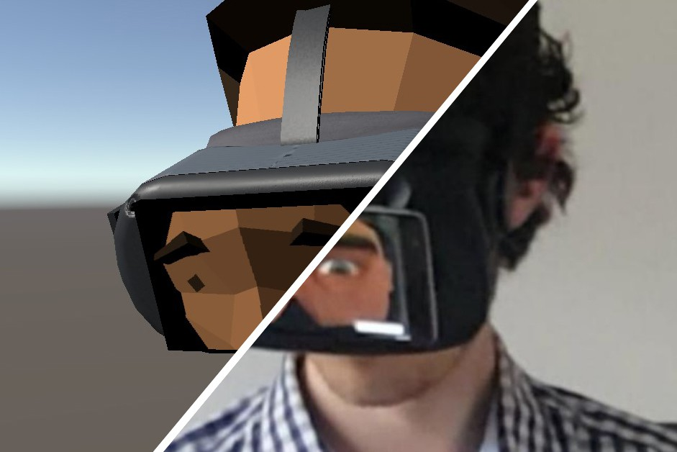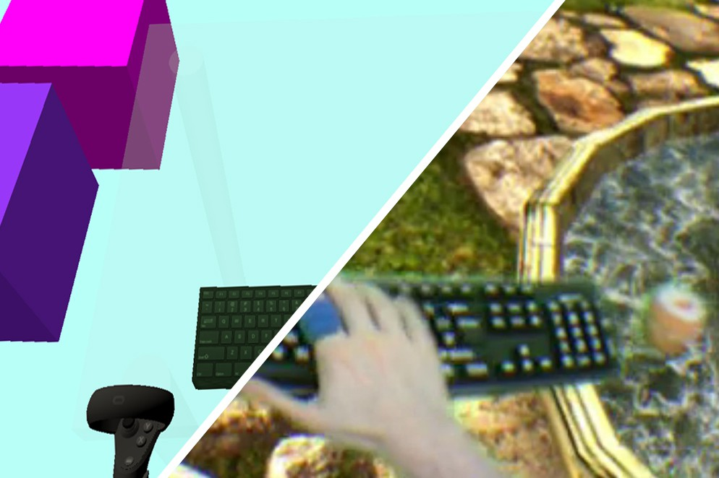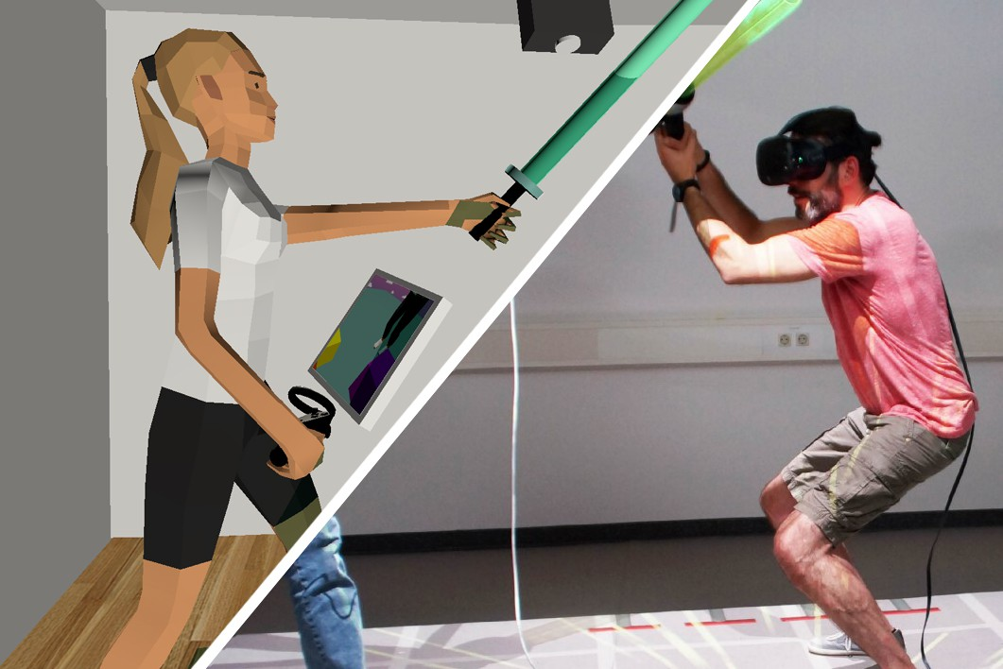
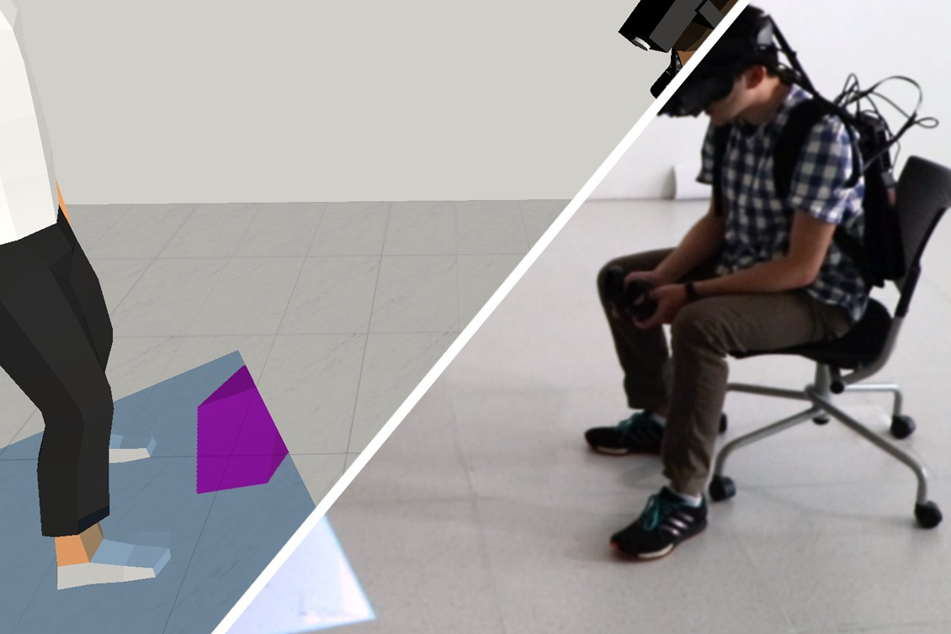
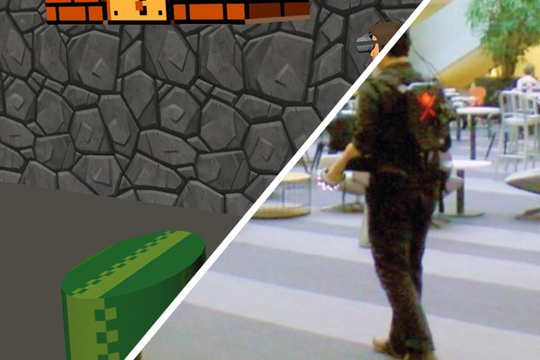
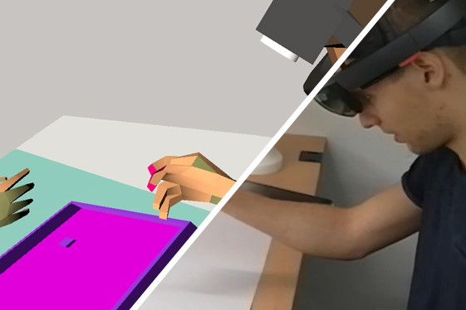
(a) TransparentHMD [36]. (b) A Dose of Reality [40]. (c) ShareVR [21].
(d) HMD Light [68]. (e) VRoamer [13]. (f) ShARe [31].

Figure 4: Re-implementation of six selected cross-reality systems proposed in previous work. For each system, we present the re-implementation in the VRception Toolkit left and the original system right (right pictures taken from the original papers; cf. citations). Figures a) and d) are VR→RW, figures b) and e) are RW→VR, and figures c) and f) are RW↔XR.

Procedure
In advance of the interview sessions, we asked the experts to launch the replicated system, which we had sent them beforehand, on their VR device for a few seconds to ensure it would run during the interview. All experts provided written informed consent upfront via email. Via Zoom, we presented a slide deck to a) set the context of the interview, b) showcase a variety of different cross-reality prototypes based on recent papers, including the interviewee’s own paper, and c) introduce the interviewees to the functionality of the VRception Toolkit. All experts experienced their prototype system in the VRception Toolkit during the interview session. The interviews took on average about 60 minutes. The semi-structured interviews were guided by the following three topics:
Topic 1 - VRception This topic aimed to elicit the experts’ opin- ions on the greatest challenges of cross-reality interaction research. Then, we presented a concept video for VRception explaining its different capabilities. We also asked for their opinions on how VR- ception can support researchers.
Topic 2 - VRception Toolkit We asked each of our interviewees to walk us through their own prototyping process for their cross- reality system and asked them how VRception Toolkit could have helped during the development process.
Topic 3 - Replicated System Experts experienced their repli- cated prototype using their VR headset while we elicited insights into the quality of our replication and the VRception Toolkit. We concluded with a short section about experts’ long-term feature requests, what they would like to explore with the VRception Toolkit, and asked them if they had any additional thoughts or opinions.

Data Analysis
We applied open coding on our interview data, followed by an inductive category development. We did this to find patterns of experts’ opinions and thoughts about the VRception Toolkit. Once all the interviews were completed, four researchers transcribed all audio recordings and open coded the transcriptions. This process generated 286 open codes. We then conducted an online affinity diagram [23] of the open codes. Next, we organized the codes into groups, which were then further refined into themes using an online whiteboard10. We visited the transcript and audio recordings again when additional information was needed during the analysis.

Results
We identified four main themes, which we outline below. We use participant IDs (P1 - P6) and the pronoun “they” for all participants to ensure anonymity.
    - Opportunities and Challenges of VRception. In the inter- views, the experts highlighted the increase in XR research (P2 - P6) and its potential (P2, P5, P6). They also underlined the challenges of hardware prototyping and technical challenges (P1, P2, P4, P5). The experts saw great value in the VRception Toolkit as a tool to overcome the aforementioned challenges of physical prototyping (P1, P2, P5, P6). The experts (P1, P4, P5, P6) further pointed out that the VRception Toolkit is great for supporting social interaction and its design is beneficial due to its flexible and remote collaboration

10 Miro. https://miro.com, last retrieved January 4, 2022

capabilities. Here, they saw the clear benefit of having the physi- cal constraints and hardware limitations removed when using the VRception Toolkit to simulate the whole XR interaction (P1, P3, P4). In comparison to co-located collaboration, however, they criticized the lack of haptic feedback (P1, P2, P4).
Finally, the experts commented on the difficulty of simulating the real world (P1 - P3, P5, P6) and the possible threats to validity of results obtained using VRception (P1, P2, P4, P6).
    - Cross-Reality Prototyping Challenges. When asked what pro- totyping challenges researchers face when conducting cross-reality interaction research, the experts generally agreed that “Hardware is hard” and that the available hardware often drives their research. P1, for example, voiced that hardware limitations forced them to adjust their research focus: “[I would have liked] to explore, for example, projecting on the user’s body, but due to the hardware limitation, we [could not] do that”. Other comments were about the prototype’s weight (P1, P2), its instability in the wild (P1), the lack of appropriate hardware components such as high-resolution depth cameras (P6) and tracking systems (P2), the difficulties of building two isolated experiences (P1, P5), and the interplay be- tween multiple devices and software/hardware components (P1 - P3, P6). P1, for example, stated that “the calibration process is a nightmare [...] I would not do that again” and P2 raised further issues around the calibrations and alignments. P6 also expressed that they had to spend a lot of effort on the actual implementation and synchronization. According to our experts, these hardware prototype systems often have only a short lifetime and many of their prototype systems are no longer available or the software on which they run is deprecated (P1, P5).
All experts but P3 wondered about the general viability of run- ning a prototype evaluation fully in VR using the VRception Toolkit. For instance, P6 stated that they “would worry slightly that you are losing something of the validity there because people are not get- ting to actually experience [the system].” P1 also argued that field studies cannot be replaced using the VRception Toolkit. However, P1 did argue that “for laboratory experiments [...] VR is enough.”
    - Opportunities and Challenges of the Toolkit. All experts agreed that the VRception Toolkit provided a rapid prototype of their im- plementations that is not possible when building it using hardware. In general, the experts saw the tool as a flexible, interactive play- ground for prototyping (P1 - P3, P5, P6). They further commented that improvements in hardware and software technology would be possible in the future (P1, P4 - P6). Overall, they valued it as an all-in-one system (P1, P5) with a low entry barrier, as prototyping can be done without coding (P1, P3, P6).
After the experts experienced their prototype using the VRcep- tion Toolkit and tested its current capabilities, they highlighted implementation drawbacks such as the limited availability of build- ing blocks (P5) and the fact that avatars could not move their arms and fingers (P5). A more general concern was that their prototype was not 100% replicated, e.g., we did not implement all the rooms (P5). On the other hand, P4 argued that it is possible to be more precise when building the replica, but in the end, the “real distortion of the projection and a re-projection” would still be missing. Finally, they asked for multi-user support (P2, P5).
To overcome these limitations, thereby allowing implementation of a perfect copy of existing prototypes, the experts asked for a number of additional features. P2 and P6 asked for a more realistic real-world simulation using a LIDAR scanner or a 360 recording to address their concern over distinguishability of the VR worlds. Other feature requests include hand tracking (P2, P4), shadows (P2), event-driven transitions (P6), and object alignment (P6).
    - VRception and its Use Cases. During the interviews, our experts mentioned different applications for which our VRception Toolkit could be suitable. There was a general consensus that the VRception Toolkit is a promising tool for creating prototype im- plementations of cross-reality interaction systems, especially as a preceding component of a real-world deployment. P1, for ex- ample, voiced that our presented toolkit is promising for quick prototype developments where the interactions are experienced in an initial state. P3 further stated that the VRception Toolkit is especially interesting for the prototyping phase because it opens the potential of prototyping and experiencing systems in different virtualities. Other use cases included using the VRception Toolkit for interdisciplinary remote research, small-scale evaluations, ideation sessions, and educational purposes. Our experts mentioned that the VRception Toolkit could help them to visualize and prototype their system in an easy and fast way (P2 - P4) and could even allow them to conduct interdisciplinary research fully remotely (P3, P4). P1 further said that the VRception Toolkit enables researchers and designers to focus more on the research itself rather than having to deal with hardware issues. One expert, P2, even mentioned that the VRception Toolkit could be used for educational purposes, as it removes the complexity of creating cross-reality prototypes and enables students to prototype whatever they imagine in an effort- less way. Similarly, P6 suggested that we think big and beyond cross-reality interaction: “I’m sure that other research areas could apply that same thing, and if your tools could enable that then, maybe that’s a whole subset of research that you’re opening up.”

Discussion
For the interviews, we derived recurring themes from the expert statements, which we discuss in the following.
Overcoming Hardware Limitations. Several experts pointed out that physical prototyping is strongly constrained by technical lim- itations. This is in line with previous work that reports blurred displays [68], imprecise servo motors [26], low projection lumi- nance [29], limited sensor capabilities [13], and uncomfortable pro- totypes [22, 26, 31]. While it certainly makes sense to respect hard- ware limitations when the goal is to develop a functioning system with state-of-the-art hardware, they overall restrict researchers’ possibilities to explore novel cross-reality systems and interactions. In some cases, certain hardware characteristics can even pose a potential safety threat, such as when laser technology is used [26]. Our experts agreed that the VRception Toolkit offers great value for overcoming the aforementioned challenges that arise during physical prototyping. Furthermore, our experts highlighted that they are convinced that VRception makes prototyping cross-reality experiences easier, as it does not require spatial calibration of the different realities and allows quicker iterations.

Collaboration and Remote Studies. Experts highlighted that VR- ception is great for supporting social interactions and their design, as multiple players could meet in the VRception Toolkit and de- sign and explore collaboratively. Furthermore, VRception enables researchers to conduct remote studies since multiple participants and researchers can be immersed together. Since the start of the currently ongoing pandemic, researchers have proposed various ways of conducting remote studies in VR [51, 52, 54]. Here, VRcep- tion adds another valuable approach to conduct these studies when investigating cross-reality interactions. To support remote studies and collaboration in the VRception Toolkit, we added network syn- chronization, avatars, voice chat and a replay system as described in Section 4.3.
Validity of User Studies. The experts raised concerns that it re- mains unclear to what degree results from a user study with the VRception Toolkit are valid and transferable to hardware imple- mentations of the same system. We agree with these concerns and acknowledge that VRception will not replace user studies with hardware prototypes. Nonetheless, previous work has shown the potential of prototyping in VR (cf. Section 2.2). Thus, we argue that VRception allows one to gain insights into hardware implementa- tions without the need for actual hardware prototyping. To improve the validity of the VRception Toolkit, we followed the experts’ advice and integrated a more realistic reality by utilizing a 3D scan of a real-world environment (see Section 4.3).

DESIGN WORKSHOP
The goal of the workshop was to understand how feasible our VRception Toolkit is for prototyping cross-reality systems. We were interested in how long it would take participants to address relevant problems from the domain of cross-reality interaction and come up with suitable solutions. Moreover, we aimed to understand how usable the VRception Toolkit is, how demanding it is to prototype cross-reality systems using our toolkit, and how users experience the prototyping process in VRception. For the design workshops, we used the prototyping workflow B (WYSIWYG; see Figure 2)

Apparatus
We used the implementation described in Section 4.2. Participants joined the workshop with their VR headset (i.e., Oculus Quest 1 or 2). Based on the comments from our experts, we extended our toolkit to support multiplayer, avatars based on inverse kinematics, voice chat, and replay.

Procedure
The workshop was conducted fully remotely via Zoom. We in- vited participants in pairs to collaboratively develop cross-reality prototypes. In the beginning, we synced participants’ knowledge about cross-reality interactions by discussing the reality-virtuality continuum [41] and presenting five different research papers (cf. [26, 34, 35, 40, 68]). Thereafter, we introduced VRception. We then showed a 5-minute video explaining the VRception Toolkit and fol- lowed that with a 10-minute practice session. An experimenter joined in the application as well to address questions of partici- pants via the in-game voice chat and to demonstrate functionalities
on request. Afterwards, we started with the main part of the study in which participants built two prototypes in the VRception Toolkit.
We presented two scenarios to the participants and asked them to develop a prototype for each one. In both scenarios, they had to imagine that they were creating their prototypes to help a 3D designer who enjoys crafting in VR. In the first scenario, we ex- plained that the designer has a TV running in the background while crafting; however, now they want to have the TV in VR to continue watching while creating 3D models. In the second scenario, we explained that the designer had an urgent assignment they needed to finish, but a friend was already there and wanted to see what the designer was crafting in VR. For each scenario, one of the two par- ticipants could initially introduce their idea of how to address the problem and thereafter, both were asked to collaborate to find the best implementation of this idea. After each session, participants could take a short break.
After both prototyping scenarios were completed, we asked the participants to fill out a System Usability Scale (SUS) [11] and a raw NASA-TLX (TLX) [24]. We ended the workshop with a semi- structured interview.

Participants
We had 8 volunteer participants (1 female, 7 male) with a mean age of 27 (SD = 3) from three different countries (Germany, France, and Brazil), recruited through social media and mailing lists. None of them had taken part in the previous interview study. For the workshop, we grouped participants into random pairs. We selected participants with prior knowledge in VR/AR development to ensure participants had experience with prototype development. On aver- age, the participants stated that they had 2.3 years of experience (SD = 3.4) in developing VR/AR prototypes.

Results
All pairs were able to address both prototyping scenarios. Each session lasted about 100 minutes on average.
/.4.1 Prototypes from Participants. Overall, the workshop partici- pants created eight prototypes, four for each prototyping scenario described in Section 7.2. In Figure 5, we present a selection of four prototypes, two for each scenario. The participants decided to use a display to bridge realities five times, while they chose the projector three times. In three out of the four workshops, the participants tried both a display and a projector during the first task. In two cases, they settled on using a display, and in one instance, they decided on a projector. For the first task, in which they were asked to bring the television (TV) from reality into virtuality, they im- plemented the following four ideas: 1) P1 and P2 created a virtual screen with the same size and position as the TV (see Figure 5a), 2) P3 and P4 created a virtual display that is attached to the user and always shows the TV (see Figure 5b), 3) P5 and P6 decided to use a projector to show the TV on the floor, and 4) P7 and P8 created a large screen and rendered the TV screen on it. For the second task, in which we asked participants to show the virtuality experience to a real-world bystanders, they had the following four ideas: 1) P1 and P2 created a display that works as a window to virtuality (see Figure 5c), 2) P3 and P4 used a display as well but attached the look at object to the VR user’s body to follow them, 3) P5 and P6

used a combination of four projectors attached to the VR user’s body to project the virtuality onto the floor in the real world (see Figure 5d), and 4) P7 and P8 created a large canvas in the real world and projected the virtuality onto it.
/.4.2 Qantitative Results. First, we looked into how long partic- ipants took to prototype a solution for the given scenario. Each pair of participants had two tasks: VR to real world and real world to VR. Hence, we had eight prototyping trials in total, which took an average time of 8 min 17 sec (Min=4 min 22sec, Max=15 min 47sec). The longest trial was for the first task, during which the participants tried out two different solutions and had their initial solution implemented in less than 7 minutes. However, they then reconsidered and tried to attach a projector and canvas to the body, which took more time.
The System Usability Scale (SUS) [11] results yield a mean score of 76.6 (SD = 10.6), rendering the overall usability of the VRception Toolkit as “good” [9]. Participants were most split for the last ques- tion (5-point Likert item), “I needed to learn a lot of things before I could get going with the system,” giving a median of 3-neutral (SD = 1.3). Moreover, the mean raw NASA-TLX showed lower task load, with 30.6 of 100 points (SD = 9.0). The mean scores of the subscales in ascending order are: frustration 3.3 (SD = 1.6), physical demand 3.6 (SD = 1.6), effort 6.1 (SD = 3.0), temporal demand 6.4
(SD = 4.0), performance 7.0 (SD = 4.2), and mental demand 10.4
(SD = 4.0).
/.4.3 Qalitative Results. For the qualitative analyses, we applied open coding on the user feedback, followed by an inductive cate- gory development. After transcribing the interview, open coding generated 145 codes. We then created an online affinity diagram
[23] for the open codes.
All participants gave general positive comments about the VR- ception Toolkit. For instance, P6 said “I wanted to stay. [...] the whole application was really good to implement [in].” Moreover, they stated that it is fun (P3, P4, P6), easy to use (P2, P5, P7), and interactive (P1, P3, P8). Moreover, P1 and P2 pointed out that the simulation environment had a positive effect on their creativity, enabling them to explore new ideas.
When we asked participants about issues with the VRception Toolkit, all participants but P6 stated that the controls are rather complex. On the other hand, six participants reported that, after a learning period, they were familiar with the controls (P1, P2, P5, P6, P7, and P8). For instance, P7 said “I needed some more time to get used to the tool – maybe like 2 minutes.”
In terms of the prototyping experience, participants reiterated that the VRception Toolkit is fast and easy to use (P2, P7). Moreover, two participants stated that they could clearly distinguish between the two worlds (P1, P2) and only one commented negatively on the fact that both worlds are virtual (P7). Finally, seven participants (P1-P3, P5-P8) added that if they would need to build the same setup in the real world, it would take weeks or even months to complete. Three of these (P2, P5, P6) further noted that this is due to the complexity of the real-world implementations.
All participants stated that the collaboration in VR was nice and worked well. They were especially surprised that it functioned well, given the fact that they were not co-located. The only downside was stated by P2: that they would have liked a better way of identifying
who spoke, which in their opinion could be solved by better spatial audio. In addition, P1 wondered how the system would be affected by having more collaborators.
All participants gave comments on features they would like to see in the next iteration of the toolkit. Here, three participants (P1- P3) wanted to be able to jump to specific positions on the Reality- Virtuality Continuum. Other requested features including real world object scanning, additional rooms, a context menu, interaction between the objects, and the option to attach scripts to objects. For enhanced collaboration, P8 asked for a out-of-view visualization of the collaborators and lip synchronization, cf. Aneja et al. [4]. Finally, six participants (P1-P4, P7, P8) asked for more assets to use. All participants could envision various examples of how to use the VRception Toolkit. The first use case was obviously for prototyp- ing during the design of new systems and the evaluation using our toolkit. Our participants saw great potential to use the toolkit for educational purposes and to explain ideas to others. Finally, par- ticipants saw how the system can be used to engage with friends and collaborators, but they would have liked to also include real by- standers while being co-located, thus making it more collaborative.

Discussion
Rapid Prototyping. During the design workshop, participants were asked to collaboratively prototype solutions for two different problem types: RW→VR and VR→RW. Participants proposed a working solution in all cases and for each of the problems. Interest- ingly, the solutions developed by the participants differed, with no strong overlap among the solutions (cf. Section 7.4.1 and Figure 5). Participants took, on average, less than 10 minutes to create their solutions. Moreover, we observed a decrease in the average proto- typing time for the second task, from 9 min 35 sec in the first task to 6 min 59 sec in the second task. This suggests that it does not take long for one to become familiar with our toolkit. Overall, we argue that our results provide evidence that the VRception Toolkit allows rapid prototyping of cross-reality systems. The participants agreed and described the toolkit as fast and easy to use, remarking that it would have taken weeks or months to prototype their solutions
with actual hardware.
Remote Collaboration. The participants highlighted that the col- laboration was well-implemented. All participants felt connected to their collaborator, with some saying that they consider the col- laboration in the VRception Toolkit to be better than real-world collaboration because they felt less distracted (P5,P6) and more connected (P7) throughout the different realities. The latter is espe- cially difficult to achieve in real-world environments, which is why the VRception Toolkit provides a built-in solution to bridge realities via the slider in the virtual menu (cf. Section 4.2). Still, the lack of lip synchronization and the limited spatial audio on the Oculus Quest headsets negatively impacted the collaboration experience. We suggest implementing additional visual cues to overcome the audio limitations. For example, in addition to lip synchronization, it could be beneficial to include an icon that shows who is talking.
Usability and Workload. The VRception Toolkit received a good rating in terms of usability [9]. However, we also found that the interface was initially overwhelming for participants. To enable

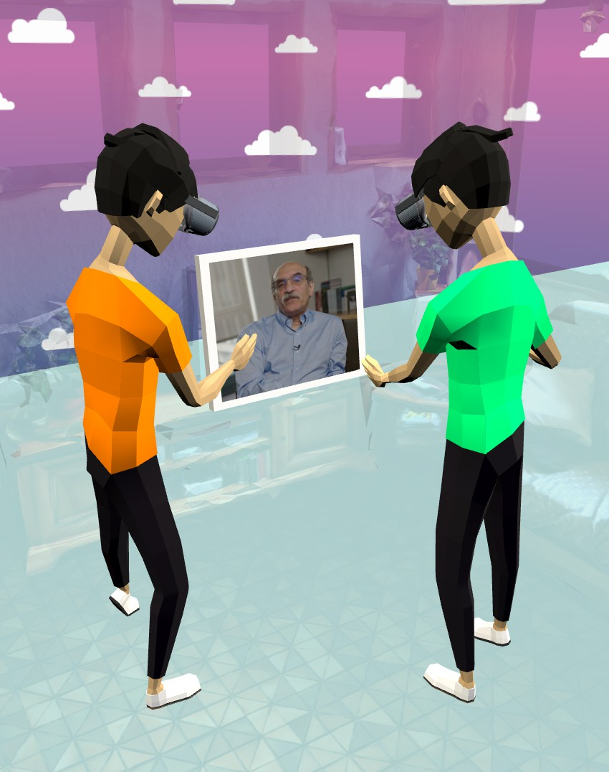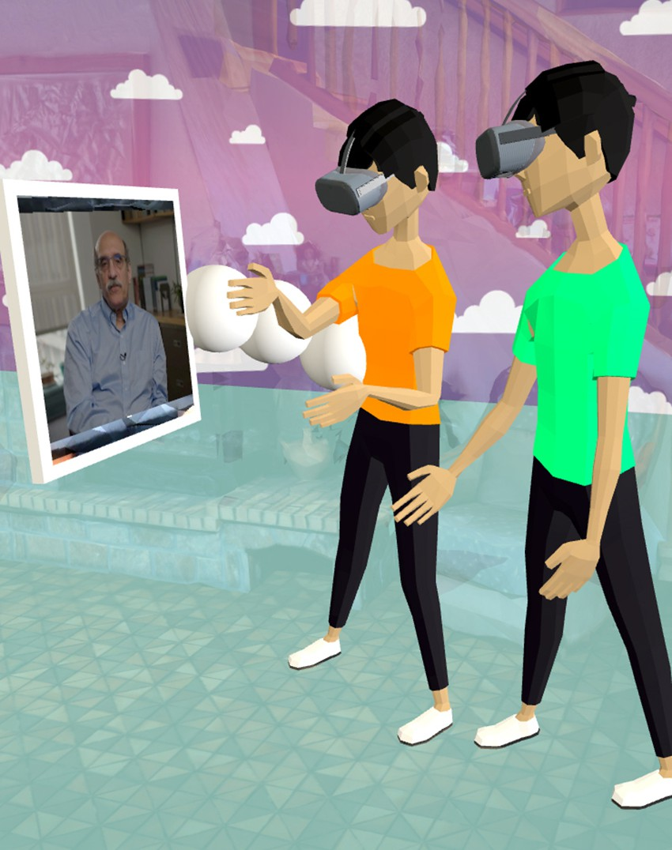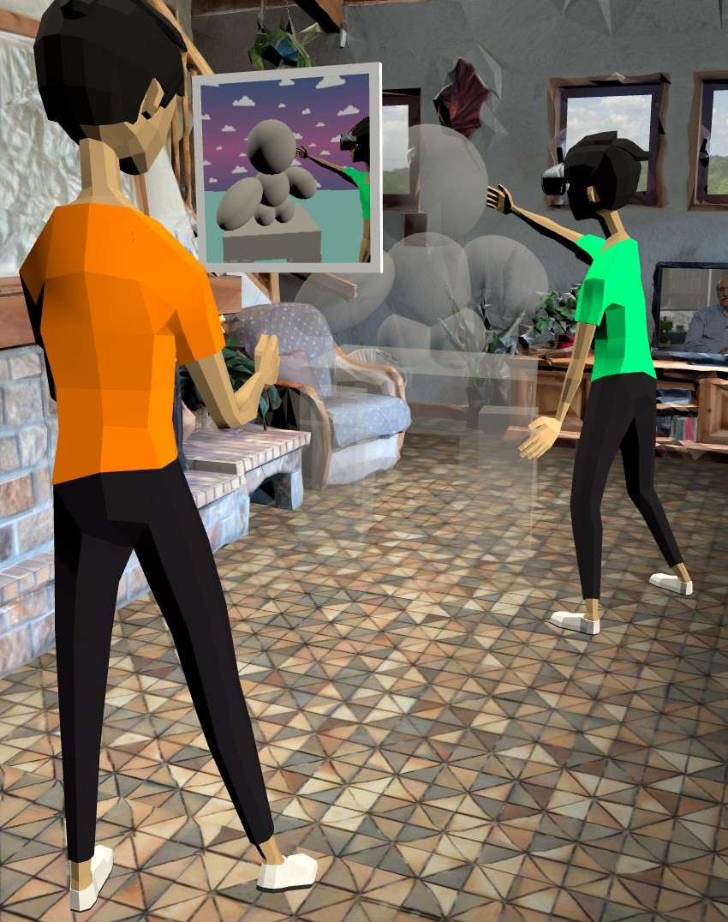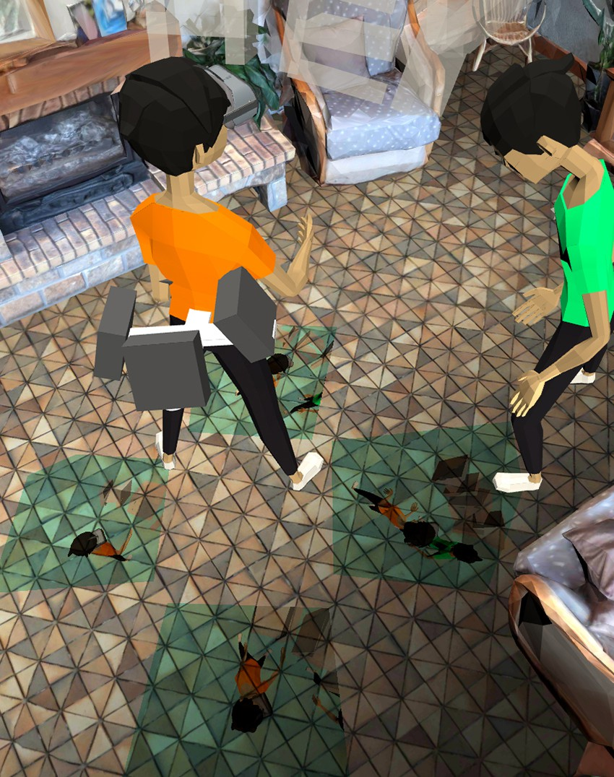
(a) Virtual Screen for Television. (b) Body-attached Display. (c) Window to Virtuality. (d) Worn Quad Projectors.

Figure 5: Example prototypes from the design workshop. In a) and b), the participants’ goal was to bring the television from reality into virtuality. In c) and d), participants aimed to give a bystander a glance at their actions in the virtual world.

users to rapidly prototype with our toolkit, we mapped all its func- tionalities to controller buttons. We also provided tooltips so that participants could find their desired action while using the VR- ception Toolkit. Some participants stated that they liked the quick actions we provided, while others said that they would have pre- ferred a context menu that provides all possible actions as visual representations. In line with Shneiderman’s eight golden rules [57], we recommend inclusion of both options to “enable frequent users to use shortcuts” while “reducing short-term memory load” with contextual actions.
Concerning the task load, the participants rated the mental de- mand highest. We think that two factors contributed to this: 1) interface complexity and 2) difficulty of distinguishing between realities. As the former point is addressed above, we continue by discussing the latter. After the experts highlighted the fact that having both realities in VR could be confusing, we included a real- world scan to make the differences more clear (see Section 4.3). Nonetheless, the predefined objects (e.g., projector or displays) still look the same in both realities. Here, we recommend using different shaders/materials for the different realities (e.g., toon-shading for virtuality objects) to help users to better distinguish between the objects.

LIMITATIONS
Some specific decisions we made are worth discussing.
Prototyping with the VRception Toolkit. We re-implemented a set of six cross-reality systems with our VRception Toolkit in Unity3D (cf. Section 5.2). Thereby, we could showcase the potential of the VRception Toolkit and gain insights from in-depth interviews with the authors. However, prototyping in Unity3D does not rely on our set of predefined objects; thus, it offers more flexibility than proto- typing in Virtual Reality, as it is not restricted by what objects are available. Our goal is to provide users of the VRception Toolkit with a promising set of objects that are frequently used when building cross-reality systems, such as projectors (e.g., [21, 30, 68]), displays (e.g., [21, 22, 36]), and additional spheres and cubes that enable
users to model simple geometry. Nonetheless, our current imple- mentation focuses mainly on displays and projectors. However, this set of primitives can easily be extended in the future by integrating objects such as depth cameras.
Missing Hardware. We also want to highlight that although the absence of physical limitations can be interpreted as an advantage of VRception over traditional real-world prototyping, simulating real- world conditions can sometimes be at the center of a researcher’s investigation. In such situations, simulating real-world conditions (e.g., real-world motion [27]) requires additional effort.
Validity of User Studies. Finally, we cannot claim that cross- reality system evaluations using VRception achieve high validity (e.g., evaluating a cross-reality system through a user study con- ducted in VRception). The value of evaluations conducted in VR- ception remains unclear. We leave this for future work, where we plan to conduct comparative evaluations of cross-reality systems in VRception and in the real world with actual hardware to pinpoint potential similarities and differences between the two approaches. Nonetheless, the main focus of VRception was to highlight its ability as a prototyping tool, not as an evaluation tool.

RESEARCH OPPORTUNITIES
We identified five opportunities and implications for future work in cross-reality system and interaction research and practice, which we will outline in the following paragraphs.
Prototype for Reality and Virtuality. VRception offers researchers and practitioners a novel approach to prototype cross-reality sys- tems and interactions. Essentially, we introduce a tool for the early prototyping phase that allows one to start without physical pro- totyping. Thus, one can rapidly create and test different solutions without hardware expenses or physical prototyping skills. More- over, VRception empowers researchers to explore novel systems and interactions that are not yet possible to build with current hardware, allowing them to focus more on users’ needs and less on hardware limitations. For the future, we envision two research directions that

would benefit our approach: 1) virtual clones of existing hardware, and 2) comparative evaluations that compare prototypes developed with VRception to their real-world implementations as discussed in the limitations section. Currently, we implemented a universal display and projector object; however, more virtual clones of exist- ing hardware are possible. For instance, we envision the addition of a depth camera that utilizes the z-buffer of its render-texture to visualize depth information.
Conducting Remote Studies. The networking feature allows one to use the toolkit not only in co-located settings, but also to conduct remote studies. Thus, it allows researchers to continue researching cross-reality systems and interactions during the ongoing pan- demic, offering an alternative approach to other recently proposed methods [51, 52, 54]. Moreover, it lowers the barrier for study par- ticipation, as it takes geographic location out of the equation; thus, it enables one to conduct studies with a more diverse population.
Communication of Ideas. Our VRception Toolkit allows researchers to communicate their prototype ideas more easily. Currently, two options exist: 1) record videos with a scripted camera drive directly in Unity3D, or 2) repeat the process of creating and designing a prototype (cf. Section 4.3). Here, our toolkit offers a new approach for recording videos across realities, which has recently received more attention in research [44]. Moreover, replay functionality al- lows collaborating researchers to simply share their recordings and enable others to replay the complete prototyping process, alter the prototype, and share their changes.
Research on the Continuum. To our knowledge, little research focuses on prototypes embracing the complete reality-virtuality continuum from Milgram and Kishino [41]. So far, only fewer tran- sitional interfaces (systems that allow users to transition on the continuum) have been proposed. However, experts expect an in- crease in headsets that do not exclusively offer AR or VR, but instead allow users to transition between different manifestations, under- scoring the need for more research in this area [61]. Moreover, foundational work exploring the continuum and revisiting impor- tant concepts aids in the development of a shared language, which benefits researchers [59]. By simulating reality and virtuality in VR, we open up the possibility of exploring these topics more easily.
Education and Learning. The interviewed experts and partici- pants of our design workshop highlighted that VRception would be a great resource for teaching and explaining the reality-virtuality continuum in a vivid way. We agree and see great potential in this use-case. Also, many existing research prototypes can be quickly replicated as lo-fi versions, allowing learners to explore cross-reality systems and easily test possible extensions.

CONCLUSION
We presented VRception, a concept and toolkit for rapid prototyp- ing of cross-reality systems. To evaluate our concept and toolkit, we replicated six cross-reality systems from previous work, con- ducted expert interviews with the authors of these systems, and ran a subsequent evaluation with VR/AR practitioners. The ex- perts unanimously agreed that we were able to replicate the core
functionalities of their systems using the VRception Toolkit. More- over, they highlighted the great potential of VRception to not only overcome hardware limitations, but also to enable remote collab- oration and studies in the context of cross-reality systems and interactions, allowing broader research on the subject. During the evaluation with VR/AR practitioners, we gathered evidence for the rapid-prototyping character of our toolkit and confirmed its good usability. They were able to prototype and experience cross-reality systems in about eight minutes, which demonstrates how quickly users can blueprint these systems with the VRception Toolkit. We conclude our work by outlining research opportunities and their implications for the future of cross-reality research. We argue that cross-reality systems and interactions should be addressed further in future prototyping tools since they are becoming a fundamental type of interaction for augmented and virtual reality applications.

ACKNOWLEDGMENTS
This work is partially funded by the German Federal Ministry of Education and Research (16SV8663, 01IS21068A). This publication was supported by the University of Edinburgh and the University of Glasgow jointly funded PhD studentships. This work is supported by the EPSRC (EP/V008870/1) and the Royal Society of Edinburgh (award number #65040).

REFERENCES
- Shivam Agarwal, Jonas Auda, Stefan Schneegaß, and Fabian Beck. 2020. A Design and Application Space for Visualizing User Sessions of Virtual and Mixed Reality Environments. In Vision, Modeling, and Visualization, Jens Krüger, Matthias Niessner, and Jörg Stückler (Eds.). The Eurographics Association, Norrköping,
Sweden, 10 pages. https://doi.org/10.2312/vmv.20201194
- Ghassem Alaee, Amit P Deasi, Lourdes Pena-Castillo, Edward Brown, and Oscar Meruvia-Pastor. 2018. A User Study on Augmented Virtuality Using Depth Sensing Cameras for Near-Range Awareness in Immersive VR. In IEEE VR’s 4th Workshop on Everyday Virtual Reality (WEVR ’18, Vol. 10). wevr.adalsimeone.me, Reutlingen, Germany, 1–6.
- Tatsuya Amano, Shugo Kajita, Hirozumi Yamaguchi, Teruo Higashino, and Mi- neo Takai. 2018. Smartphone Applications Testbed Using Virtual Reality. In Proceedings of the 15th EAI International Conference on Mobile and Ubiquitous Systems: Computing, Networking and Services (New York, NY, USA) (MobiQui- tous ’18). Association for Computing Machinery, New York, NY, USA, 422–431. https://doi.org/10.1145/3286978.3287028
- Deepali Aneja, Daniel McDuff, and Shital Shah. 2019. A High-Fidelity Open Embodied Avatar with Lip Syncing and Expression Capabilities. In 2019 In- ternational Conference on Multimodal Interaction (Suzhou, China) (ICMI ’19). Association for Computing Machinery, New York, NY, USA, 69–73. https:
//doi.org/10.1145/3340555.3353744
- Csaba Antonya and Doru Talaba. 2007. Design Evaluation and Modification of Mechanical Systems in Virtual Environments. Virtual Reality 11, 4 (Oct. 2007), 275–285. https://doi.org/10.1007/s10055-007-0074-6
- Andreas Aristidou and Joan Lasenby. 2011. FABRIK: A fast, iterative solver for the Inverse Kinematics problem. Graphical Models 73, 5 (2011), 243–260. https://doi.org/10.1016/j.gmod.2011.05.003
- Narges Ashtari, Andrea Bunt, Joanna McGrenere, Michael Nebeling, and Par- mit K. Chilana. 2020. Creating Augmented and Virtual Reality Applications: Current Practices, Challenges, and Opportunities. In Proceedings of the 2020 CHI Conference on Human Factors in Computing Systems (Honolulu, HI, USA) (CHI ’20). Association for Computing Machinery, New York, NY, USA, 1–13. https://doi.org/10.1145/3313831.3376722
- Jonas Auda, Uwe Gruenefeld, and Sven Mayer. 2020. It Takes Two To Tango: Conflicts Between Users on the Reality-Virtuality Continuum and Their By- standers. In In the Proceedings of the International Workshop on Cross-Reality (XR) Interaction (2020-11-08) (XR ’20). CEUR-WS, Lisbon, Portugal, 1–5. http://ceur- ws.org/Vol-2779/paper3.pdf
- Aaron Bangor, Philip Kortum, and James Miller. 2009. Determining What Indi- vidual SUS Scores Mean: Adding an Adjective Rating Scale. J. Usability Studies 4, 3 (May 2009), 114–123.
- Mark Billinghurst and Michael Nebeling. 2021. Rapid Prototyping of XR Expe- riences. In Extended Abstracts of the 2021 CHI Conference on Human Factors in

Computing Systems. Association for Computing Machinery, New York, NY, USA,
Article 132, 3 pages. https://doi.org/10.1145/3411763.3445002
- John Brooke. 1996. SUS: a "quick and dirty" usability. Usability evaluation in industry 189 (1996), 6 pages.
- Liwei Chan and Kouta Minamizawa. 2017. FrontFace: Facilitating Communi- cation between HMD Users and Outsiders Using Front-Facing-Screen HMDs. In Proceedings of the 19th International Conference on Human-Computer Inter- action with Mobile Devices and Services (Vienna, Austria) (MobileHCI ’17). As- sociation for Computing Machinery, New York, NY, USA, Article 22, 5 pages. https://doi.org/10.1145/3098279.3098548
- Lung-Pan Cheng, Eyal Ofek, Christian Holz, and Andrew D. Wilson. 2019. VRoamer: Generating On-The-Fly VR Experiences While Walking inside Large, Unknown Real-World Building Environments. In 2019 IEEE Conference on Vir- tual Reality and 3D User Interfaces. IEEE, Piscataway, New Jersey, United States, 359–366. https://doi.org/10.1109/VR.2019.8798074
- Shuchisnigdha Deb, Daniel W. Carruth, Richard Sween, Lesley Strawderman, and Teena M. Garrison. 2017. Efficacy of virtual reality in pedestrian safety research. Applied Ergonomics 65 (2017), 449 – 460. https://doi.org/10.1016/j.apergo.2017.
03.007
- Kevin Doherty and Gavin Doherty. 2018. Engagement in HCI: Conception, Theory and Measurement. ACM Comput. Surv. 51, 5, Article 99 (Nov. 2018), 39 pages. https://doi.org/10.1145/3234149
- Kevin Fan, Liwei Chan, Daiya Kato, Kouta Minamizawa, and Masahiko Inami. 2016. VR Planet: Interface for Meta-View and Feet Interaction of VR Contents. In ACM SIGGRAPH 2016 VR Village (Anaheim, California) (SIGGRAPH ’16). ACM,
New York, NY, USA, Article 24, 2 pages. https://doi.org/10.1145/2929490.2931001
- Gabriel Freitas, Marcio Sarroglia Pinho, Milene Selbach Silveira, and Frank Mau- rer. 2020. A Systematic Review of Rapid Prototyping Tools for Augmented Reality. In 2020 22nd Symposium on Virtual and Augmented Reality (SVR ’20). IEEE, Pis- cataway, New Jersey, United States, 199–209. https://doi.org/10.1109/SVR51698. 2020.00041
- Ceenu George, Philipp Janssen, David Heuss, and Florian Alt. 2019. Should I Interrupt or Not? Understanding Interruptions in Head-Mounted Display Settings. In Proceedings of the 2019 on Designing Interactive Systems Conference (San Diego, CA, USA) (DIS ’19). Association for Computing Machinery, New York, NY, USA, 497–510. https://doi.org/10.1145/3322276.3322363
- Andrzej Grabowski and Jarosław Jankowski. 2015. Virtual Reality-based pilot training for underground coal miners. Safety Science 72 (2015), 310–314. https:
//doi.org/10.1016/j.ssci.2014.09.017
- Uwe Gruenefeld, Abdallah El Ali, Susanne Boll, and Wilko Heuten. 2018. Beyond Halo and Wedge: Visualizing out-of-View Objects on Head-Mounted Virtual and Augmented Reality Devices. In Proceedings of the 20th International Conference on Human-Computer Interaction with Mobile Devices and Services (Barcelona, Spain) (MobileHCI ’18). Association for Computing Machinery, New York, NY, USA,
Article 40, 11 pages. https://doi.org/10.1145/3229434.3229438
- Jan Gugenheimer, Evgeny Stemasov, Julian Frommel, and Enrico Rukzio. 2017. ShareVR: Enabling Co-Located Experiences for Virtual Reality between HMD and Non-HMD Users. In Proceedings of the 2017 CHI Conference on Human Factors in Computing Systems. Association for Computing Machinery, New York, NY,
USA, 4021–4033. https://doi.org/10.1145/3025453.3025683
- Jan Gugenheimer, Evgeny Stemasov, Harpreet Sareen, and Enrico Rukzio. 2018. FaceDisplay: Towards Asymmetric Multi-User Interaction for Nomadic Virtual Reality. In Proceedings of the 2018 CHI Conference on Human Factors in Computing Systems (Montreal QC, Canada) (CHI ’18). Association for Computing Machinery,
New York, NY, USA, 1–13. https://doi.org/10.1145/3173574.3173628
- Gunnar Harboe and Elaine M. Huang. 2015. Real-World Affinity Diagramming Practices: Bridging the Paper-Digital Gap. In Proc. 33rd Annual ACM Conf. Human Factors in Computing Systems. ACM, New York, NY, USA, 95–104. https://doi. org/10.1145/2702123.2702561
- Sandra G. Hart. 2006. NASA-task load index (NASA-TLX); 20 years later. In Proceedings of the Human Factors and Ergonomics Society Annual Meeting, Vol. 50. Sage publications Sage CA: Los Angeles, CA, Los Angeles, California, United States, 904–908. https://doi.org/10.1177/154193120605000909
- Jeremy Hartmann, Christian Holz, Eyal Ofek, and Andrew D. Wilson. 2019. RealityCheck: Blending Virtual Environments with Situated Physical Reality. In Proceedings of the 2019 CHI Conference on Human Factors in Computing Systems (Glasgow, Scotland Uk) (CHI ’19). Association for Computing Machinery, New York, NY, USA, 1–12. https://doi.org/10.1145/3290605.3300577
- Jeremy Hartmann, Yen-Ting Yeh, and Daniel Vogel. 2020. AAR: Augmenting a Wearable Augmented Reality Display with an Actuated Head-Mounted Projector. In Proceedings of the 33rd Annual ACM Symposium on User Interface Software and Technology (Virtual Event, USA) (UIST ’20). Association for Computing Machinery,
New York, NY, USA, 445–458. https://doi.org/10.1145/3379337.3415849
- Philipp Hock, Sebastian Benedikter, Jan Gugenheimer, and Enrico Rukzio. 2017. CarVR: Enabling In-Car Virtual Reality Entertainment. In Proceedings of the 2017 CHI Conference on Human Factors in Computing Systems. Association for Computing Machinery, New York, NY, USA, 4034–4044. https://doi.org/10.1145/ 3025453.3025665
- Arief Ernst Hühn, Vassilis-Javed Khan, Andrés Lucero, and Paul Ketelaar. 2012. On the Use of Virtual Environments for the Evaluation of Location-Based Appli- cations. In Proceedings of the SIGCHI Conference on Human Factors in Computing Systems (Austin, Texas, USA) (CHI ’12). Association for Computing Machinery,
New York, NY, USA, 2569–2578. https://doi.org/10.1145/2207676.2208646
- Akira Ishii, Masaya Tsuruta, Ippei Suzuki, Shuta Nakamae, Tatsuya Minagawa, Junichi Suzuki, and Yoichi Ochiai. 2017. ReverseCAVE: Providing Reverse Perspec- tives for Sharing VR Experience. In ACM SIGGRAPH 2017 Posters (Los Angeles, California) (SIGGRAPH ’17). Association for Computing Machinery, New York,
NY, USA, Article 28, 2 pages. https://doi.org/10.1145/3102163.3102208
- Akira Ishii, Masaya Tsuruta, Ippei Suzuki, Shuta Nakamae, Junichi Suzuki, and Yoichi Ochiai. 2019. Let Your World Open: CAVE-Based Visualization Methods of Public Virtual Reality towards a Shareable VR Experience. In Proceedings of the 10th Augmented Human International Conference 2019 (Reims, France) (AH ’19). ACM, New York, NY, USA, Article 33, 8 pages. https://doi.org/10.1145/3311823. 3311860
- Pascal Jansen, Fabian Fischbach, Jan Gugenheimer, Evgeny Stemasov, Julian Frommel, and Enrico Rukzio. 2020. ShARe: Enabling Co-Located Asymmet- ric Multi-User Interaction for Augmented Reality Head-Mounted Displays. In Proceedings of the 33rd Annual ACM Symposium on User Interface Software and Technology (Virtual Event, USA) (UIST ’20). Association for Computing Machin- ery, New York, NY, USA, 459–471. https://doi.org/10.1145/3379337.3415843
- Ben Kenwright. 2012. Inverse Kinematics – Cyclic Coordinate Descent (CCD).
Journal of Graphics Tools 16, 4 (2012), 177–217. https://doi.org/10.1080/2165347X.
2013.823362
- Jarrod Knibbe, Jonas Schjerlund, Mathias Petraeus, and Kasper Hornbæk. 2018. The Dream is Collapsing: The Experience of Exiting VR. In Proceedings of the 2018 CHI Conference on Human Factors in Computing Systems. Association for Computing Machinery, New York, NY, USA, 1–13. https://doi.org/10.1145/ 3173574.3174057
- Pascal Knierim, Valentin Schwind, Anna Maria Feit, Florian Nieuwenhuizen, and Niels Henze. 2018. Physical Keyboards in Virtual Reality: Analysis of Typing Per- formance and Effects of Avatar Hands. In Proceedings of the 2018 CHI Conference on Human Factors in Computing Systems. Association for Computing Machinery,
New York, NY, USA, 1–9. https://doi.org/10.1145/3173574.3173919
- Zhengqing Li, Liwei Chan, Theophilus Teo, and Hideki Koike. 2020. Om- niGlobeVR: A Collaborative 360° Communication System for VR. In Extended Abstracts of the 2020 CHI Conference on Human Factors in Computing Systems (Honolulu, HI, USA) (CHI EA ’20). Association for Computing Machinery, New York, NY, USA, 1–8. https://doi.org/10.1145/3334480.3382869
- Christian Mai, Lukas Rambold, and Mohamed Khamis. 2017. TransparentHMD: Revealing the HMD User’s Face to Bystanders. In Proceedings of the 16th Inter- national Conference on Mobile and Ubiquitous Multimedia (Stuttgart, Germany) (MUM ’17). Association for Computing Machinery, New York, NY, USA, 515–520. https://doi.org/10.1145/3152832.3157813
- Christian Mai, Tim Wiltzius, Florian Alt, and Heinrich Hußmann. 2018. Feeling Alone in Public: Investigating the Influence of Spatial Layout on Users’ VR Experience. In Proceedings of the 10th Nordic Conference on Human-Computer Interaction (Oslo, Norway) (NordiCHI ’18). Association for Computing Machinery,
New York, NY, USA, 286–298. https://doi.org/10.1145/3240167.3240200
- Ville Mäkelä, Rivu Radiah, Saleh Alsherif, Mohamed Khamis, Chong Xiao, Lisa Borchert, Albrecht Schmidt, and Florian Alt. 2020. Virtual Field Studies: Con- ducting Studies on Public Displays in Virtual Reality. In Proceedings of the 2020 CHI Conference on Human Factors in Computing Systems (Honolulu, HI, USA) (CHI ’20). Association for Computing Machinery, New York, NY, USA, 1–15. https://doi.org/10.1145/3313831.3376796
- Florian Mathis, Kami Vaniea, and Mohamed Khamis. 2021. RepliCueAuth: Vali- dating the Use of a lab-based Virtual Reality Setup for Evaluating Authentication Systems. In Proceedings of the 39th Annual ACM Conference on Human Factors in Computing Systems (Yokohama, Japan) (CHI ’21). ACM, New York, NY, USA, 21 pages. https://doi.org/10.1145/3411764.3445478
- Mark McGill, Daniel Boland, Roderick Murray-Smith, and Stephen Brewster. 2015. A Dose of Reality: Overcoming Usability Challenges in VR Head-Mounted Displays. In Proceedings of the 33rd Annual ACM Conference on Human Factors in Computing Systems. Association for Computing Machinery, New York, NY, USA, 2143–2152. https://doi.org/10.1145/2702123.2702382
- Paul Milgram and Fumio Kishino. 1994. A taxonomy of mixed reality visual displays. IEICE TRANSACTIONS on Information and Systems 77, 12 (1994), 1321–
1329.
- Mark P. Mobach. 2008. Do Virtual Worlds Create Better Real Worlds? Virtual Reality 12, 3 (Sept. 2008), 163–179. https://doi.org/10.1007/s10055-008-0081-2
- Michael Nebeling, Katy Lewis, Yu-Cheng Chang, Lihan Zhu, Michelle Chung, Piaoyang Wang, and Janet Nebeling. 2020. XRDirector: A Role-Based Collab- orative Immersive Authoring System. In Proceedings of the 2020 CHI Confer- ence on Human Factors in Computing Systems (Honolulu, HI, USA) (CHI ’20). Association for Computing Machinery, New York, NY, USA, 1–12. https:
//doi.org/10.1145/3313831.3376637

- Michael Nebeling, Katy Lewis, Yu-Cheng Chang, Lihan Zhu, Michelle Chung, Piaoyang Wang, and Janet Nebeling. 2020. XRDirector: A Role-Based Collab- orative Immersive Authoring System. In Proceedings of the 2020 CHI Confer- ence on Human Factors in Computing Systems (Honolulu, HI, USA) (CHI ’20). Association for Computing Machinery, New York, NY, USA, 1–12. https:
//doi.org/10.1145/3313831.3376637
- Michael Nebeling and Katy Madier. 2019. 360proto: Making Interactive Virtual Reality & Augmented Reality Prototypes from Paper. In Proceedings of the 2019 CHI Conference on Human Factors in Computing Systems (Glasgow, Scotland Uk) (CHI ’19). Association for Computing Machinery, New York, NY, USA, 1–13. https://doi.org/10.1145/3290605.3300826
- Michael Nebeling, Janet Nebeling, Ao Yu, and Rob Rumble. 2018. ProtoAR: Rapid Physical-Digital Prototyping of Mobile Augmented Reality Applications. In Proceedings of the 2018 CHI Conference on Human Factors in Computing Systems (Montreal QC, Canada) (CHI ’18). Association for Computing Machinery, New York, NY, USA, 1–12. https://doi.org/10.1145/3173574.3173927
- Michael Nebeling and Maximilian Speicher. 2018. The Trouble with Augmented Reality/Virtual Reality Authoring Tools. In 2018 IEEE International Symposium on Mixed and Augmented Reality Adjunct (ISMAR-Adjunct ’18). IEEE, Piscataway, New Jersey, United States, 333–337. https://doi.org/10.1109/ISMAR-Adjunct. 2018.00098
- Benjamin Nuernberger, Eyal Ofek, Hrvoje Benko, and Andrew D. Wilson. 2016. SnapToReality: Aligning Augmented Reality to the Real World. In Proceedings of the 2016 CHI Conference on Human Factors in Computing Systems. Association for Computing Machinery, New York, NY, USA, 1233–1244. https://doi.org/10.1145/ 2858036.2858250
- Thammathip Piumsomboon, Gun A. Lee, Andrew Irlitti, Barrett Ens, Bruce H. Thomas, and Mark Billinghurst. 2019. On the Shoulder of the Giant: A Multi-Scale Mixed Reality Collaboration with 360 Video Sharing and Tangible Interaction. In Proceedings of the 2019 CHI Conference on Human Factors in Computing Systems (Glasgow, Scotland Uk) (CHI ’19). Association for Computing Machinery, New York, NY, USA, 1–17. https://doi.org/10.1145/3290605.3300458
- Charles Pontonnier, Georges Dumont, Asfhin Samani, Pascal Madeleine, and Marwan Badawi. 2014. Designing and evaluating a workstation in real and virtual environment: toward virtual reality based ergonomic design sessions. Journal on Multimodal User Interfaces 8, 2 (2014), 199–208. https://doi.org/10.1007/s12193-
013-0138-8
- Rivu Radiah, Ville Mäkelä, Sarah Prange, Sarah Delgado Rodriguez, Robin Piening, Yumeng Zhou, Kay Köhle, Ken Pfeuffer, Yomna Abdelrahman, Matthias Hoppe, Albrecht Schmidt, and Florian Alt. 2021. Remote VR Studies: A Framework for Running Virtual Reality Studies Remotely Via Participant-Owned HMDs. ACM Trans. Comput.-Hum. Interact. 28, 6, Article 46 (nov 2021), 36 pages. https:
//doi.org/10.1145/3472617
- Jack Ratcliffe, Francesco Soave, Nick Bryan-Kinns, Laurissa Tokarchuk, and Ildar Farkhatdinov. 2021. Extended Reality (XR) Remote Research: a Survey of Drawbacks and Opportunities. In Proceedings of the 2021 CHI Conference on Human Factors in Computing Systems (2021-05-08) (CHI ’21). Association for Computing Machinery, New York, New York, USA, 1–13. https://doi.org/10.1145/ 3411764.3445170 arXiv:2101.08046 [cs.HC]
- Francisco Rebelo, Paulo Noriega, Emília Duarte, and Marcelo Soares. 2012. Using Virtual Reality to Assess User Experience. Human Factors 54, 6 (2012), 964–982. https://doi.org/10.1177/0018720812465006
- David Saffo, Sara Di Bartolomeo, Caglar Yildirim, and Cody Dunne. 2021. Re- mote and Collaborative Virtual Reality Experiments via Social VR Platforms. In Proceedings of the 2021 CHI Conference on Human Factors in Computing Systems (2021-05-08) (CHI ’21). Association for Computing Machinery, New York, New York, USA, 1–15. https://doi.org/10.1145/3411764.3445426
- Valentin Schwind, Pascal Knierim, Lewis Chuang, and Niels Henze. 2017. "Where’s Pinky?": The Effects of a Reduced Number of Fingers in Virtual Reality. In Proceedings Annual Symposium on Computer-Human Interaction in Play (Am- sterdam, The Netherlands) (CHIPlay ’17). ACM, New York, NY, USA, 507–515. https://doi.org/10.1145/3116595.3116596
- Valentin Schwind, Jens Reinhardt, Rufat Rzayev, Niels Henze, and Katrin Wolf. 2018. Virtual Reality on the Go? A Study on Social Acceptance of VR Glasses. In Proceedings of the 20th International Conference on Human-Computer Interaction with Mobile Devices and Services Adjunct (Barcelona, Spain) (MobileHCI ’18). Association for Computing Machinery, New York, NY, USA, 111–118. https:
//doi.org/10.1145/3236112.3236127
- Ben Shneiderman, Catherine Plaisant, Maxine S Cohen, Steven Jacobs, Niklas Elmqvist, and Nicholas Diakopoulos. 2016. Designing the user interface: strategies for effective human-computer interaction. Pearson, London, United Kingdom.
- Adalberto L. Simeone, Mohamed Khamis, Augusto Esteves, Florian Daiber, Matjaž Kljun, Klen Čopič Pucihar, Poika Isokoski, and Jan Gugenheimer. 2020. Interna- tional Workshop on Cross-Reality (XR) Interaction. In Companion Proceedings of the 2020 Conference on Interactive Surfaces and Spaces (Virtual Event, Portugal) (ISS ’20). Association for Computing Machinery, New York, NY, USA, 111–114. https://doi.org/10.1145/3380867.3424551
- Richard Skarbez, Missie Smith, and Mary C. Whitton. 2021. Revisiting Milgram and Kishino’s Reality-Virtuality Continuum. Frontiers in Virtual Reality 2 (2021),
27. https://doi.org/10.3389/frvir.2021.647997
- Mel Slater, Martin Usoh, and Anthony Steed. 1994. Depth of Presence in Virtual Environments. Presence: Teleoperators and Virtual Environments 3, 2 (05 1994),
130–144. https://doi.org/10.1162/pres.1994.3.2.130
- Maximilian Speicher, Brian D. Hall, and Michael Nebeling. 2019. What is Mixed Reality?. In Proceedings of the 2019 CHI Conference on Human Factors in Computing Systems (Glasgow, Scotland Uk) (CHI ’19). ACM, New York, NY, USA, 1–15. https://doi.org/10.1145/3290605.3300767
- Maximilian Speicher, Brian D. Hall, Ao Yu, Bowen Zhang, Haihua Zhang, Janet Nebeling, and Michael Nebeling. 2018. XD-AR: Challenges and Opportunities in Cross-Device Augmented Reality Application Development. Proc. ACM Hum.- Comput. Interact. 2, EICS, Article 7 (June 2018), 24 pages. https://doi.org/10.1145/
3229089
- Frank Steinicke, Gerd Bruder, Klaus Hinrichs, Anthony Steed, and Alexander L. Gerlach. 2009. Does a Gradual Transition to the Virtual World increase Presence?. In 2009 IEEE Virtual Reality Conference. IEEE, Piscataway, New Jersey, United States, 203–210. https://doi.org/10.1109/VR.2009.4811024
- Balasaravanan Thoravi Kumaravel, Cuong Nguyen, Stephen DiVerdi, and Bjoern Hartmann. 2020. TransceiVR: Bridging Asymmetrical Communication Between VR Users and External Collaborators. In Proceedings of the 33rd Annual ACM Symposium on User Interface Software and Technology (Virtual Event, USA) (UIST ’20). Association for Computing Machinery, New York, NY, USA, 182–195. https:
//doi.org/10.1145/3379337.3415827
- Dimitar Valkov and Steffen Flagge. 2017. Smooth Immersion: The Benefits of Making the Transition to Virtual Environments a Continuous Process. In Proceedings of the 5th Symposium on Spatial User Interaction (Brighton, United Kingdom) (SUI ’17). Association for Computing Machinery, New York, NY, USA, 12–19. https://doi.org/10.1145/3131277.3132183
- Alexandra Voit, Sven Mayer, Valentin Schwind, and Niels Henze. 2019. Online, VR, AR, Lab, and In-Situ: Comparison of Research Methods to Evaluate Smart Ar- tifacts. In Proceedings of the 2019 CHI Conference on Human Factors in Computing Systems (Glasgow, Scotland Uk) (CHI ’19). Association for Computing Machinery,
New York, NY, USA, 1–12. https://doi.org/10.1145/3290605.3300737
- Chiu-Hsuan Wang, Chia-En Tsai, Seraphina Yong, and Liwei Chan. 2020. Slice of Light: Transparent and Integrative Transition Among Realities in a Multi-HMD- User Environment. In Proceedings of the 33rd Annual ACM Symposium on User Interface Software and Technology (Virtual Event, USA) (UIST ’20). Association for Computing Machinery, New York, NY, USA, 805–817. https://doi.org/10.1145/ 3379337.3415868
- Chiu-Hsuan Wang, Seraphina Yong, Hsin-Yu Chen, Yuan-Syun Ye, and Liwei Chan. 2020. HMD Light: Sharing In-VR Experience via Head-Mounted Projector for Asymmetric Interaction. In Proceedings of the 33rd Annual ACM Symposium on User Interface Software and Technology (Virtual Event, USA) (UIST ’20). Association for Computing Machinery, New York, NY, USA, 472–486. https://doi.org/10. 1145/3379337.3415847
- Maximilian Weiß, Katrin Angerbauer, Alexandra Voit, Magdalena Schwarzl, Michael Sedlmair, and Sven Mayer. 2021. Revisited: Comparison of Empirical Methods to Evaluate Visualizations Supporting Crafting and Assembly Purposes. IEEE Transactions on Visualization and Computer Graphics 27, 2 (2021), 1204–1213. https://doi.org/10.1109/TVCG.2020.3030400
- Julie R. Williamson, Mark McGill, and Khari Outram. 2019. PlaneVR: Social Acceptability of Virtual Reality for Aeroplane Passengers. In Proceedings of the 2019 CHI Conference on Human Factors in Computing Systems (Glasgow, Scotland Uk) (CHI ’19). Association for Computing Machinery, New York, NY, USA, 1–14. https://doi.org/10.1145/3290605.3300310
- Keng-Ta Yang, Chiu-Hsuan Wang, and Liwei Chan. 2018. ShareSpace: Facilitating Shared Use of the Physical Space by Both VR Head-Mounted Display and External Users. In Proceedings of the 31st Annual ACM Symposium on User Interface Software and Technology (Berlin, Germany) (UIST ’18). Association for Computing Machin- ery, New York, NY, USA, 499–509. https://doi.org/10.1145/3242587.3242630

Start of PDF Naman_Omar 3

Full Citation: J. Guan, A. Morris and J. Irizawa, ”Cross-Reality for Extending the Metaverse: Designing Hyper-Connected Immersive Environments with XRI,” 2023 IEEE Conference on Virtual Reality and 3D User Interfaces Abstracts and Workshops (VRW), ShangHai, China, 2023, pp. 305-311, DOI: 10.1109/VRW58643.2023.00071.

©2023 IEEE. Personal use of this material is permitted. Permission from IEEE must be obtained for all other uses, in any current or future media, including reprinting/republishing this material for advertising or promotional purposes, creating new collective works, for resale or redistribution to servers or lists, or reuse of any copyrighted component of this work in other works.
arXiv:2306.01113v1 [cs.HC] 1 Jun 2023

Cross-Reality for Extending the Metaverse: Designing Hyper-Connected Immersive Environments with XRI
Jie Guan * Alexis Morris† Jay Irizawa ‡

Adaptive Context Environments (ACE) Lab OCAD University

Abstract
The Metaverse comprises technologies to enable virtual twins of the real world, via mixed reality, internet of things, and others. As it matures unique challenges arise such as a lack of strong connections between virtual and physical worlds. This work presents design frameworks for cross-reality hybrid spaces. Contributions include:
- clarifying the metaverse ”disconnect”, ii) extended metaverse design frameworks, iii) prototypes, and iv) discussions toward new metaverse smart environments.
Index Terms: Virtual Reality, Mixed Reality, Augmented Reality, Extended Reality, Internet of Things, Human Computer Interaction

Introduction
The metaverse refers to “a virtual environment blending physical and digital, facilitated by the convergence between the Internet and web technologies, and Extended Reality” [15]. This blended environment promises numerous benefits for society, which can be environmental, social, economic, and even psycho-physiological; as this technology has broad human-factor impacts on society such as the physical, psychological, social, organizational, and political dimensions [30]. For example the metaverse can impact the environment when largely adopted, by reducing transportation costs and resources within the environment, while simultaneously enhancing people’s efficiency when working and studying remotely in dynamic shared virtual spaces.
Moreover, the time spent in metaverse environments that are more dynamic, immersive, and creative has the potential to extend these human factors; from the world of physical limitations to the more unlimited virtual environment. This is currently being adopted by large-scale industry developments and the metaverse has become one of the most influential trends in the marketplace. Various industries, such as health-care [28], marketing and advertising [27], travel and tourism [9], education and training [4] are adapting their services to provide metaverse-enabled networked platforms.
Today’s metaverse applications remain limited, however, as they are primarily online social experiences composed of virtual envi- ronments, virtual objects, and virtual avatars. This introduces a set of metaverse challenges for humans-in-the-loop. One of these challenges is the metaverse ”disconnect” problem, as in [6]. Diverse metaverse platforms and virtual spaces host activities with stan- dalone computers, mobile devices, and head-mounted display VR devices. Most of them bring humans into complete virtual spaces, thereby focusing on the virtual content leading to the metaverse dynamics being independent of - or disconnected from - the physi- cal space. This disconnect presents a challenge to the adoption of the metaverse, as there is a need to allow the human-in-the-loop

*e-mail: jie.guan@ocadu.ca
†e-mail:amorris@ocadu.ca
‡e-mail:jirizawa@ocadu.ca
to be more aware of real-world environmental contexts as they si- multaneously become more immersed in virtual and mixed reality environments.

Extending the Metaverse with Cross-Reality XR-IoT (XRI)
An extended metaverse offers the potential to inhabit two spaces concurrently. One space is the physical world, and the other is the metaverse, which is constructed of computational graphics and simulated environments. Living and working in immersive hybrid virtual and physical worlds with smart devices (i.e., head-mounted displays) may become as commonplace as the mobile phone today. Within these speculative futures parameters, this work explores an extended metaverse framework to enhance embodiment, interac- tion, and agency [10] that could provide a seamless interface to the physical world.
To explore designs for this new interface across both physical and virtual sides of the metaverse, requires a hybrid approach that encompasses the ubiquitous computing and immersive interface domains, within what is considered as ”Cross-Reality,” or ”X-Reality (XR),” i.e., the ubiquitous mixed reality environment when combined with context sensing [22] [18]. This work achieves this by extending traditional IoT interfaces with XR-IoT (XRI) interfaces, toward hybrid virtual and physical objects.
A hybrid approach exploring both physical and virtual attributes of the metaverse is needed in developing a new and cohesive in- terface. Previous works have presented hybrid mixed-reality and internet-of-things frameworks (known as XR-IoT, or XRI) [18] [29], and more recent work has presented early prototypes [7], [6] in- cluding an approach to strengthen the connection between physical spaces and metaverse environments (such as an XRI Lamp controller and an XRI Ambient Lighting system connecting real physical lamps to their virtual counterparts [7]). The current paper furthers these research contributions for extending the metaverse, based on [6].
The project explores an extended metaverse framework for ap- plying the metaverse layer in the physical space(s) to increase dy- namic inter-connections of humans, agents, and the environment through MR and the IoT. The extended metaverse framework fo- cuses on improving interaction, embodiment, and agency [10] in the human-in-the-loop MR space. The contributions of this include:
i) an exploration of the metaverse disconnect problem and back- ground literature, ii) an architectural framework for extending the metaverse, iii) design prototypes using the framework, (one for a hyper-connected space for time-awareness while in the metaverse; and the other for enabling users to transition between real and vir- tual environments where the environment helps to detect physical objects), and iv) a discussion-based evaluation of these approaches. The problems of the current metaverse platforms have yet to address these models of connection with the physical space in depth, and this work has the potential to elucidate the disconnect problem and to lay the groundwork for future exploration toward seamless immersive engagements in metaverse applications.

Background and Related Works
To discuss the concept of extended metaverse frameworks and agents, this section provides the background knowledge of the metaverse, related theory of XR and the IoT, and introduction of the context awareness along with generative and procedural content concepts. The background of the metaverse addresses the history, current state of technological development, and future possibilities.
XR is the method to embody the virtual and physical objects and environment while the IoT is considered to be for virtual and physical communication. Context awareness is introduced to capture and sense information in the physical environment, and procedural content is the method and rules to embody and enhance dynamic virtual objects.

The Background of Metaverse
As mentioned by Dionisio et al. [5], the metaverse is a portmanteau that combines with the prefix “meta,” which means “beyond,” and the suffix “verse,” which is shorthand for “universe.” It represents a universe beyond the space we live in physically. Specifically, it is a computer-generated environment that simulates the world and distinguishes it from the ”metaphysical” or ”spiritual” concepts. The concept of the metaverse, originally from the fiction novel Snow Crash, was developed by Neal Stephenson in 1992 [13]. In the novel, the metaverse was portrayed as a virtual world with humans interacting with intelligence agencies and each other as avatars in that space. It is a scenario similar to that in Ready Player One by Ernest Cline, where users can adopt any role or play as any character-type in a completely virtual world [1] The metaverse has various definitions (see table 1) because it is a state-of-the-art term that is being continually explored. Dionisio et al. [5] presented that the metaverse is constructed by multiple individual virtual worlds, defined as a fully immersive, three-dimensional digital environment that reflects the totality of shared online space. Lee et al. [15] considered the metaverse as a virtual environment constructed by the internet, web technologies, and extended reality (XR) toward hybrid physical and virtual space.
There are many applications and platforms for the metaverse today. Understanding their features and limitations will provide a better direction for addressing metaverse disconnect. Digital owner- ship is a big problem in the metaverse, and blockchain is applied in some platforms to deal with it, such as Decentraland¹, Cryptovox- els², and Somnium Space³. Decentraland attempts to be a virtual reality platform based on the Ethereum blockchain, where users own the creation’s property entirely when they purchase the “land.” The land is a non-fungible token (NFT), a digital asset stored as an Ethereum smart contract that users can create [21]. Cryptovoxels and Somnium Space also have a similar approach to defining the ownership of digital assets. Although Decentraland’s VR feature is still in development, Cryptovoxels’s ”Origin City” is available to be visited through VR in other popular VR worlds like VRChat, NeosVR, and Substrata. Meanwhile, Somnium Space allows for VR support via common SteamVR supported VR headsets.

Extended Reality and Internet-of-Things
XR-IoT Theory: As examined in works like [18] and [29], design- ing a more connected metaverse requires the merger of technology paradigms of XR and IoT – to connect with the physical environ- ment while extending into the virtual environment. Augmented Reality provides this with an interactive medium of overlaid virtual objects anchored to the real environment, while IoT refers to the networking of physical objects with computing devices for sensing and communication, as examined in [11]. This hybridization, as

1https://decentraland.org/
2https://www.cryptovoxels.com/ 3https://somniumspace.com/
in [29] is here referred to as XR-IoT (XRI), which represents the combination of XR-based IoT systems as well as IoT-based XR sys- tems. XRI engages in immersive, information-rich, multi-user, and agent-driven systems [18]. The combination of these technologies has the potential to bring a closer connection between humans and their environmental objects, as well as each other, and future hybrid XRI applications are being developed for applied situations, like education, cyber security, and marketing [2].
XR-IoT Applications: A selection of these XRI applications is described below, highlighting those projects which embed IoT systems into mixed reality projects, and those that apply XR features in IoT system designs. These metaverse systems merge multiple technologies, as well as interaction techniques, as in [33], in order to create cross-reality experiences. Much of these works are recent and gaining momentum as both paradigms attain maturity and adoption. For instance, the series of XR-IoT projects presented IoT Avatars and workstation prototypes. The IoT Avatar was started with a simple proof of concept that embodies the MR representation Avatar for a plant and provides buttons to control physical servo motors and LEDs of an IoT device through a mobile phone [25]. This has been extended to explore MR frameworks for IoT with head-mounted displays for immersion and expressiveness [8] [19]. The work used video-passthrough MR and collected real-time context of a plant (i.e., its lighting intensity, soil moisture, and the number of people nearby to attend to the plant), which was used to project emotional states of a virtual plant avatar via fuzzy logic. Based on the avatar, XRI workstation [18] extended the avatar by expanding environmental objects (virtual desk) into the scenario to explore a workstation use case. Similarly, “Digi-log” [12] provided an augmented reality shopping scenario using IoT-enabled products within a seamless and scalable AR service. The project presented data visualization based on object position, and mechanisms for access, control, interaction, and content interoperability. A further example, Seiger et al. [24] presented HoloFlows, a new MR interaction method for end-users to manage standard IoT devices without coding. Together these early explorations have set the stage toward the extended metaverse themes of this research.

An Architecture for Extended Metaverse Agents
Figure 1 presents a scene design and architecture for XRI systems that are oriented toward addressing the metaverse disconnect chal- lenge through a convergence of prior research on the Metaverse, XRI, context awareness, Mixed Reality Agents, presence and generative design [7] [18] [29].

Architecture Component Design
The architecture in (Figure 1(a)) outlines the design components needed for providing users with an immersive extended metaverse. This includes the user’s physical environment, the user’s mixed- reality environment (and HMD displays), and an immersive meta- verse environment (virtual reality content), and a bridge between these environments. The system enables users to transition between these hybrid spaces, as shown by the red arrows. The blue arrows highlight the bi-directional information communication between the shared metaverse content and the physical environment. These components are described below:
Physical Environment refers to the real space humans live in ev- ery day, and all the objects there could be interacted with physically. In the extended metaverse agent design, it has smart agents perform- ing as actuators (smart light as an example) and sensors (Arduino sensors and computer visions), and a computer to operate the sys- tem (to perform the operation). These agents are IoT-enabled with informational communication (shown as the blue arrows) between physical and virtual agents (named as shared metaverse content), that could be affected by each other.

Literature | Metaverse Definition | Purpose of Article
Metaverse Theory (2021)  [1] | The metaverse is a sci-fi world from Snow Crash that enables people to do  similar activities as in Ready Player One [3]. | To guide the development of future blockchain games  within the context of the metaverse.
3D Virtual Worlds and the  Metaverse (2013) [5] | The metaverse is a fully immersive, three- dimensional digital environment  constructed by the interconnection of individual virtual worlds. | To present a survey and history of the metaverse.
Escaping the Gilded Cage  (2004) [20] | The metaverse is an online environment that is real for users, which can  interact with each other similar to the real world. | To show the economic and legal decisions that maximize  the power of player creativity for the metaverse.
Higher Education in the  metaverse CHRIS (2008)  [4] | The metaverse is beyond the vision of Stephenson’s immersive 3D virtual  world, to include the aspects of physical world objects that are virtually- enhanced physical and physically persistent virtual space. | To address the problem of higher education and use the metaverse platform for teaching.
A content service deploy-  ment plan for metaverse mu- seum (2017) [26] | The metaverse includes AR and simulation as one of the fundamental axes  (lines), and another is internal and external elements. The key elements of the metaverse include AR, virtual worlds, lifelogging, and mirror worlds. | To provide a metaverse exhibition experience service that  allows users to journey back and forth between real and virtual spaces.
Distribute the Metaverse  (2018) [23] | The metaverse is a persistent and constant collection of MR space mapped  into different geospatial locations. | To decrease the computational costs for mobile MR appli-  cations and expand available interactive spaces.
All One Needs to Know  about the Metaverse (2021) [16] | The metaverse is a virtual space that blends the digital and physical world with the internet, web, and extended reality (XR) technologies. | To provide a survey to offer a comprehensive view of the  metaverse that includes multiple underlying technologies and the resulting social ecosystem.
Table 1: Comparison of selected papers about the metaverse, as in [6].
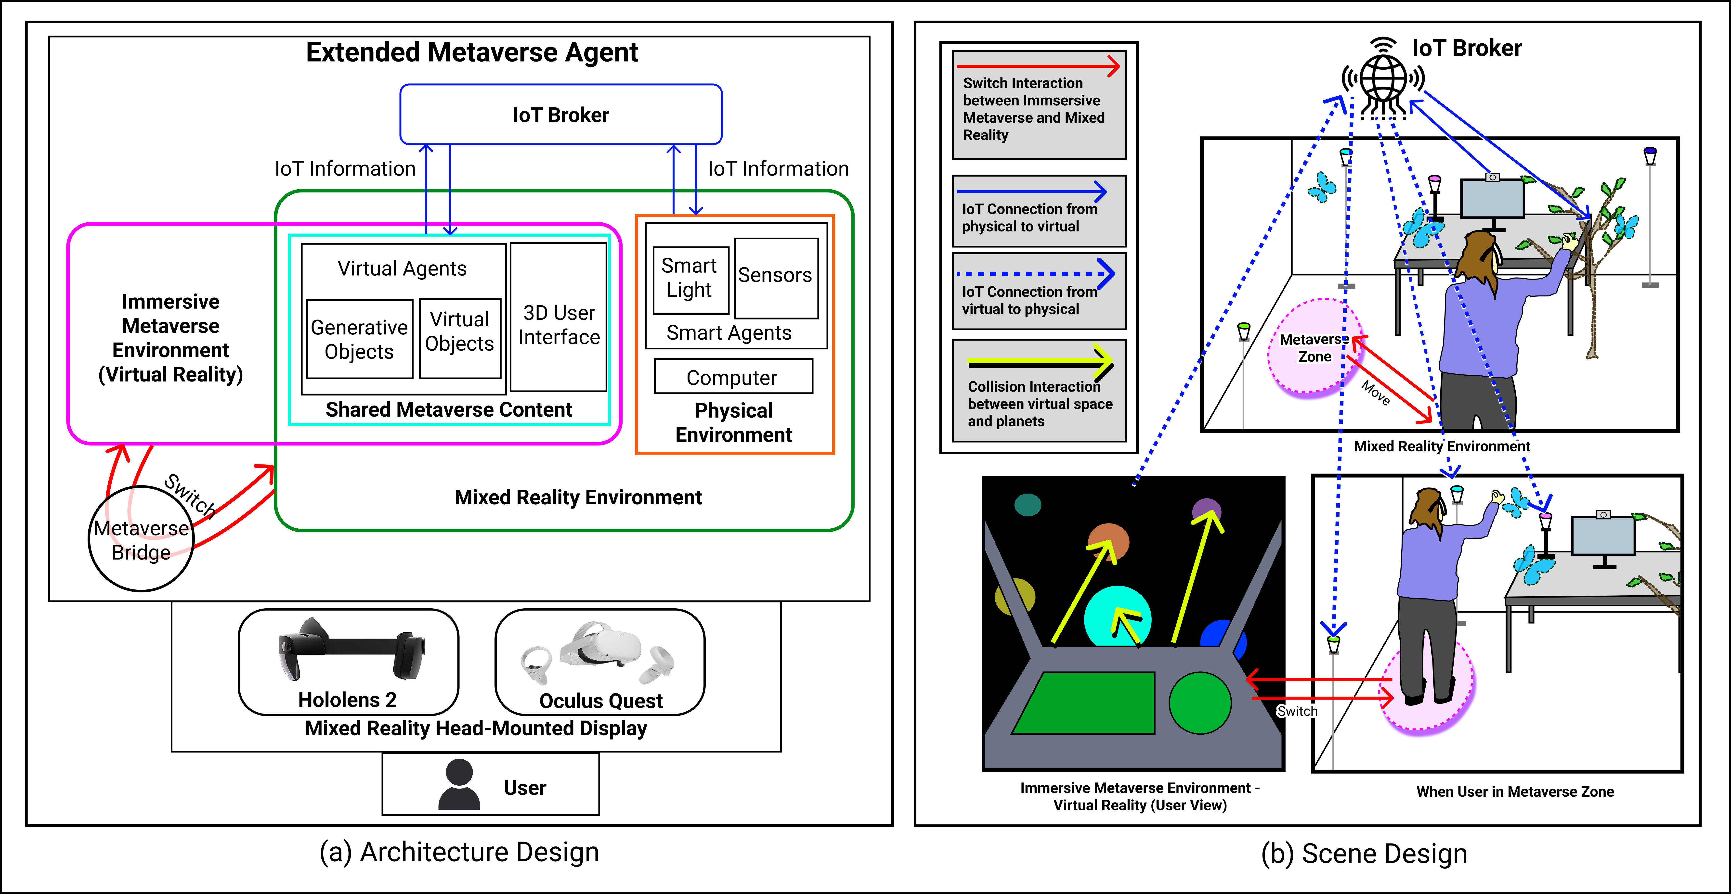

Figure 1: (a) Conceptual Architecture for extended metaverse framework systems that strongly connect the real and the virtual (i.e., the entire RV spectrum [17] [6]). A metaverse bridge enables switching between immersive VR and XR environments while an IoT broker enables communication and control of IoT physical and virtual objects. (b) Reference illustration of a scene design reflecting the architecture and details related to user position, environment lighting, and immersive content during an example metaverse interaction.

Shared Metaverse Content refers to the virtual elements (includ- ing virtual agents and 3D user interface) that could be access both in mixed reality and the immersive metaverse environment. The virtual agent is the virtual representation (for full or partial embodiment) of the smart agents ⁴, that may also perform tasks. The generative objects of the metaverse content are non-static objects with fixed em- bodiment (3D models), that also change and grow dynamically. In the design of this architecture, the generative objects are influenced in their behavior physical context information. Additionally, the ele- ments of 3D user interfaces and widgets is represented, accounting for the new forms of user interaction becoming common for virtual content interfaces that differs from the traditional 2D interface on screen-based devices.
Mixed Reality Environment refers to the hybrid virtual and phys- ical environment, where users see the computer-generated graphic and real space together (through optical or video pass-through) [17]. It includes the physical environment and the shared metaverse con- tent which represented the virtual elements.

4Note that in this work embodiment of IoT objects is considered as the expression of the physical object via its virtual or hybrid virtual-physical counterpart.
Immersive Metaverse Environment refers to a completely syn- thetic world that could immerse the user in totally [17], with con- structing by multiple virtual worlds in fully immersive environ- ment [5].

IoT Broker:The smart agents with sensors in physical environ- ment has the ability to capture context information that could affect and control the shared metaverse content (such as affecting the gen- erative objects, and controlling the behaviours of virtual agetns) through IoT broker. Likewise, the smart light showed in the com- ponent represented the physical actuators, which could affected and controlled by the information from shared metaverse content (such as the interacting with the 3D user interface and virtual objects collision) through IoT Broker.

Metaverse Bridge: act as the method for user to switch between the mixed reality environment and the immersive metaverse envi- ronment. With this bridge, it could enhance the usability of virtual reality applications since it could increase the accessible of physical environment which users rely on.

Scenario Design
Figure 1(b) presents an overall scenario reflecting the architecture components and details. For the mixed reality environment, the user is wearing a head-mounted display headset and could see both the virtual elements (shared metaverse content) and the physical environment. Users could see a virtual tree, virtual butterflies, and a virtual circle represented the metaverse zone on the space. A webcam is attached to the monitor for capturing the physical context through computer vision, and such information could affect and control the virtual elements through IoT communication indicated as solid blue arrows. A metaverse zone is designed to reflect the metaverse bridge in the architecture design, it allow users to move in and move out to switch between immersive metaverse environment and mixed reality environment, as indicated with red arrows. When in the immersive metaverse environment, the user is able to operate a virtual spaceship and perform collision interaction with the virtual planets (indicated with yellow arrows), and such interaction could control the color of physical ambient lighting as indicated with dashed blue arrows through IoT broker.

Extended Metaverse Design Prototypes: MetaPlant and Meta-RV-Traveller
The architecture has been instantiated into two prototype scenar- ios for demonstrating interaction and design within the extended metaverse scenarios. This includes a design exploration of user awareness of time spent in a work context, as in Figure 2; and a similar exploration with a focus on user transitions across immersive contexts, as in Figure 3. Each prototype is described in the following subsections below, based on [6] [7].
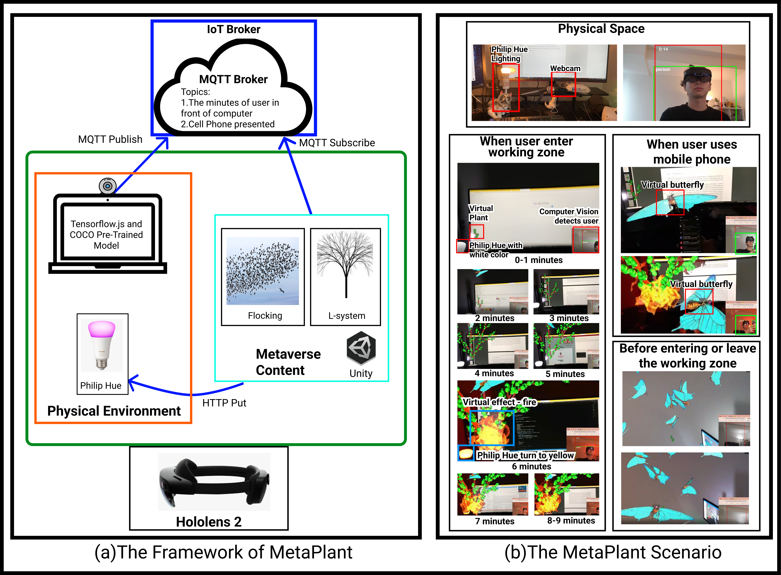
Figure 2: (a) The framework of MetaPlant with the IoT (MQTT and HTTP protocol) connection between physical (computer vision model detect environment context) and virtual (Unity visualization with Hololens 2) environment, based on [6]. (b) The MetaPlant scenario connects user context with mixed reality and the phys- ical environment (ambient lighting). A growing tree represents time-context, and a merger of visual effects, and physical lighting dynamics enrich the environment.

MetaPlant: An Extended Metaverse Scenario for Cross-Reality Awareness of Time Context
The goal of this prototype is to illustrate a more complex extended
timing (the length of time a user sits in front of the computer) as con- text to effect the shape, presentation, and growth of the MetaPlant (a virtual plant in the metaverse) and the color of physical ambient lighting. Also, using a mobile phone will attract a virtual butterfly to fly around the head of the user. This project aims to build an immersive and dynamic “clock” to provide a ten-minute block alarm to prevent users from sitting too long in front of computers and the distraction of virtual butterflies flying around when the user uses a cellphone at work. It is a form of data visualization project that represents the time as the virtual tree grows and turns the minutes to the iteration of the L-system.
This project provides two-way communication (information con- nection from virtual to physical and vice versa) between the meta- verse and physical space. In addition, it is a proof-of-concept pro- totype that demonstrates how the generative and procedural virtual object through the L-system and flocking algorithm could enhance the dynamic of the extended metaverse environment. As demon- strated in Figure 2(b), a Philip Hub ambient light is presented as an actuator by changing color in the physical space. At the same time, a webcam can be used as a sensor in a computer vision model through a web browser to detect whether the user is in front of the computer. In this scenario, the user is wearing a HoloLens 2 to enter an extended metaverse space that could see the virtual embodiment of the plant agent and butterfly. The virtual plant has eight states, with iterations growing with L-system based on the time, combined with expressive mixed reality effects, such as fire on the virtual plant (over time) and corresponding change in physical lighting color (after a fixed time-frame, in minutes).
The framework (see Figure 2(a)) of MetaPlant contains an MQTT Broker that addresses the IoT protocol on the cloud that is used to connect the computer vision model and the Unity environment. A computer vision model in Tensorflow.js ⁵ is available via a browser, and detects whether the human is visible in the space over time and whether they are using a mobile phone (in this case this is whether or not the phone is visible), which then publishes this context in- formation to the MQTT Broker with “Minutes” and “Cell Phone Presented” topics. Unity is the visualization and interaction engine used to subscribe to these topics and use these data to generate a virtual plant with L-system and operate the butterfly movement. Re- garding the physical implementation, a Philip Hue was considered in Prototype 2 to change a physical agent that presented the two-way communication between the metaverse and physical space.
The system starts with object detection when the class detected is equal to “person,” and the timer starts. Likewise, when the label is equal to “cell phone,” a timer of the cell phone being in proximity begins. Communication of this data is via a private MQTT broker powered by Mosquitto⁶ for IoT publish and subscribe messaging. Additionally for the selected IoT devices, the physical light (Philip Hue), is controlled by sending HTTP Put requests with JSON data. In terms of the visualization of the virtual content in HoloLens 2 with Unity, the L-system generates the virtual plant with iterations and the flocking behaviors of the butterfly. The L-system starts with pre-set parameters to indicate the growing shape of the virtual tree in different iterations. The butterfly’s movement is controlled by a conventional flocking engine (Cloud Fine). For butterfly movement the head of the user and the location of the virtual plant allow for queuing behavior settings, allowing them to be dynamic in the user’s environment, while switching between these two positions in
different conditions.
This prototype uses a simple way for the detection of context, by capturing human and mobile phone present in front of the computer. By combining the color control of the light, as in [7], it can perform two-way communication between metaverse content and the physi- cal agent. With the generative object of a virtual plant, the system

metaverse agent scenario with a generative object and context aware-

ness approach in a smart space. This prototype (see Figure 2) uses location (computer vision detects a user in front of their desktop) and
5https://www.tensorflow.org/js 6https://mosquitto.org/

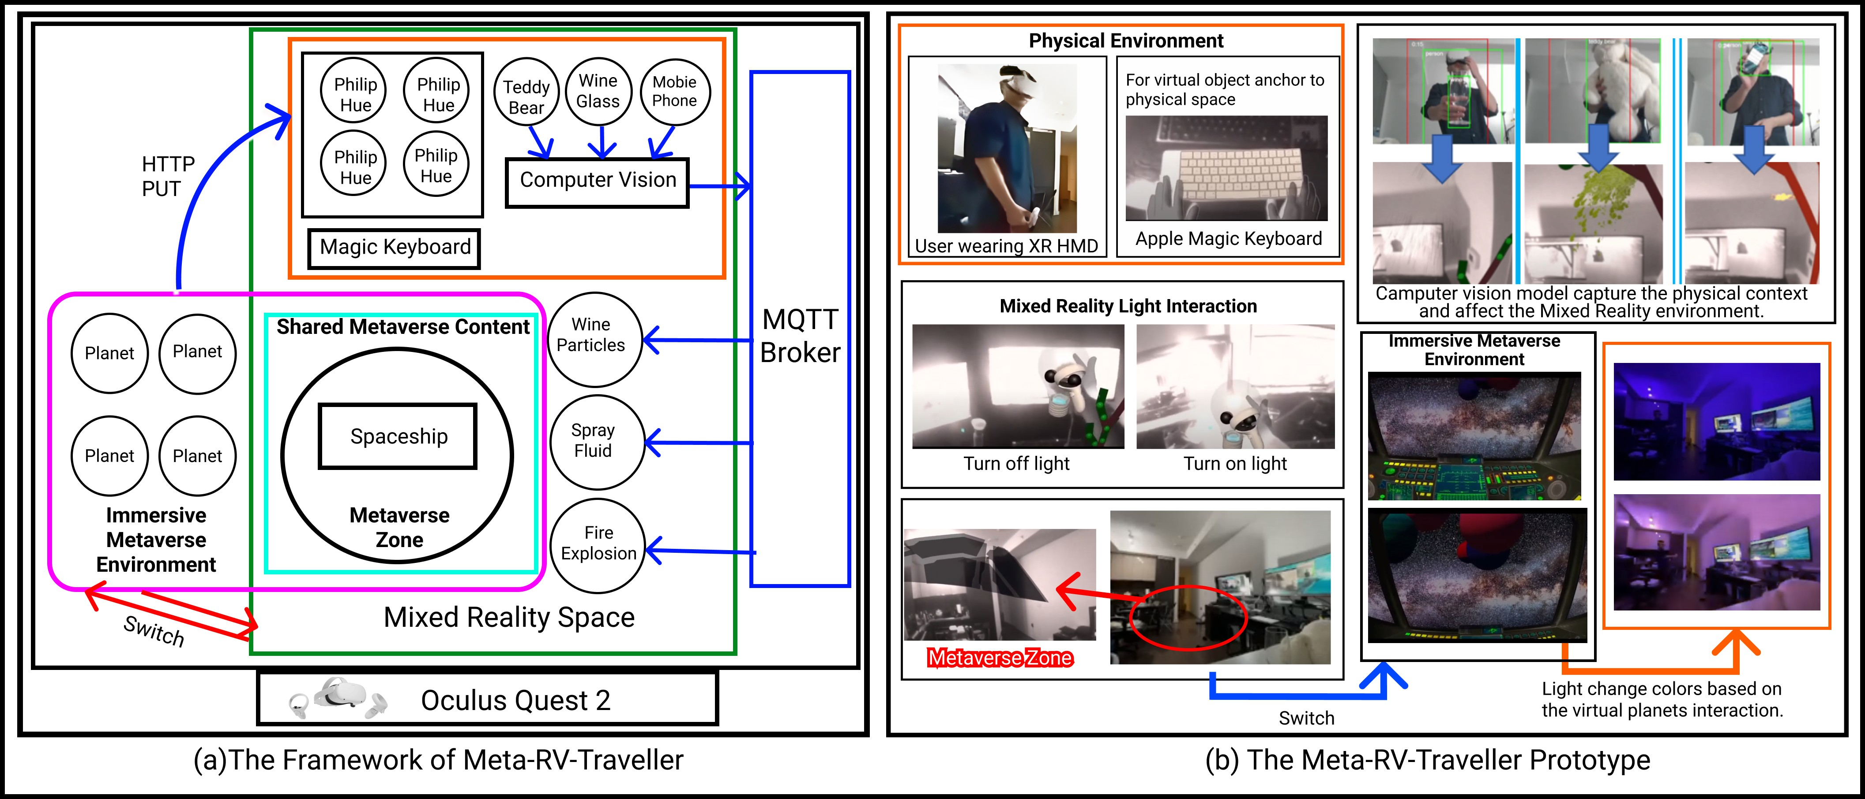

Figure 3: (a) Prototype Framework for Transitioning in a Hyper-Connected Metaverse Environment, as in [6]. (b) The Meta-RV-Traveller prototype explores possible user interactions in the hyper-connected metaverse, as the user transitions between virtual, mixed, and physical environments.

is considered to enhance the overall dynamics and promote an en- gaging MR experience (it is noted that evaluating this experience remains for future testing with users).

Meta-RV-Traveller: Cross-Reality Transitions in a Hyper-Connected Metaverse Environment
Meta-RV-Traveller explores the concept of how users can engage and “travel” between real and virtual environments based on the virtuality continuum [17] in the metaverse context. Figure 3 presents the prototype framework designed for exploring this transition aspect of the extended metaverse, and the resulting prototype exploration is shown in Figure 3(b). This involved designing a metaverse zone in the physical space by combining previous work [7] of switching capacity between two spaces. The virtual environment (a spaceship and universe background) would appear immersive when users enter the area. A virtual bulb is also a shared object of the metaverse virtual and mixed reality environment. The user could also switch on the physical light by moving in/out in a specific area in the MR space and can bring this object with them into the metaverse (fully virtual) zone where they can use it to control the spaceship movement in the virtual universe. In the virtual environment, the bulb attaches to a virtual joystick to control the movement of the spaceship. Two- way communication from virtual to physical and from physical to virtual is shown by switching on and off the physical light using a virtual bulb as one of the interactions from virtual to physical communication. Additionally, when driving the spaceship in the metaverse, there are many planets moving toward the users. Users can move the spaceship by manipulating the virtual joystick to avoid or collide with the planets. If the spaceship hits a planet, then the physical ambient light in the room will change the color to that of the recently collided planet.
On the other hand, similar to previous prototype, the from phys- ical to virtual interaction uses computer vision to detect physical context. The generative tree, from previous, is also incorporated into this project, plus object detection to affect the virtual presentation. When the computer vision model detects example objects (in this case a wine glass, teddy bear, and phone), the MR environment will relatively display a representative visualization (e.g., flowing wine particles, spray fluid, and fire explosion), thereby enabling the fully immersed user to experience the physical context.

Discussion
The proof-of-concept prototypes presented in the previous section are designed to be representative and exploratory. They highlight the potential for interaction simultaneously between the metaverse environments, mixed reality, and the physical environment. They explore possible control of devices in one part of the spectrum that influence those in another part of the spectrum. These also bring attention to the need for designs that bring the benefits of virtual and mixed reality to communicate to the user in rich visual dimensions. Likewise, they also show the merger of IoT sensing and control, with computer vision, can be actively applied to mixed reality scenes for environment understanding and presentation of a shared context, which will be essential for a more hyper-connected metaverse. Al- though this work is not comprehensively evaluated (such as via user study), the frameworks developed are a step toward future research in this direction. However, to show how these prototypes can relate to other work in this area, a subjective rating has been applied, based on a selection of factors (inspired by [10] [17] [14] [32]) considered deemed important for such systems.
Table 2 presents the definitions of the factors for comparison, including embodiment, connectedness, content generation, mixed reality access, context awareness, virtual-physical agency and user- interactive level, with the meaning of the levels of very low, low, medium, high, and very high. Figure 4 shows the authors’ subjective comparison of levels of the related works with those of the proto- types presented in Section 4, MetaPlant and Meta-RV-Traveller, as described below. These show how the prototypes can be considered to address the merger of a broad range of needs and factors, at a high level.

Directions for Future Work
The current work centered on the design and prototyping of these systems, and a more rigorous evaluation of these concepts is left as a direction for future research. For instance, more experimentation is needed to clearly show how cross-reality benefits users. Further, this work only considers a single-user cross-reality scenario, and multi-user explorations would be beneficial for proving the concept across different scenarios. New forms of representing changes in the physical and virtual environment and new design approaches are needed for users regardless of whether they are physically present, or virtually telepresent, across the entire cross-reality spectrum.

Design Factors | Description | Very Low | Low | Medium | High | Very High
Embodiment | The level of corporeal pres- ence of the metaverse con- tent. | The virtual con-  tent is only two- dimensional User Interface. | The virtual content is rep- resented as 3D simple shapes and is static | The virtual content is dy-  namic (e.g., moving in the environment and perform- ing animations). | The virtual content is not only  represented as avatars or objects, but also have fixed effects on the virtual environment. | The virtual content has dynamic effects on the virtual environment such as particles effects.
Connectedness | The level of information  communication between the metaverse and phys- ical space (single and bi-directional communica- tion). | There are no com- munications be- tween objects. | Objects connect only on physical or virtual side. | Objects could have single directional communication between virtual and physi- cal. | Objects could have bi-directional communications between virtual and physical through IoT broker. | Objects have bi-directional com- munications with multiple IoT virtual and physical objects and multiple communication meth- ods.
Content Genera- tion | The level of objects that are generated in the scene based on the context information. | There are no gen- erative content in the system. | Context changes could  affect the behaviours or shapes of virtual objects, but these are not gener- ated in the scene. | The shapes or behaviours  of the objects are generated based on the context infor- mation through simple logic rules. | The shapes and behaviours of the objects are generated by more complex logic states, such as L- systems and flocking. | Shapes and behaviours of the ob- jects are generated through ad- vanced machine learning meth- ods.
Mixed Reality Access (inspired by [17]) | The level of mixed reality presence and immersion in the metaverse based on de- vices. | Users could only access real envi- ronment or the virtual reality en- vironment. | Users could access low level of immersion with mixed reality such as us- ing AR in mobile de- vices. | Users could access mixed  reality through head- mounted display devices (optical or video pass- through) with limited field of view. | Users access mixed reality through head-mounted display devices (optical or video pass- through) with wide field of view. | User can not only have high im- mersion in mixed reality, but also switch between virtual reality en- vironment and real environment inside the devices.
Context Aware- ness | The level of context sensing capacity in the real environ- ment. | The system do not capture information from physical space. | The system could capture raw sensor data (as nu- meric values) from a sin- gle source. | The system could capture multiple raw sensor data through multiple sensor sources. | The system could capture, infer,  and process complex data as in- put (such as real-time video ob- ject detection, or audio speech detection, resulting in a single classification (such as a number value or class label). | The system could understand  complex data input, same as high, but resulting in more complex high-level or hierarchical context descriptions (such as detecting that a meeting is taking place, based on multiple sensor infor- mation).
Virtual-Physical Agency (inspired by [31] [10]) | The level of autonomous, re- active, proactive, and social capability of the entire meta- verse ecosystem. | The system does not have agent ca- pabilities. | The system performs low  levels of agent function in virtual or physical inter- actions, such as trigger- ing a single event based on a sensor. | The system performs  medium levels of agent function for either virtual or physical interactions, such as handling multiple events based on multiple sensors. | The agents should be capable  of performing hybrid virtual and physical interactions and also has high agency (i.e., autonomous, reactive, proactive, and social in- teractions). | Same as high, but via more human-like, complex mecha- nisms and controllers, such as having cognitive or machine learning architectures.
User-Interactive Level (inspired by [32] [10]) | The level of control and feedback available for the user from the entire meta- verse ecosystem. | Users can not ma- nipulate the simu- lated content. | Users could manipulate  low degree of interaction with the simulated param- eters of the virtual con- tent, such as changing a Boolean value flag. | Users could manipulate medium degree of the simulated parameters, such as changing one or more values across a spectrum. | Users could manipulate high de- gree of the simulated parame- ters, such as manipulate multi- ple spectrum values, multiple ob- jects, and multiple control types. | Same as high, but allow users to manipulate both physical and vir- tual objects to perform the inter- action.
Table 2: Factors for comparison of the related prototypes (showed in Figure 4), and their meanings from very low to very high.

Additionally, as the current work relies on subjective evaluation, a more thorough user evaluation is required to objectively assess the benefits and significance of this cross-reality research, as well as user-experience and performance. In the two example prototypes presented, the users can direct the virtual or physical world via their interactions, but the system-directed interactions to the user have not been examined, i.e., the cross-reality user interaction and feedback loop could be a significant factor for designers of future systems.
Further, more system performance and functionality evaluations are also required. It is also noted that new head-mounted displays and cross-reality hardware also remains to be incorporated into the framework, which would address several limitations related to visi- bility and immersion (i.e., use of color-passthrough HMD’s versus the black & white passthrough HMD used in this work). Lastly, an exploration of how to optimize the anchoring and placement of mixed reality objects without obstructing the user’s field of view is also an important question for further research, such as positioning content in the peripheral field-of-view, or minimizing visual clutter.

Summary

This work has addressed the metaverse disconnect problem and the underlying challenges related to bridging and extending the metaverse concept across virtual, mixed, and physical environments through a single architectural framework. This framework has been instantiated to show two distinct prototype designs as cross-reality use cases wherein a user immersed in a mixed reality environment is able to engage with objects and elements from across either environ- ment, and transition between these contexts while remaining in touch with each. This approach examines through design, outlining the need for connectivity, shared visualizations, and context awareness as ways to bridge the human-in-the-loop and the many virtual, mixed, and physical reality environments that they will increasingly engage in as the metaverse advances to maturity. Together, it is hoped that these will help foster the design-creation of a more seamless and extended metaverse environment.

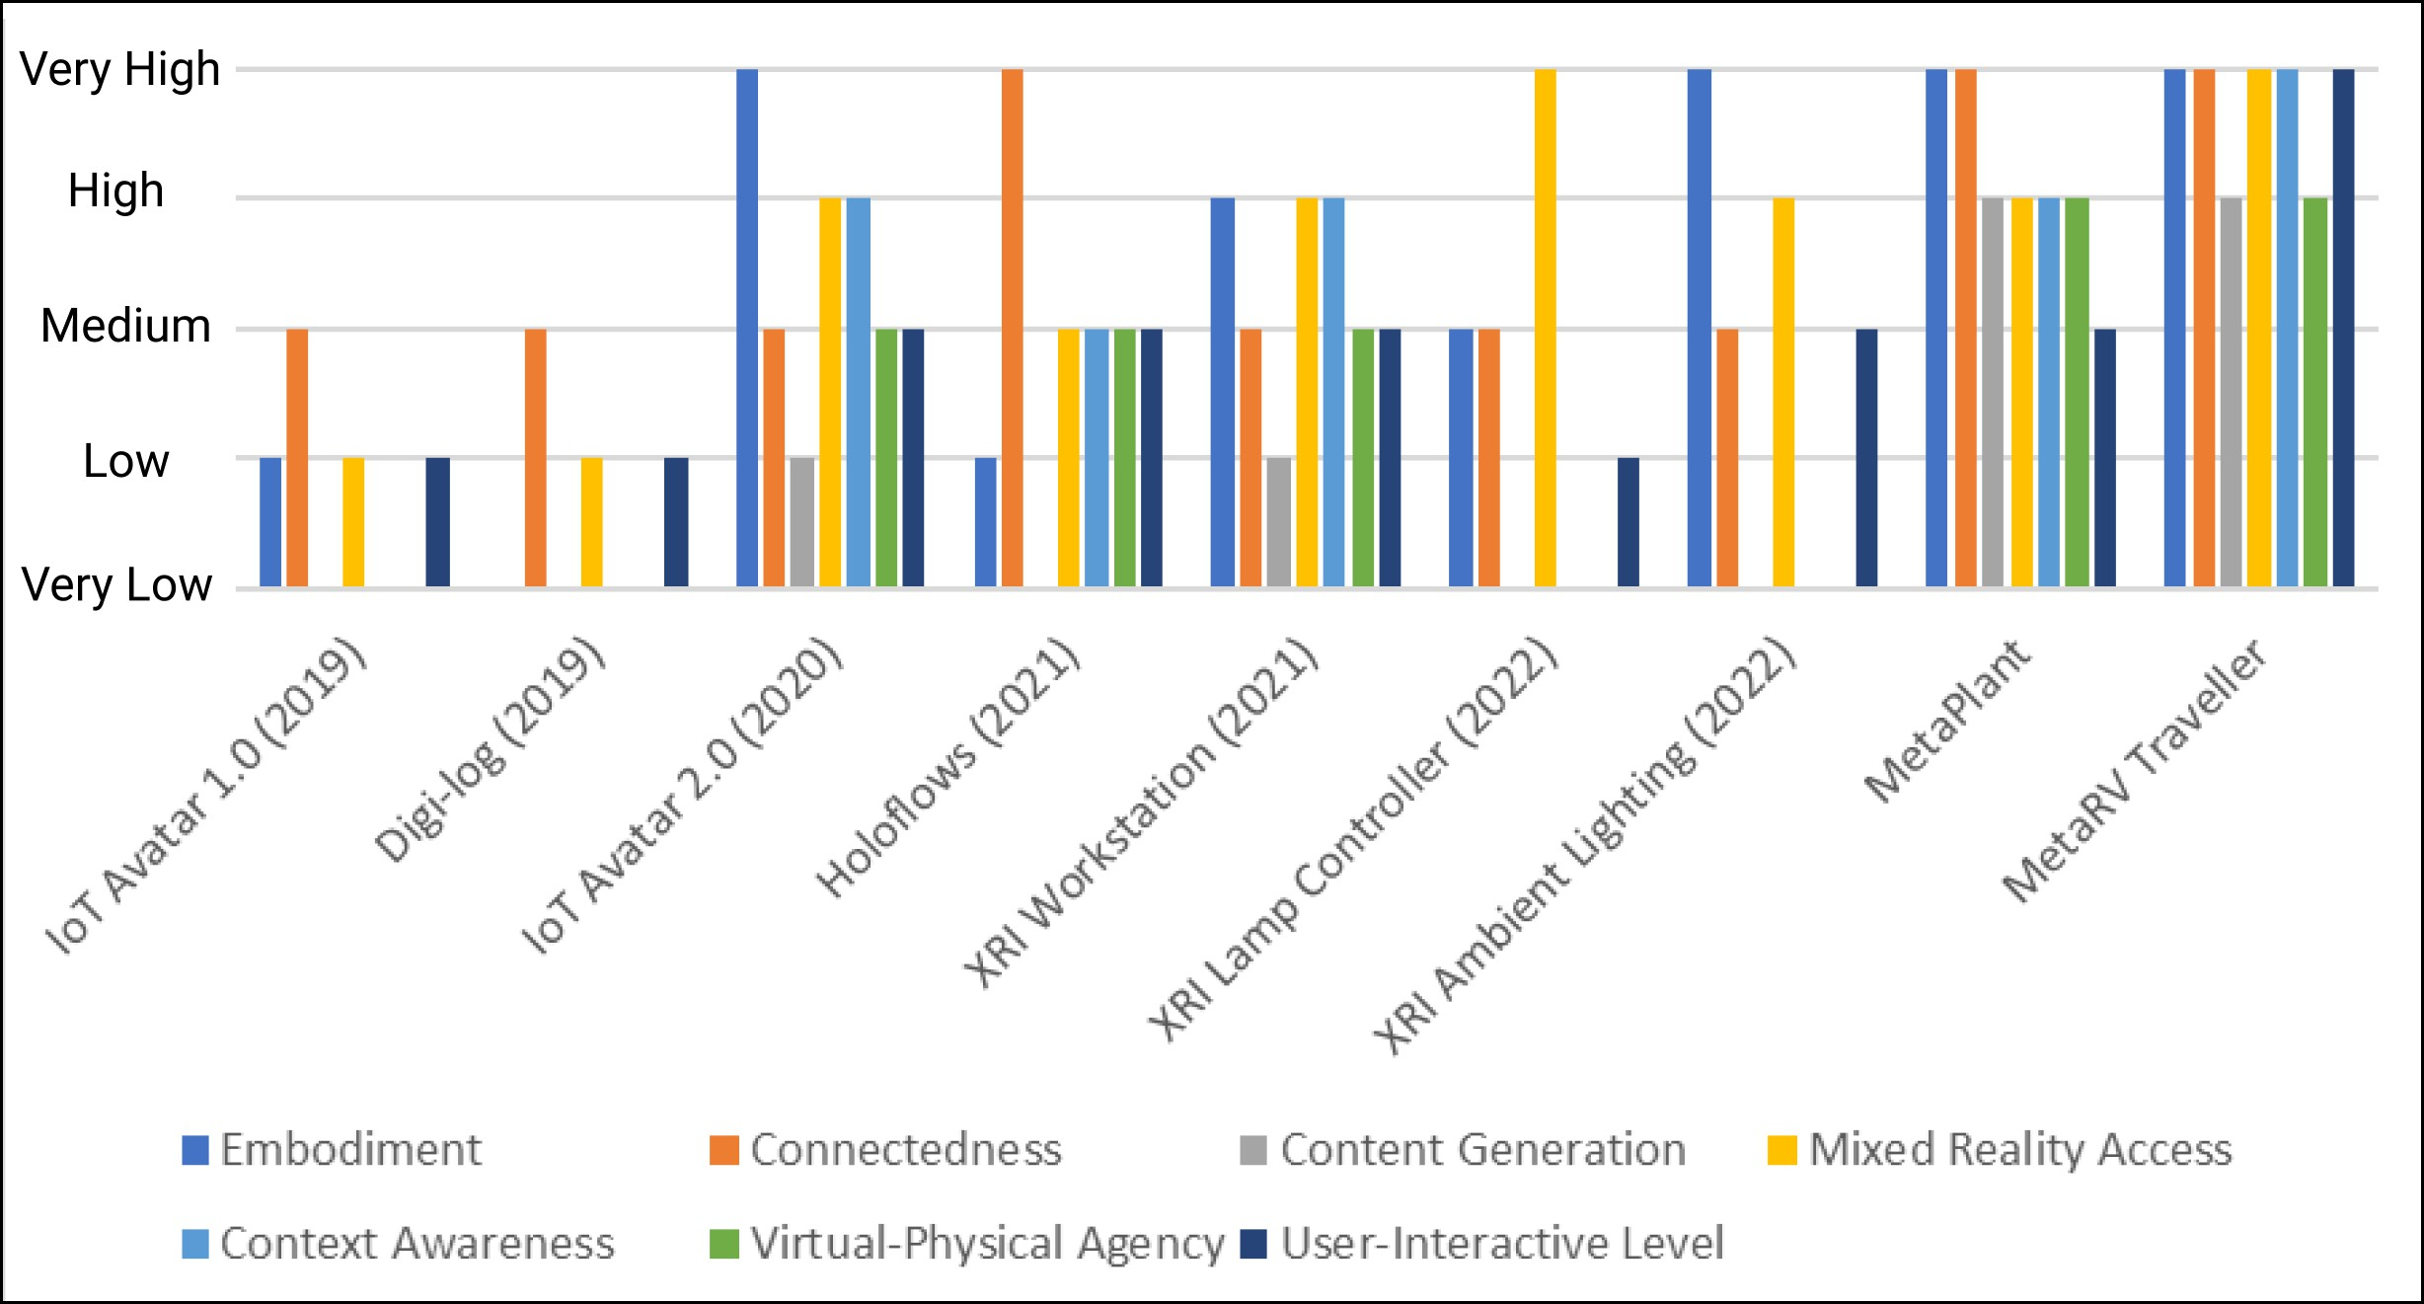
Figure 4: A comparison of the prototypes (based on the factors in Table 2) developed versus related work. It provides a subjective comparison with criteria in Table2 from 0-5 (very low to very high) of XR and IoT related projects, IoT Avatar 1.0 [25], IoT Avatar 2.0 [19], XRI Workstation [18], Digi-log [12], Holoflows [24], XRI lamp Controller [7], XRI Ambient Lighting [7], and the two prototypes presented in this paper.

Acknowledgments
This work was supported by funding from the Tri-council of Canada under the Canada Research Chairs program.

References
- T. Ai. Metaverse Theory. SSRN Electronic Journal, pp. 1–4, 2021. doi: 10.2139/ssrn.3840764
- T. Andrade and D. Bastos. Extended reality in iot scenarios: Concepts, applications and future trends. In 2019 5th Experiment International Conference (exp.at’19), pp. 107–112, 2019. doi: 10.1109/EXPAT.2019
.8876559
- E. Cline. Ready Planyer One. Crown Publishers, New York, 2011.
- C. Collins. Looking to the Future: Higher Education in the Metaverse.
EDUCAUSE Review, 43(5):50–52, 2008.

- J. D. N. Dionisio, W. G. Burns, and R. Gilbert. 3D virtual worlds and the metaverse: Current status and future possibilities. ACM Computing Surveys, 45(3), 2013. doi: 10.1145/2480741.2480751
- J. Guan. Extending the metaverse: Exploring generative objects with extended reality environments and adaptive context awareness. 2022.
- J. Guan, J. Irizawa, and A. Morris. Extended reality and internet of things for hyper-connected metaverse environments. In 2022 IEEE Conference on Virtual Reality and 3D User Interfaces Abstracts and Workshops (VRW), pp. 163–168. IEEE, 2022.
- J. Guan, N. Lessio, Y. Shao, and A. Morris. Exploring a mixed re- ality framework for the internet-of-things: Toward visualization and interaction with hybrid objects and avatars. In 2020 IEEE Conference on Virtual Reality and 3D User Interfaces Abstracts and Workshops (VRW), pp. 857–857. IEEE, 2020.
- D. Gursoy, S. Malodia, and A. Dhir. The metaverse in the hospitality and tourism industry: An overview of current trends and future research directions. Journal of Hospitality Marketing & Management, pp. 1–8, 2022.
- T. Holz, A. G. Campbell, G. M. Ohare, J. W. Stafford, A. Martin, and
M. Dragone. MiRA-mixed reality agents. International Journal of Human Computer Studies, 69(4):251–268, 2011. doi: 10.1016/j.ijhcs. 2010.10.001
- D. Jo and G. J. Kim. AR enabled IoT for a smart and interactive environment: A survey and future directions. Sensors (Switzerland), 19(19), 2019. doi: 10.3390/s19194330
- D. Jo and G. J. Kim. Iot+ ar: pervasive and augmented environments for “digi-log” shopping experience. Human-centric Computing and Information Sciences, 9(1):1–17, 2019.
- J. Joshua. Information Bodies: Computational Anxiety in Neal Stephen- son’s Snow Crash. Penn State University Press, 19(1):17–47, 2017.
- A. Jovanovic´ and A. Milosavljevic´. VoRtex Metaverse Platform for Gamified Collaborative Learning. Electronics (Switzerland), 11(3), 2022. doi: 10.3390/electronics11030317
- L.-H. Lee, T. Braud, P. Zhou, L. Wang, D. Xu, Z. Lin, A. Kumar,
C. Bermejo, and P. Hui. All One Needs to Know about Metaverse: A Complete Survey on Technological Singularity, Virtual Ecosystem, and Research Agenda. 14(8):1–66, 2021.
- L.-H. Lee, Z. Lin, R. Hu, Z. Gong, A. Kumar, T. Li, S. Li, and P. Hui. When Creators Meet the Metaverse: A Survey on Computational Arts, vol. 37. Association for Computing Machinery, 2021.
- P. Milgram. a Taxonomy of Mixed Reality Visual Displays. Industrial Engineering, (12):1–14, 2011.
- A. Morris, J. Guan, and A. Azhar. An xri mixed-reality internet-of- things architectural framework toward immersive and adaptive smart environments. In 2021 IEEE International Symposium on Mixed and Augmented Reality Adjunct (ISMAR-Adjunct), pp. 68–74. IEEE, 2021.
- A. Morris, J. Guan, N. Lessio, and Y. Shao. Toward mixed reality hybrid objects with iot avatar agents. In 2020 IEEE International Conference on Systems, Man, and Cybernetics (SMC), pp. 766–773. IEEE, 2020.
- C. Ondrejka. Escaping the Gilded Cage: User Created Content and Building the Metaverse. NYL Sch. L. Rev., 49(1):81, 2004.
- E. Ordano, A. Meilich, Y. Jardi, and M. Araoz. Decentraland white paper. p. 15, 2017.
- J. A. Paradiso and J. A. Landay. Guest editors’ introduction: Cross- reality environments. IEEE Pervasive Computing, 8(3):14–15, 2009.
- B. Ryskeldiev, Y. Ochiai, M. Cohen, and J. Herder. Distributed meta- verse: Creating decentralized blockchain-based model for peer-To-peer sharing of virtual spaces for mixed reality applications. ACM Inter- national Conference Proceeding Series, 2018. doi: 10.1145/3174910. 3174952
- R. Seiger, R. Ku¨hn, M. Korzetz, and U. Aßmann. Holoflows: modelling of processes for the internet of things in mixed reality. Software and Systems Modeling, 20(5):1465–1489, 2021.
- Y. Shao, N. Lessio, and A. Morris. Iot avatars: Mixed reality hybrid objects for core ambient intelligent environments. vol. 155, pp. 433–
440. Elsevier, 2019.
- H. soo Choi and S. heon Kim. A content service deployment plan for metaverse museum exhibitions—Centering on the combination of beacons and HMDs. International Journal of Information Management,
37(1):1519–1527, 2017. doi: 10.1016/j.ijinfomgt.2016.04.017
- E. Swilley. Moving virtual retail into reality: Examining metaverse and augmented reality in the online shopping experience. In Looking Forward, Looking Back: Drawing on the Past to Shape the Future of Marketing, pp. 675–677. Springer, 2016.
- J. Thomason. Metahealth-how will the metaverse change health care?
Journal of Metaverse, 1(1):13–16, 2021.
- T. Tsang and A. Morris. A hybrid quality-of-experience taxonomy for mixed reality iot (xri) systems. In 2021 IEEE International Conference on Systems, Man, and Cybernetics (SMC), pp. 1809–1816. IEEE, 2021.
- K. J. Vicente. The human factor: Revolutionizing the way people live with technology. Routledge, 2013.
- M. Wooldridge and N. R. Jennings. Agent theories, architectures, and languages: A survey. Lecture Notes in Computer Science (including subseries Lecture Notes in Artificial Intelligence and Lecture Notes in Bioinformatics), 890:1–39, 1995. doi: 10.1007/3-540-58855-8 1
- D. Zeltzer. Autonomy, Interaction, and Presence. (September):127– 132, 1992.
- Y. Zhao, J. Jiang, Y. Chen, R. Liu, Y. Yang, X. Xue, and S. Chen. Metaverse: Perspectives from graphics, interactions and visualization. Visual Informatics, 2022.

